MX17 February Beam Test at n_Tof

Post Beam AI Run Summary

Saturday January 31
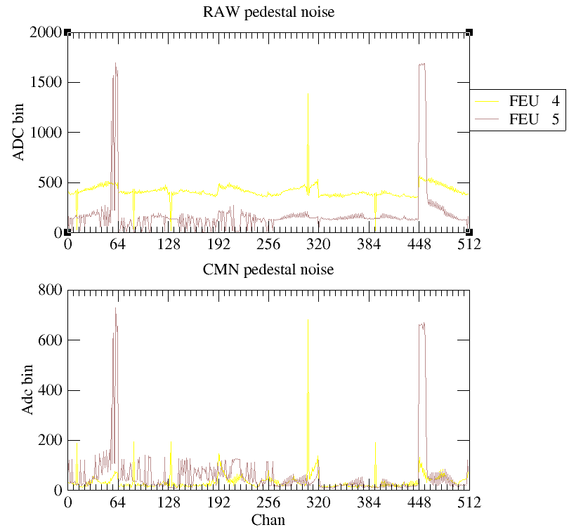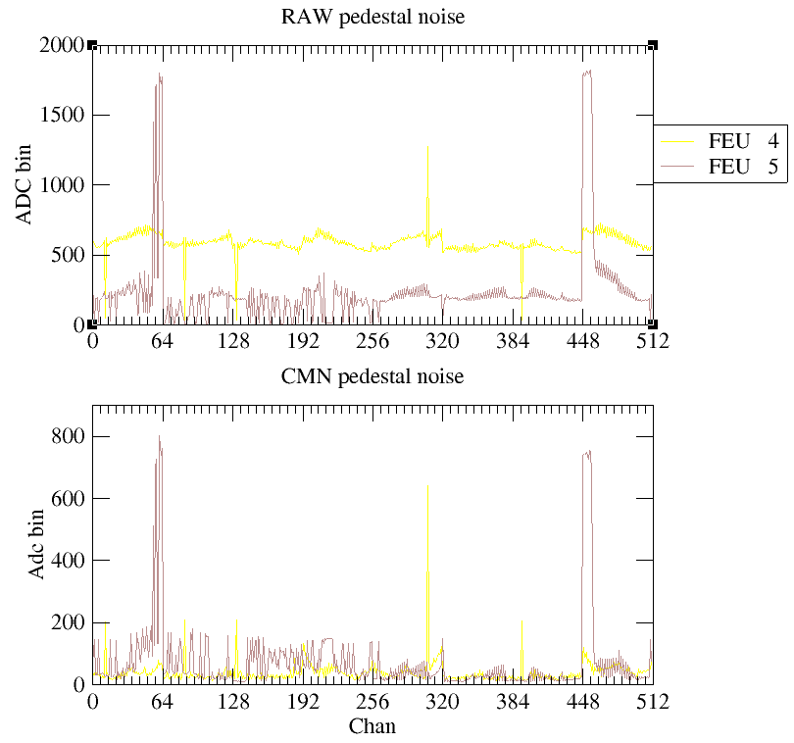

Noise looks bad after initial plug in of detectors. Top no HV bottom with HV.
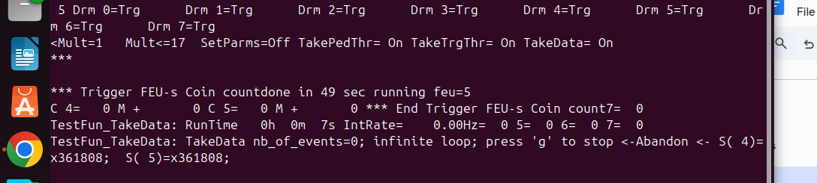
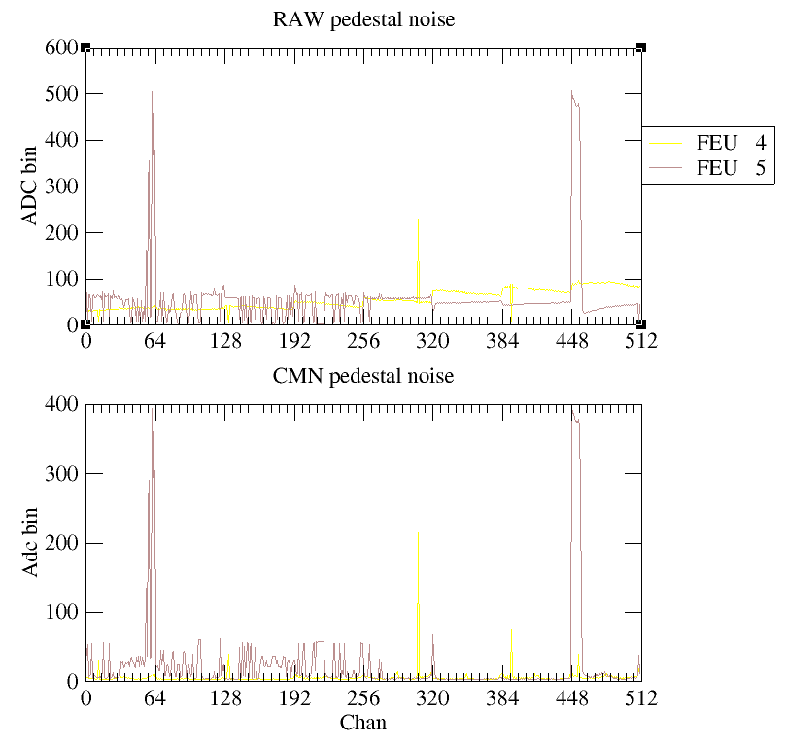
After some grounding. Feu 5 DREAMs 0 and 7 still have some very bad noise. Masking these DREAMs out for now.
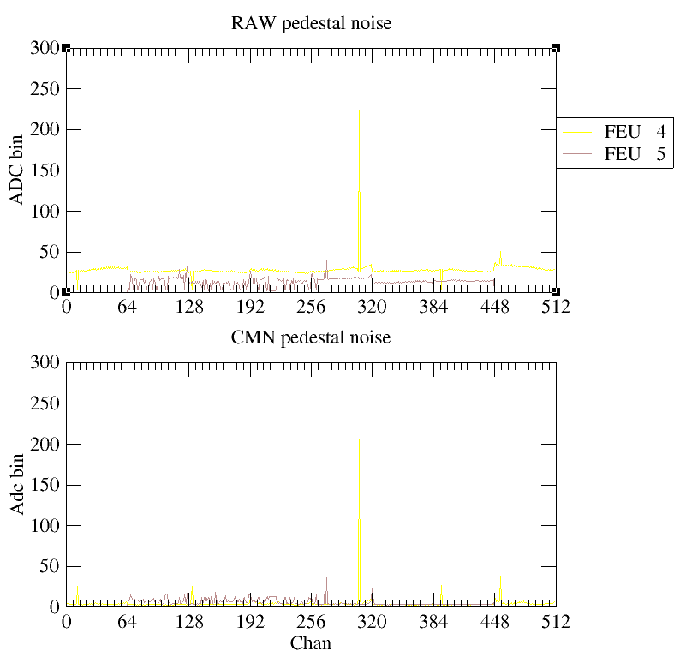
After masking, just one or two noisy strips in FEU 4 DREAM 4.
Ran in self trigger mode and only saw signal in FEU

FEU 4 Channel 306 is noisy, see if we can mask.

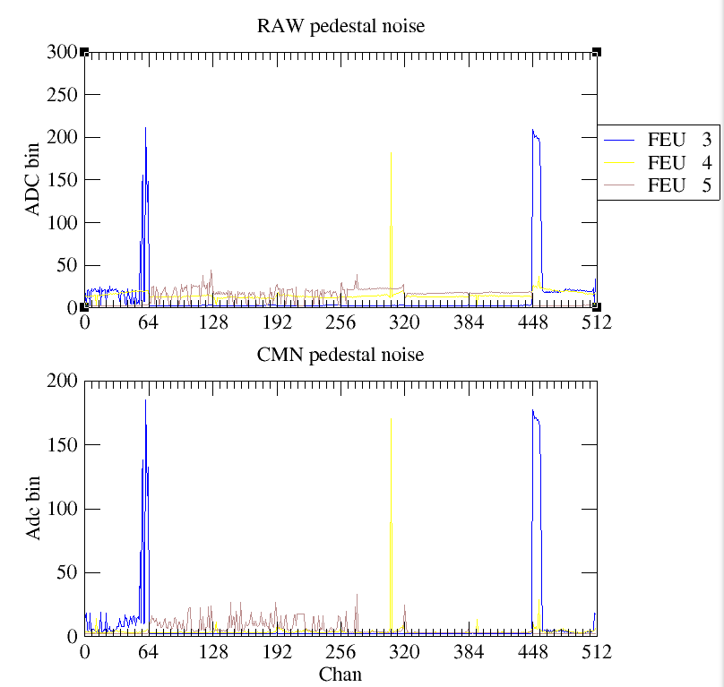
Pedestals with M4 Card on Feu5 256-447, Feu3 448-512
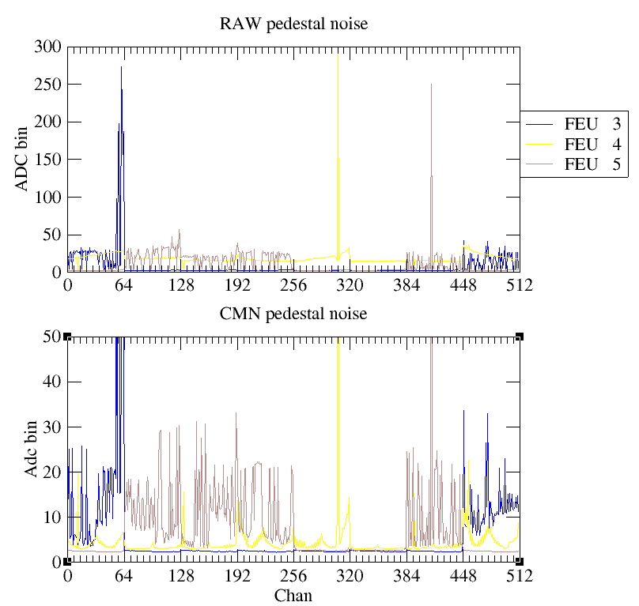
Pedestals with M4 swapped with M2 card. Plugged to Feu5 channels 384-447 and FEU 3 448-512
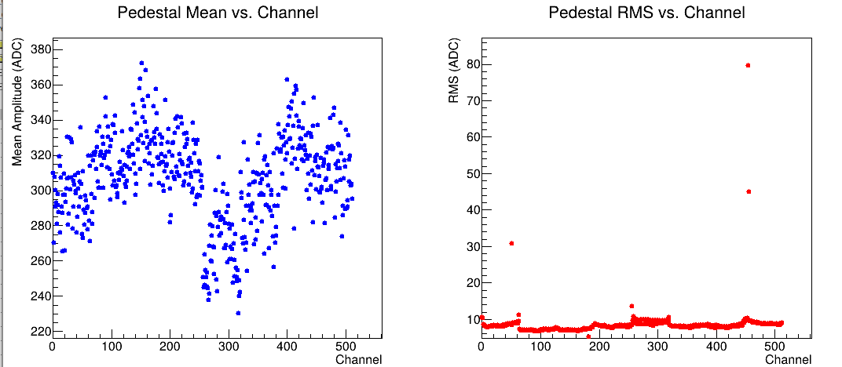
From Saclay cosmics. Much lower noise. Not sure why so much higher at ntof

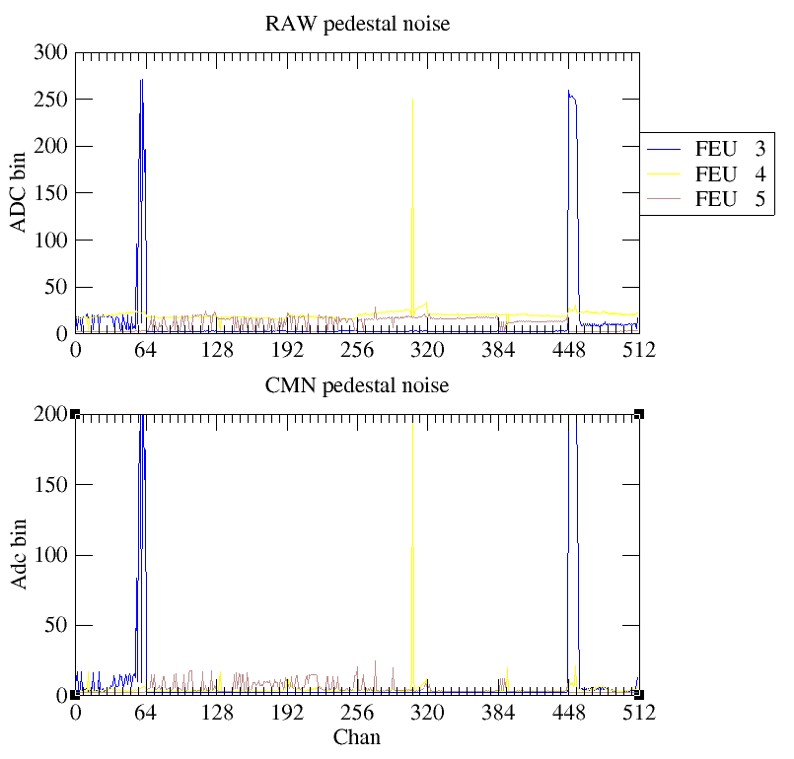
Plugging M4 back in, recover almost exaclty what we had before. Must be a M4 PCB issue. Also used a new J7 connector, didn’t seem to make any difference.

Start overnight cosmics with drift at -600V and resist at +490V.

Sunday February 1
Ended overnight run and mounting the detector on the beam. Once it was mounted and DREAM cables plugged in but before plugging in HV or gound to rack with copper braid. Only FEUs 4 and 5 plugged as usual, FEU 3 unplugged. Taking pedestals with the Self trigger config in test5.
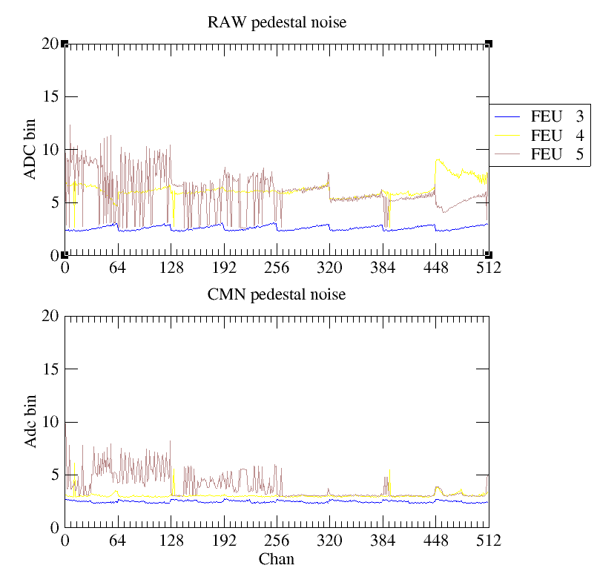
Pedestals above without copper braid grounding or either HV plugged.
Pedestals again after copper braid grounding.
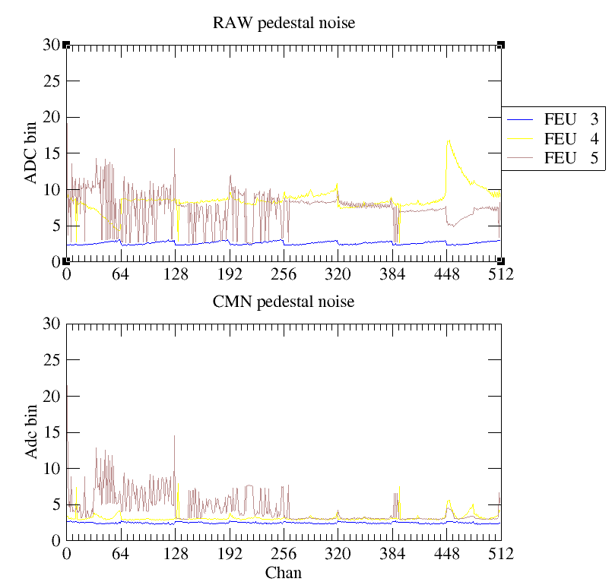
Pedestals after Drift plugged in but resist unplugged, still looks fine.
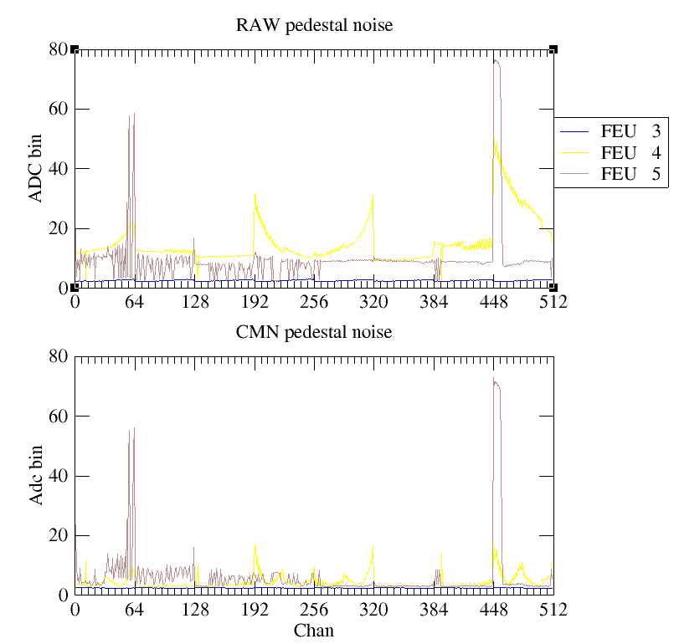
Pedestals after plugging in Resist.
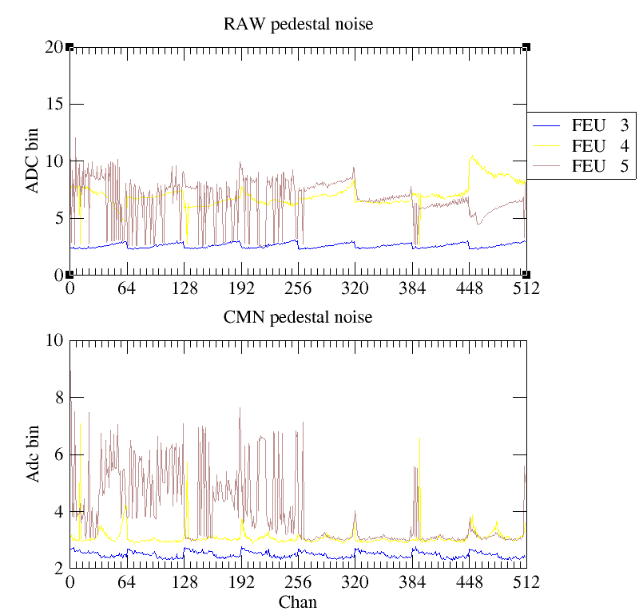
After grounding the resist HV ground directly to the board. Seems to have been a problem.
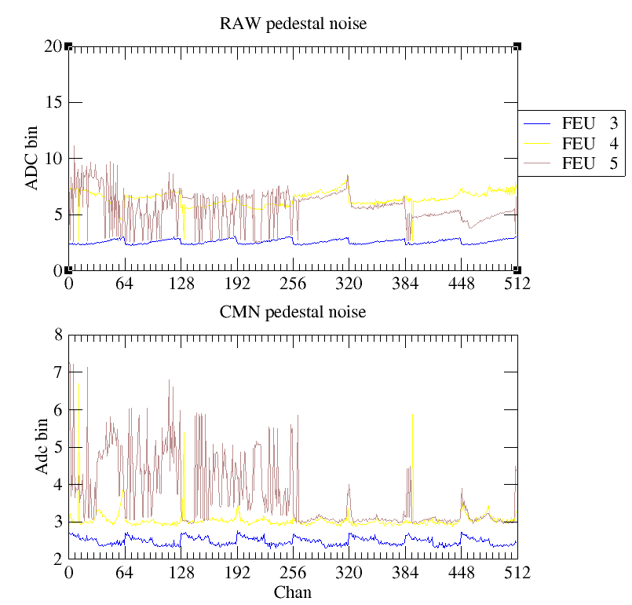
After applying -600V to the Drift. Still good

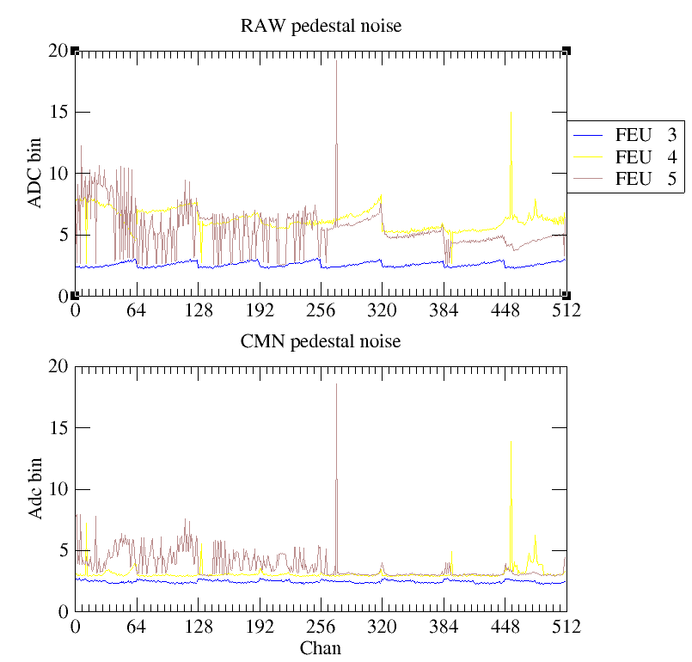
After also applying +490V to resist. Some channels noisy but overall much better
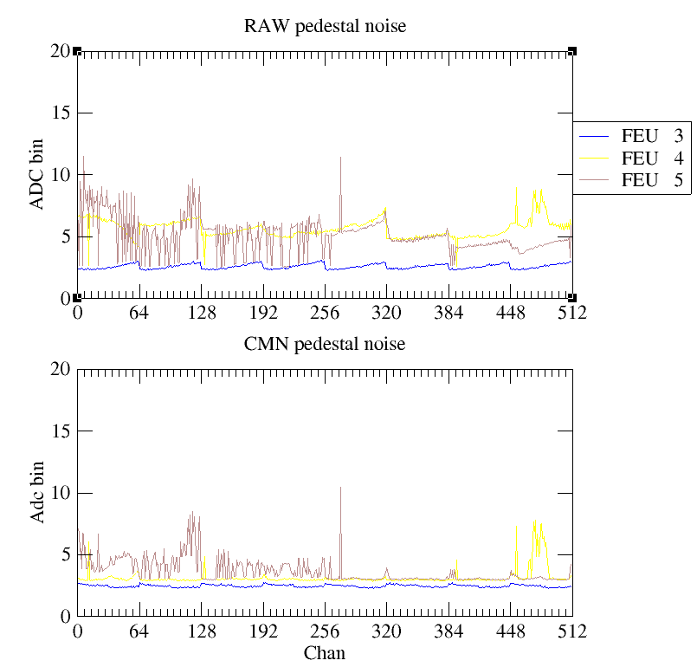
After going to +500V on the resist looks better. Probably due to letting it sit at voltage for a few minutes

FEU 4 → All X strips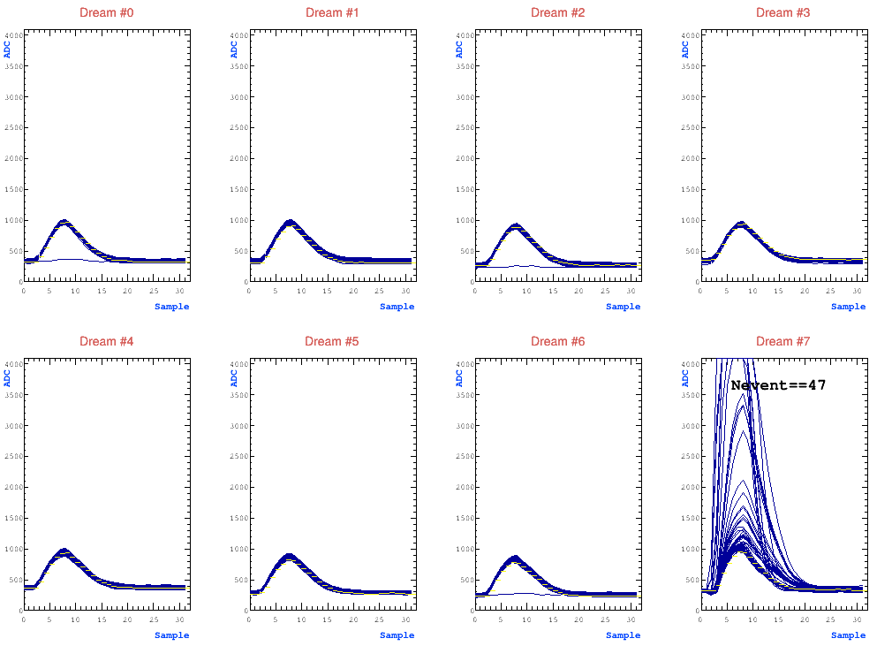
FEU 5 → All Y strips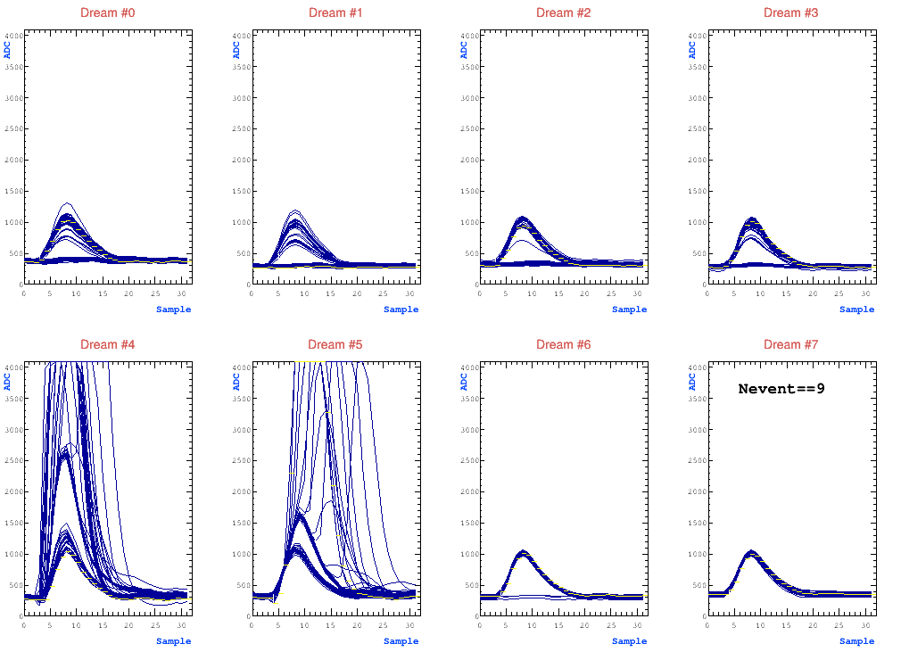
Seeing common noise. Saw yesterday as well but didn’t seem quite as bad. My theory is that we were horizontal yesterday and seeing relatively more signal. Today vertical, so seeing less, so this noise dominates.
Looks like a large spike in some channels, typically in the same place in both x and y, though some variation. The remaining strips all see almost the exact same, smaller waveform. It looks as though the strips that see nothing are probably disconnected, as they match roughly what we see in low noise pedestal strips.
At 490V resist, about 1.6Hz.
Turned drift off and still saw this noise at around 0.8Hz. Think that tells us that these aren’t normal signals from a charged particle ionizing in the drift gap. I’m guessing sparks.
Tried putting HV box in faraday cage with aluminum foil. Didn’t change anything.
Talk of removing filter in the HV box, just sending HV from cables directly to drift/resist. Decided to wait, will have to dismount detector.

Trying with our caen unit, bypassing the GDD external filter as well.

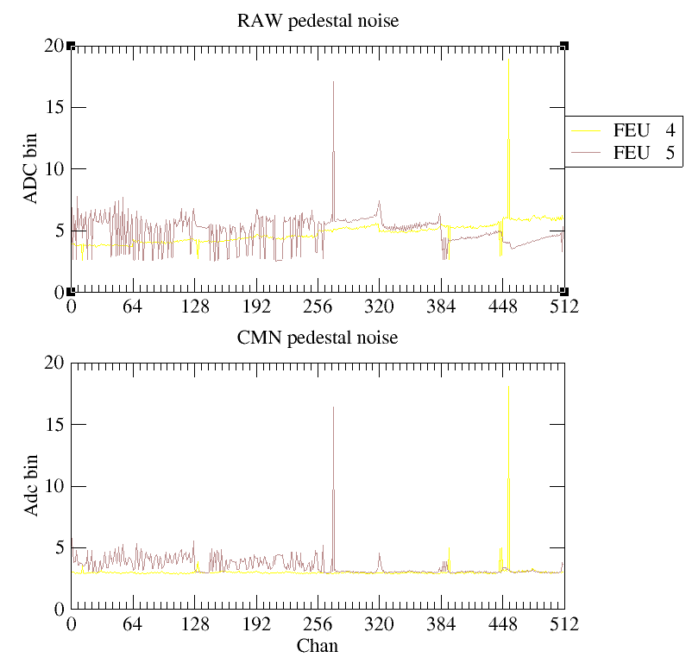
Same noise and roughly same rate with CAEN unit from our rack.

Put back on n_Tof CAEN HV and set to run overnight with drift at -600V and resist at +490V.

Monday February 2
Connected to CERN network with the daq machine. Spent morning setting up daq.

Got beam. No external trigger for some reason, will have to check that later. For now, go in self trigger mode at low Resist and slowly ramp up. Drift at -600V. At resist of +450V and latency of 90 (0x005A), we get below
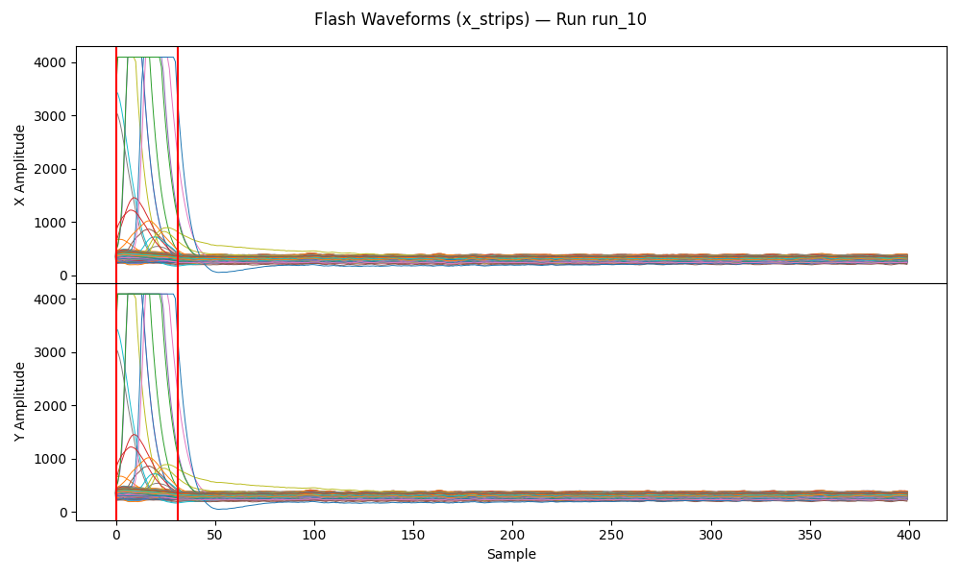

At latency of 150 (0x0096)
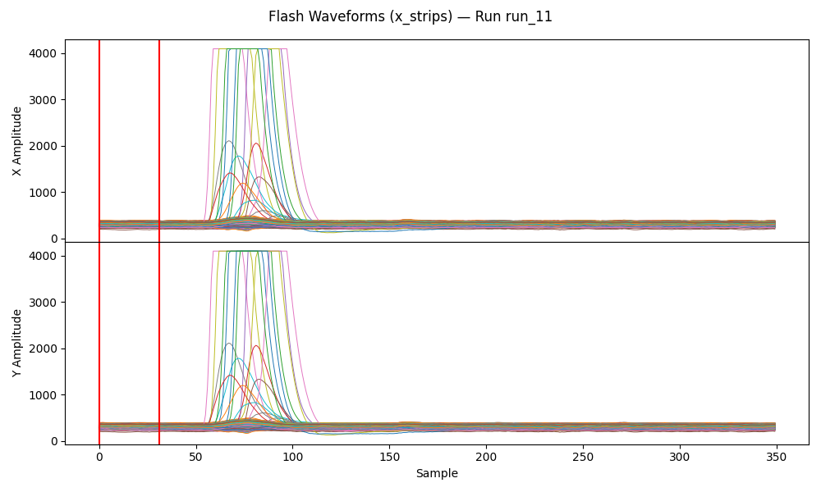
At latency of 125 (0x007D)
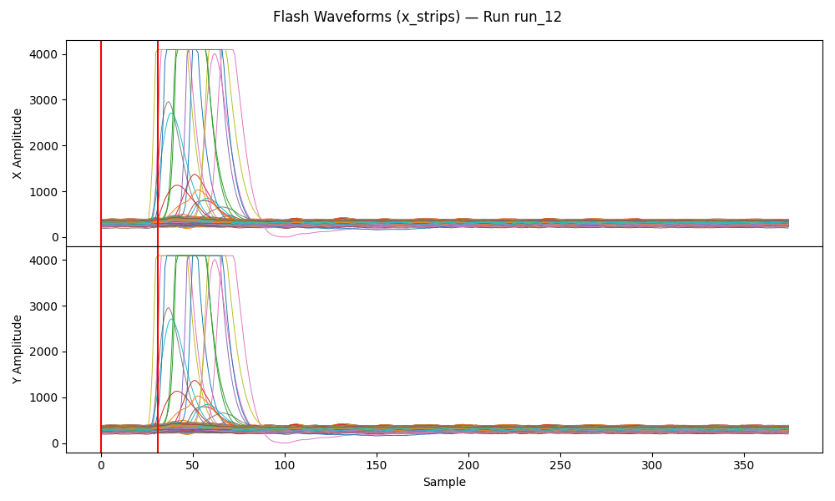
At latency of 110 (0x006E). Stay here.
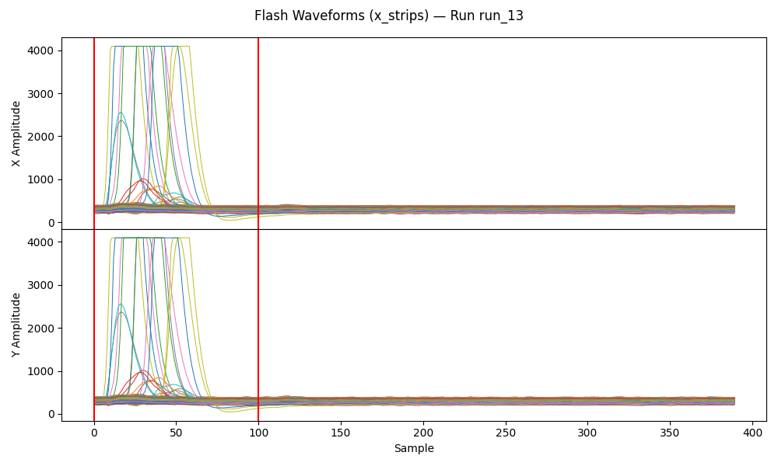
At 450V most of the detector seems to be below operating voltage. We get a rate of about 0.13Hz of the signal above. Plotting in rough x/y, it’s isolated to the same spot.
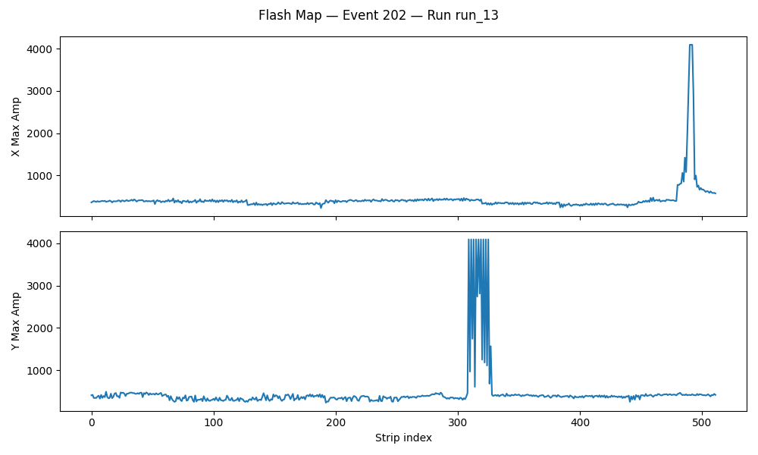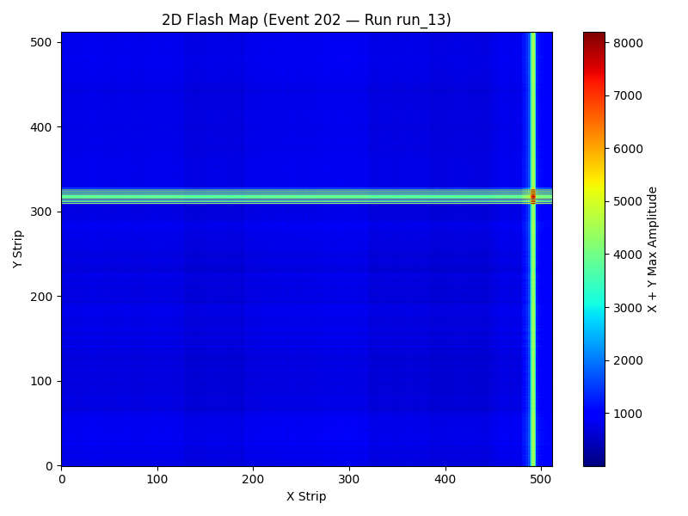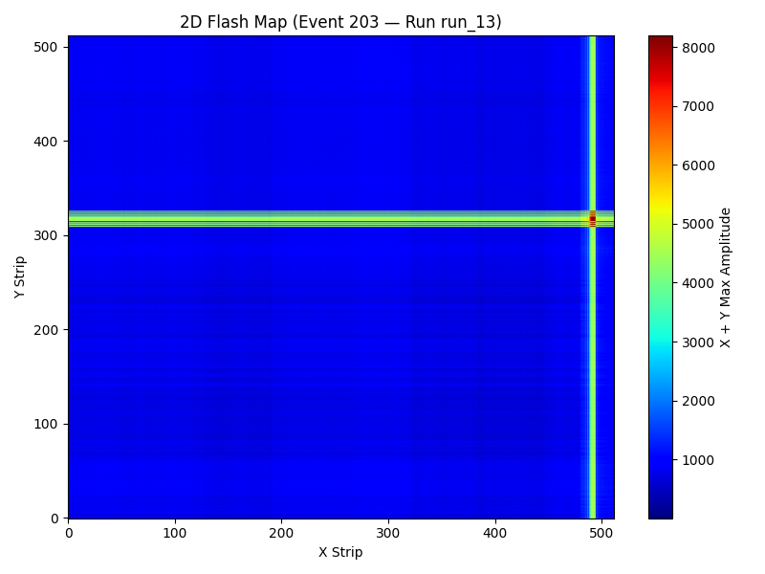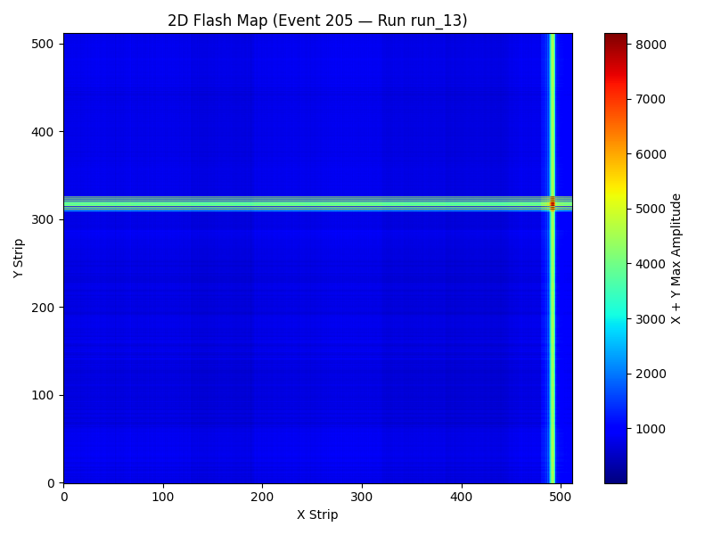

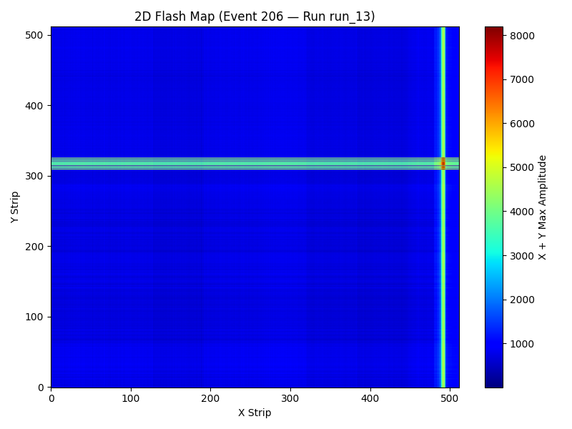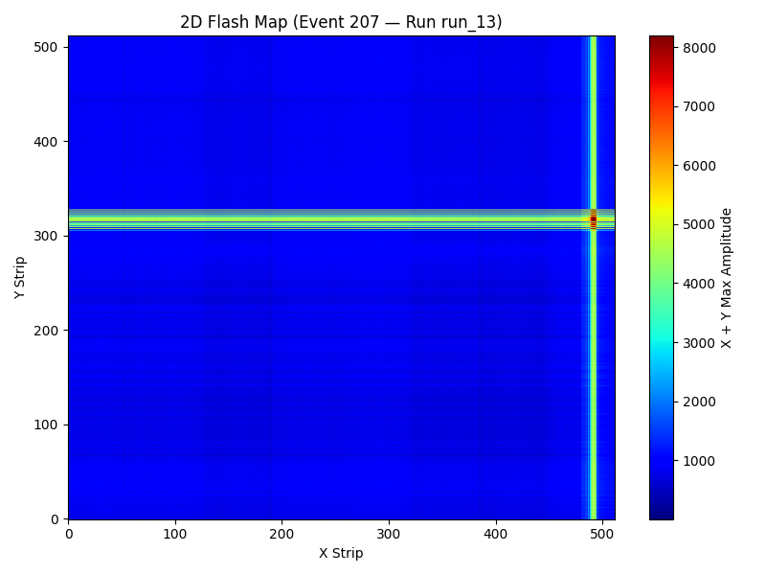
Some huge noise that lights up all channels. Could be gamma flash I guess, but why only once every minute/longer?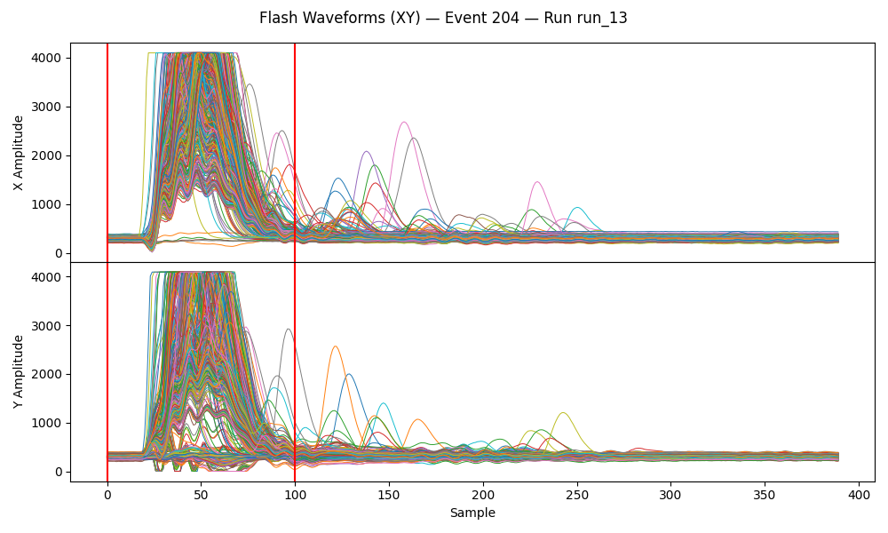
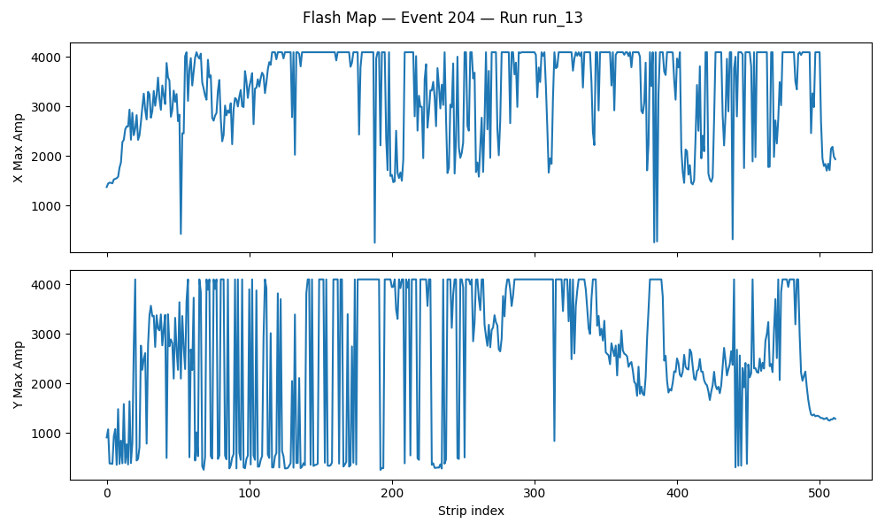
From the cosmic bench, get a rough hitmap:
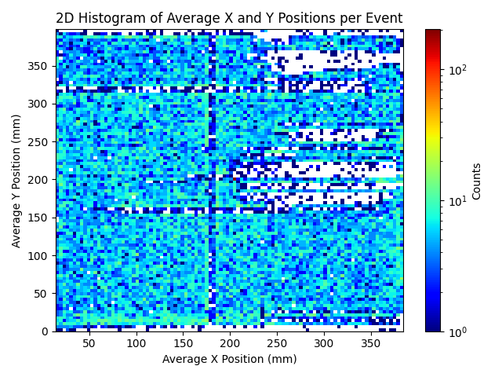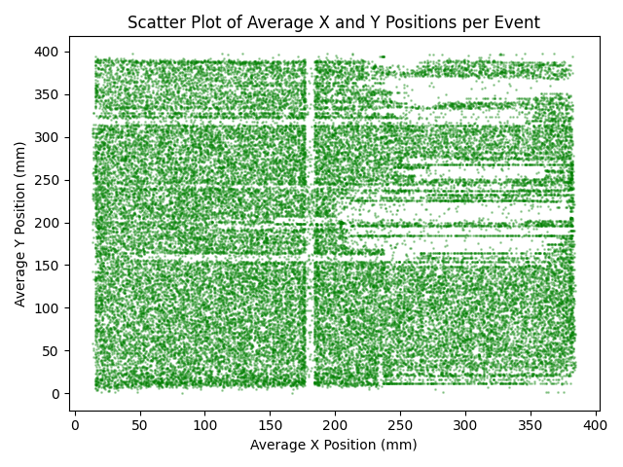
Run 15: HV scan starting from 450V in steps of +5V for 5 minutes each. Looks like full beam. Some drops, though, so rate measurements might not make a lot of sense.
Resist (V) | Rate (Hz)
450 | 0.18
455 | 0.7
460 | 0.45
465 | 0.55
470 | 0.68
475 | 0.78
480 | 0.97
485 | 1.05
490 | 1.43

One possibly good signal at 485V
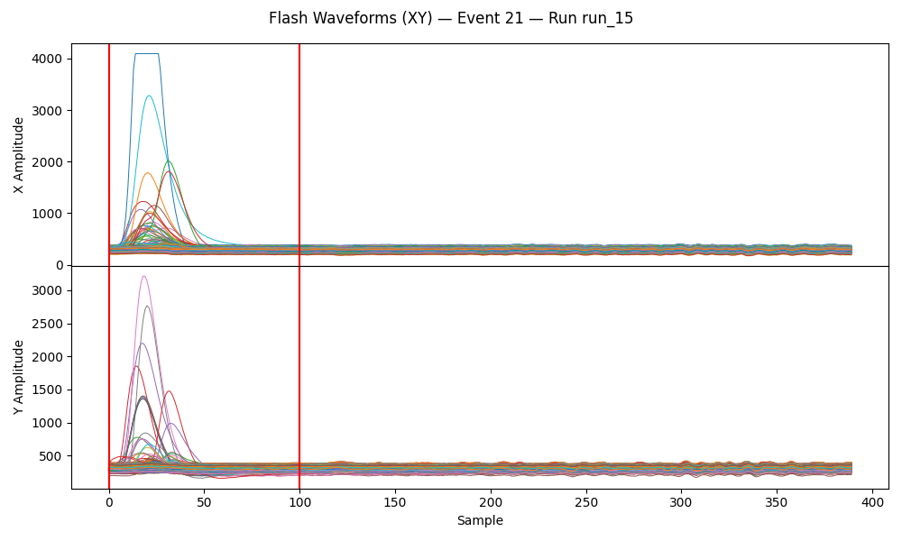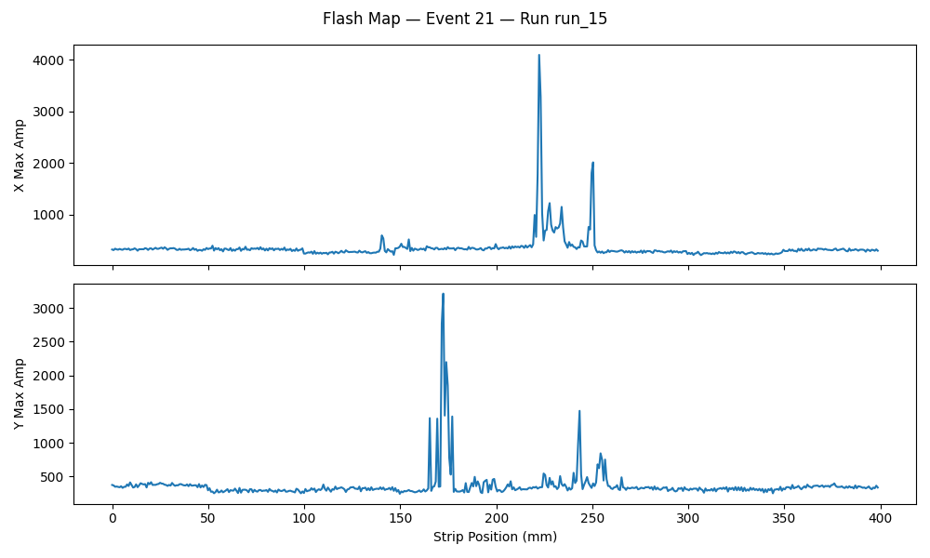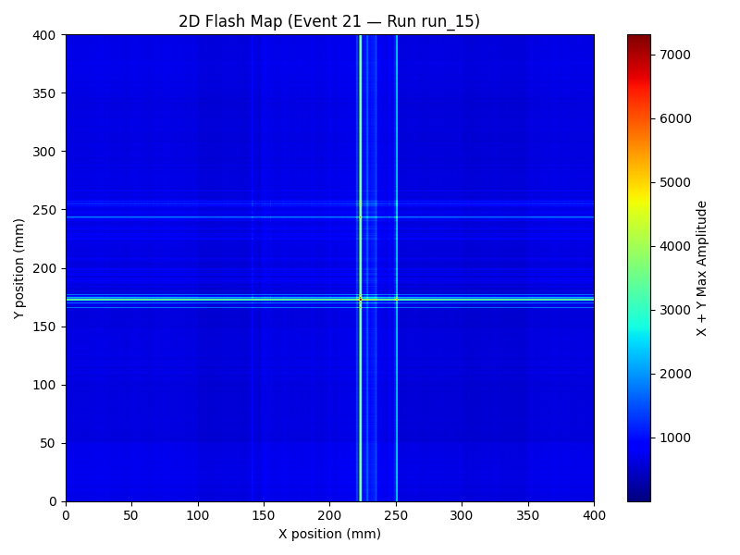
This looks real at 485V:
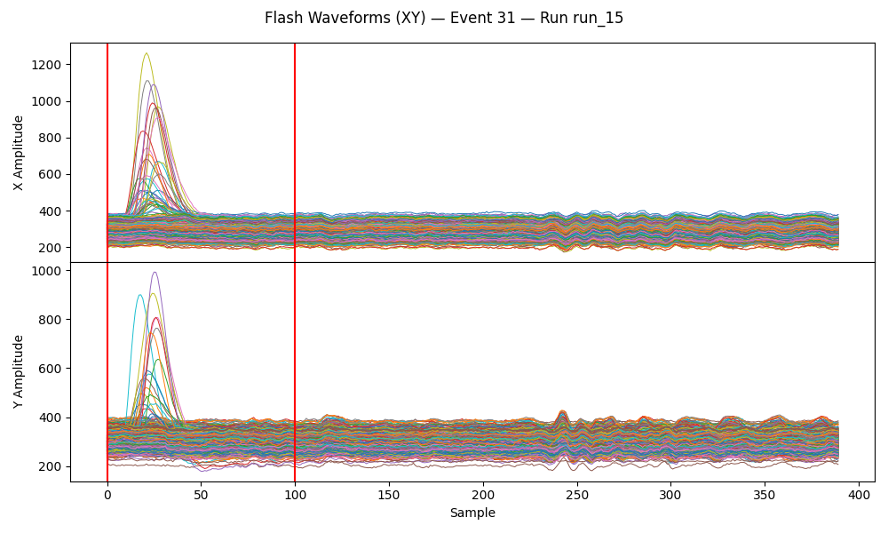
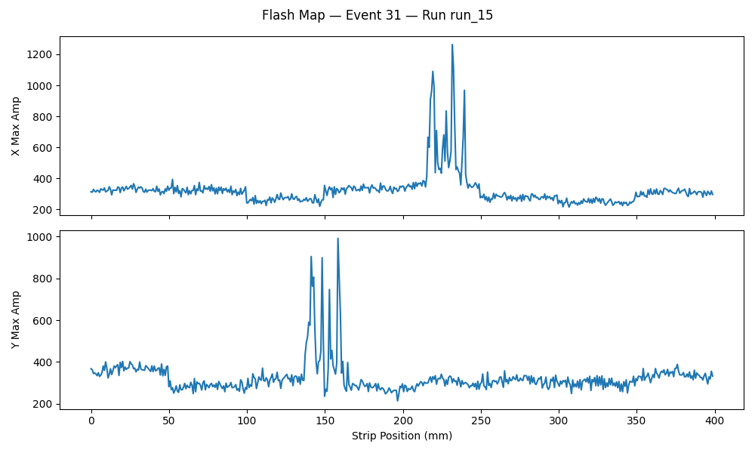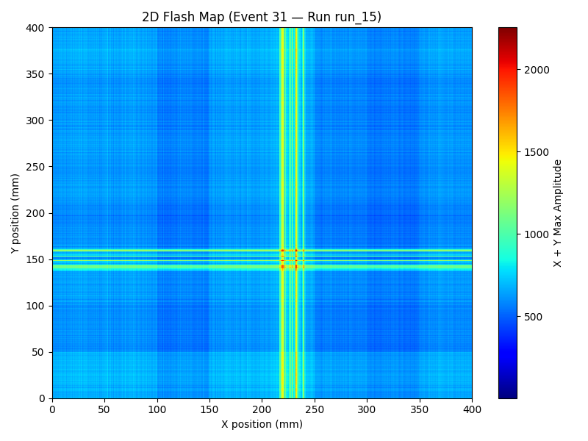
Run 16: Continue HV scan to 530V. Will stop early if things get too crazy.
Resist (V) | Rate (Hz)
490 | 1.13
495 | 1.85
500 | 3.05
505 | 4.85
510 | 7.8
515 | 10.0
520 | 12.75
525
530

Starting to see discharge like things in other places on the detector, at 505V
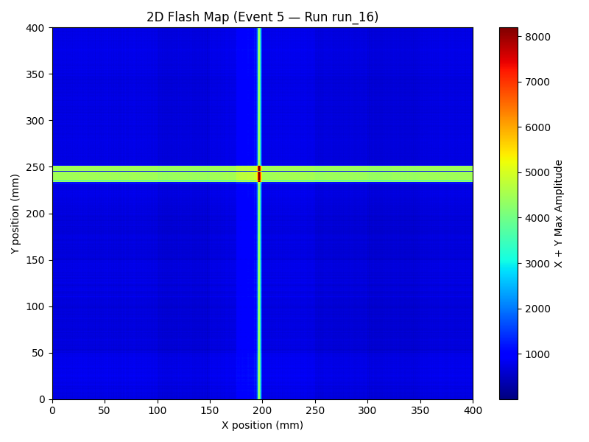
Some decent signals
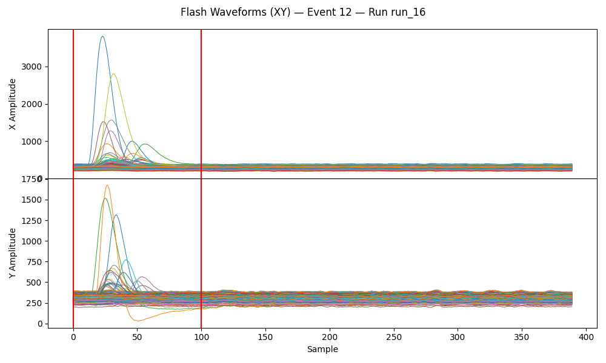
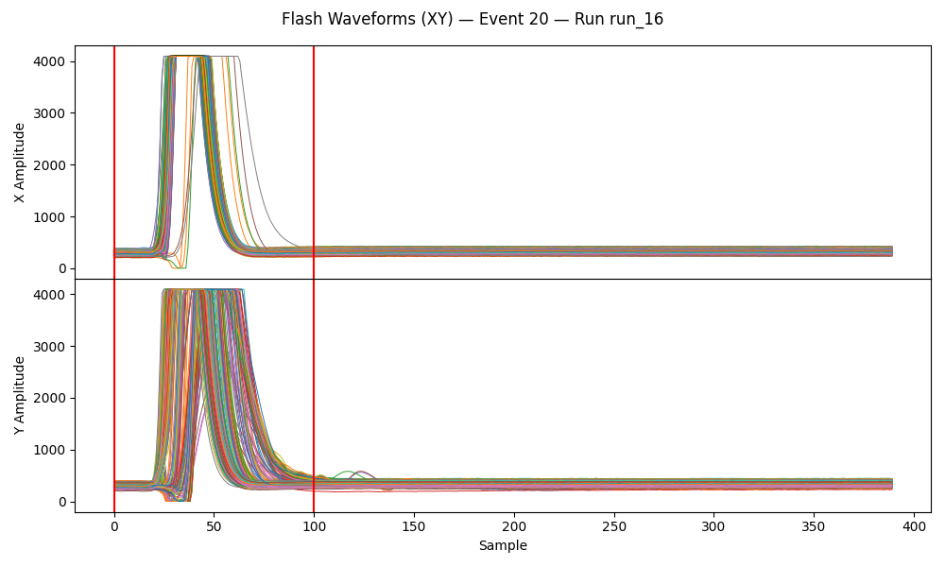
Notes from Irakli chat:
Can disconnect individual channels from self-triggering with the discriminator registers. 0 to participate, 1 to bit reject. Two words 32 32
Maybe go to 600 fC gain.

Entered the area and swapped HV to the CEA crate’s HV unit. Resist on 2.0, drift on 5.0. Put voltage on and it looked ok. No external filter. Had a lot of trouble with the HV box, hopefully no issues.
Saw that the trigger from PS was somehow not counting? Riccardo did some things and seems to be working. Put in delay of 9.6 us. On channel C.

Run 17: Started a Resist HV scan from 440V to 525V in steps of 5V. Set to run for statistics at 490V after but bad HV in config killed this long run before it started. Timepix target

Tuesday February 3
Run from last night (17) seems to have gone well, timed in. Find some interesting behaviour, though. At lowest voltage – 440V – we see the flash with saturation of almost all channels with possible signals after.
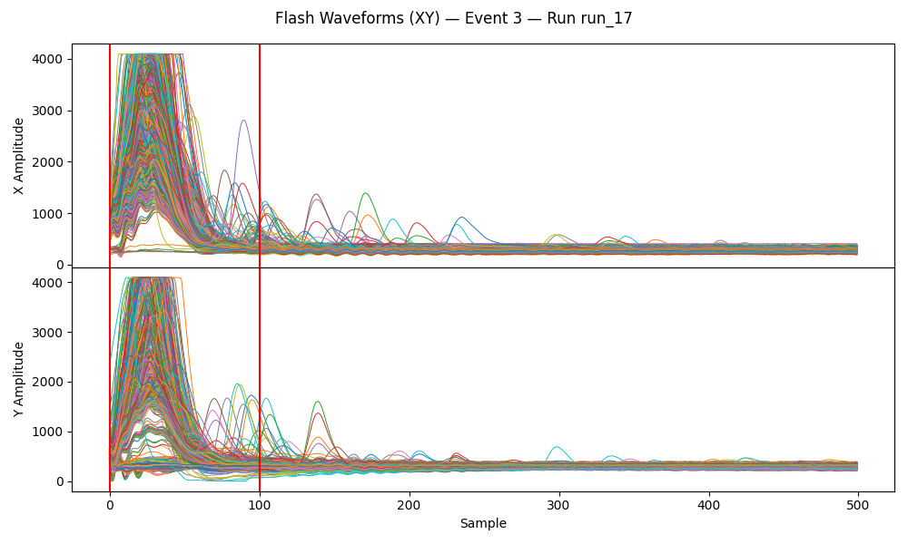
At 490V – where we were at operational voltage for cosmics – we see a very fast saturation. However, at this voltage we really don’t see any signals after recovering. Is the detector dead? Is the DAQ dead? Unclear. It looks like the flash saturation pulse is thinner here at higher voltage. Maybe at 440V we’re seeing a clean pile-up of multiple signals? While at 490V all channels just saturate and then go dead?
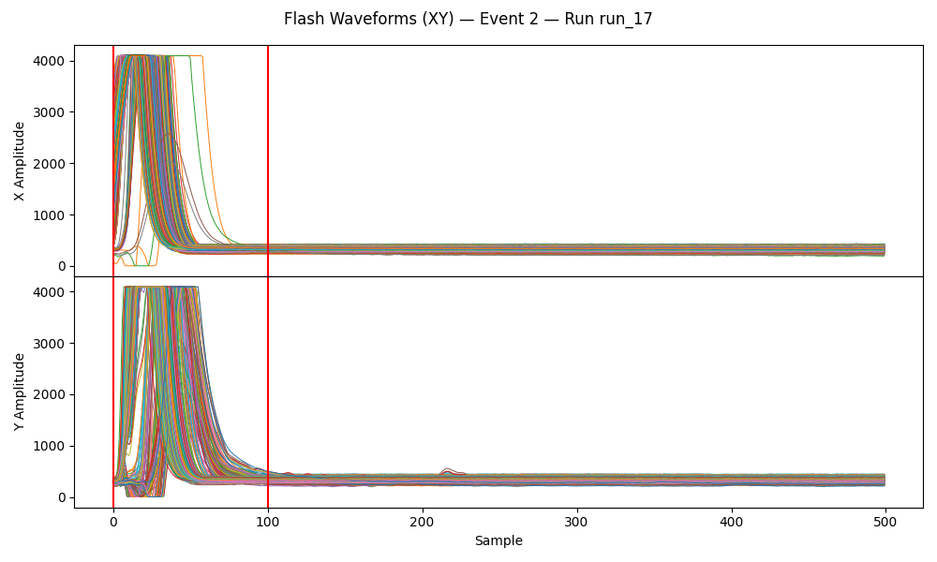
Beam off after lunch, waiting for it to come back before trying to time in then run a HV scan with the Ar:88-CF4:10-Iso:2 gas from very low ~350V to ~500V. At end of the day, switch gas to Helium and run another scan over night.
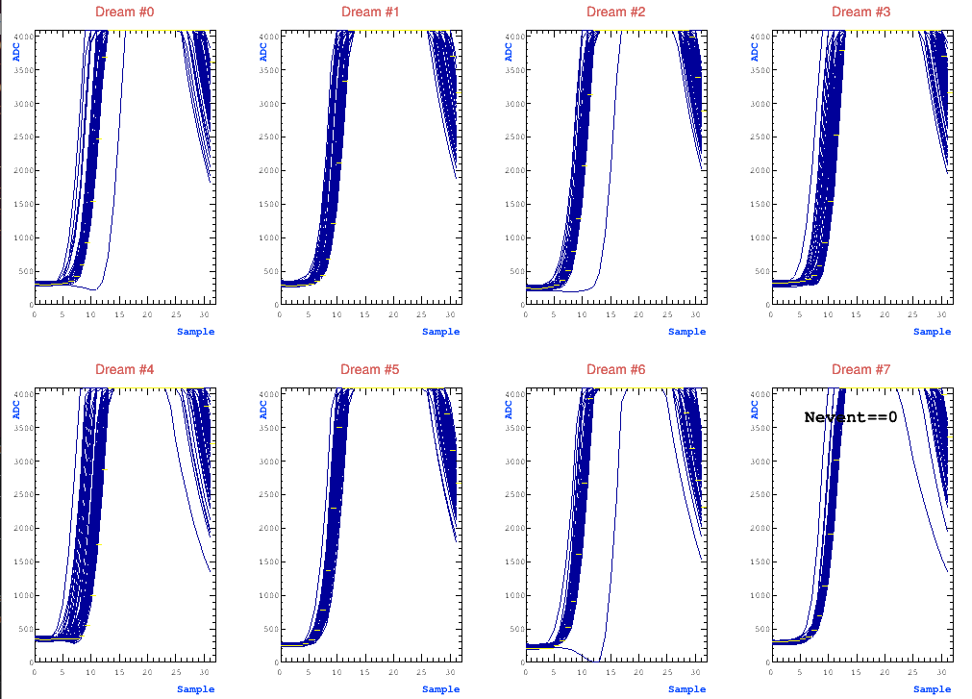
For TCM trigger config going from 0x000C latency to 0x001. Will try to adjust with trigger delay from ntof NIM module. Go from 500 to 510 samples.
Changed PS trigger delay from 9.6us to 9.4us, seems to be good with the latency of 1.

Got beam back and lowered HV on resist to see when the gamma flash would disappear. Surprisingly, we found that even with 0V on the resist we still see noise.

Run 18: Running an HV scan of 1 minute subruns from the resist at 0V to 520V in steps of 10V, drift at -600V. First two runs are different: first is resist 0V drift 0V, second is resist 0V drift 300V. Suspect timepix target! Sounds like it was removed Wednesday.

After run 18 finished around 7PM, we changed the gas from Argon/CF4/Iso 88/10/2 to Helium/Ethane 96.5/3.5. Just swapped the bottles outside so that we didn’t have to make an access. Left for dinner without running and allowed detector to flush. Starting run 19 after dinner around 11:15PM.

Run 19: Run same HV scan as run 18 with new gas. Added a 60 minute run at the beginning with drift at -600V and resist at +450V to allow more time to flush and see if there is any drift over this run later. Also added a similar run at the end until beam stops at 6AM to compare. Set to power off HV after run ends. Suspect timepix target! Sounds like it was removed Wednesday.

Wednesday February 4
Spent the morning in GDD lab. Confirmed that on Detector 2 the resistive strips were just disconnected from the HV contact.
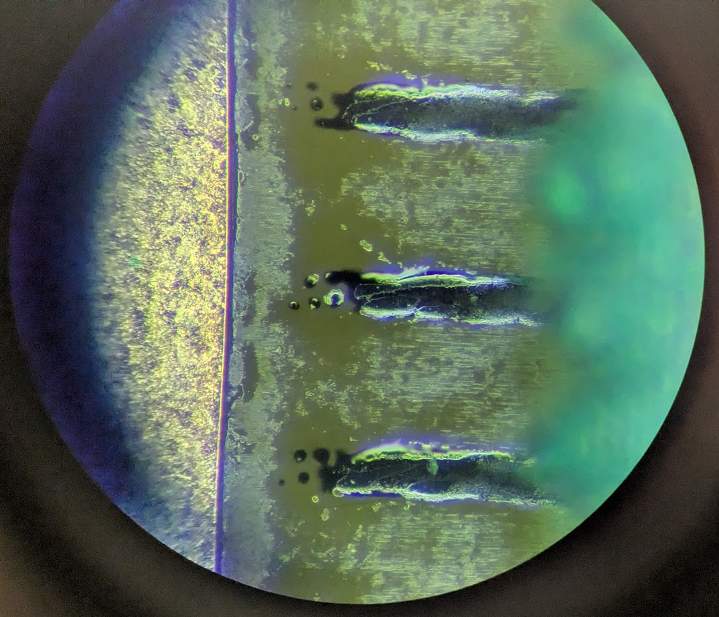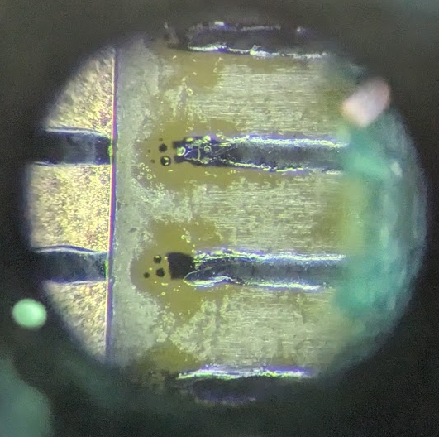
At n_Tof around 11:30, went straight into the noise generator test. Sounds like it’s just a preamp charging/discharging. They used a cut lemo on the oscilloscope as an antenna and saw the noise from the other side of EAR 2.
We tried using the oscilloscope as a trigger for DREAM daq but couldn’t get counts. Piped the oscilloscope trigger out to the fancy NIM module, a Strange, since the

Runs 20-22: Tests with noise generator. Run 20 was self trigger at 0V, think it’s empty saw nothing. Run 21 was external trigger but for some reason the external trigger didn’t trigger DREAM? Maybe too short? Run 22 was self trigger where I slowly ramped up HV while firing the noise. Didn’t see any triggers until operating region where we probably saw cosmics, would be decent idea to check.

Run 23: Quick HV scan with He gas and (allegedly) no target. Turns out plastic cap was left on!

Interesting results from He gas. At Resist 400V and Timepix target (Run 19), we see almost no gamma flash! Confusingly though, with no target we see a worse background after? Are we sure there is no target on the beam? Plastic cap was on!
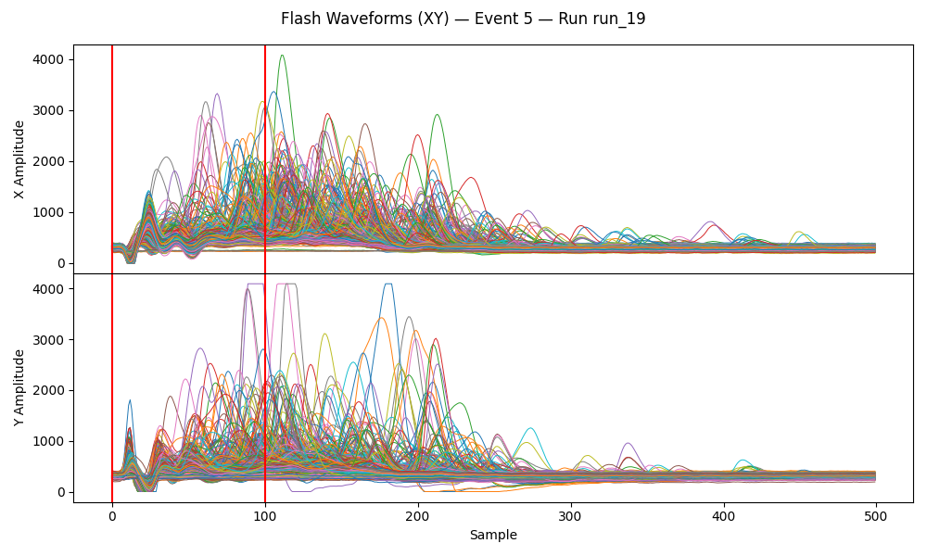
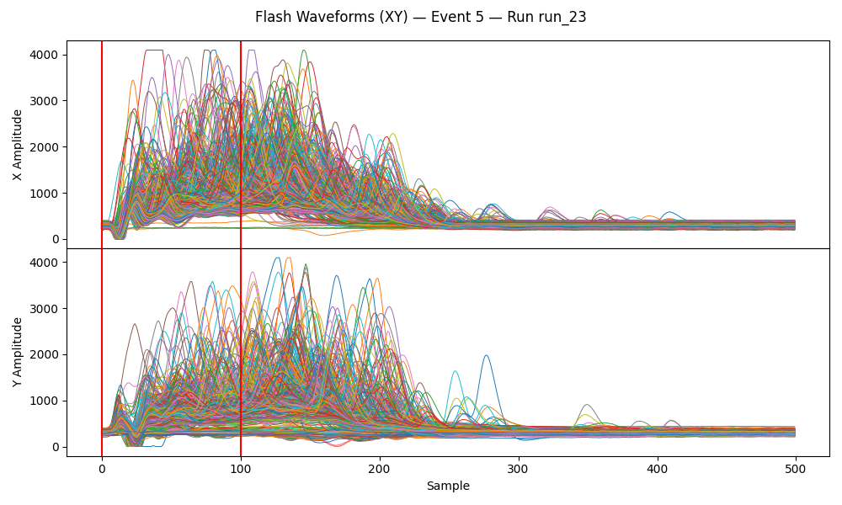
Made an access to remove plastic cap and test without either Drift or Resist HV plugged in. If we see no electronic noise at the flash, tells us it’s the HV cables. If no change, HV probably not the culprit. Also unplugged one DREAM cable from the detector and another from the FEU.

Run 24: Test without HV cables plugged in.

See the same noise, virtually no change. Don’t see much of anything on either of the two slots with unplugged DREAM cables. Tells us that its really noise on the detector itself.

Run 25: Quick HV scan no target He gas.
Looks like much less intense situation after the flash, but still a lot of signal to decouple. Need to see if we can understand and work on this background.
Is Timepix holder still over the beam?

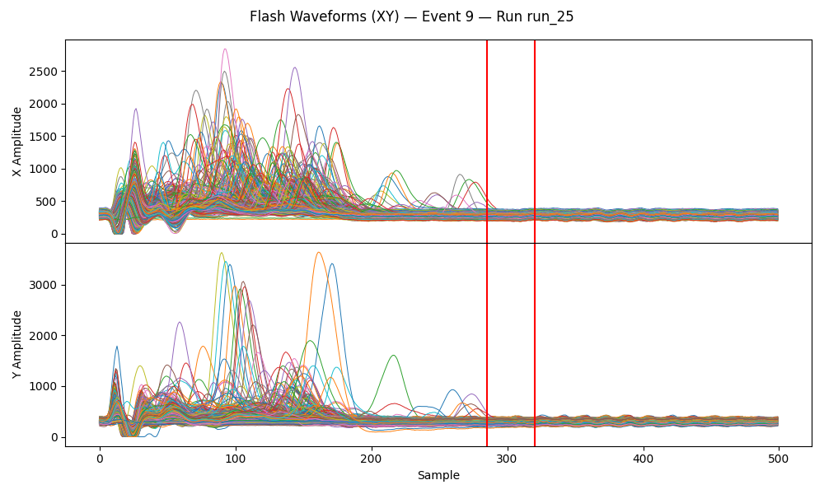

Run 26: Overnight HV scan with He gas and no target. Steps of 5V from 0V to ~520V, 5 minutes each. After, long run at 450V.

Thursday February 5
Plan for day:
- Morning Access
  - Put in lead target ✅
  - Noise generator testing ❌
- Go to electronics pool ❌
  - Rent delay module ❌
  - Look for CAEN HV for ❌
- Evening Access
  - Put in B4C target

Access around 11:30 AM. Mounted the lead target. Simone wasn’t around so didn’t test noise.
Will run HV scan with lead in same configuration. Before leaving for the day, make an access to swap lead for B4C.

Run 27: Lead target with He gas. 30 minutes at 450V for some statistics. Then HV scan from 0V to 520V in steps of 20V till 300V, then 10V the rest of the way. Stats run after until evening access.

Found that plotting the number of strip hits (x and y counted separately) per event as a function of HV gives a pretty good efficiency curve to deal with the apparent dead time induced at high voltage. Run 19 (left) is with Timepix, Run 26 (right) is with no target.
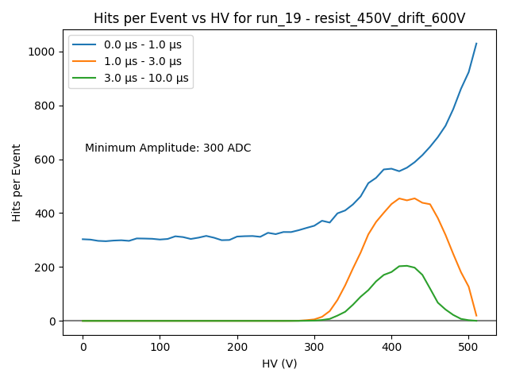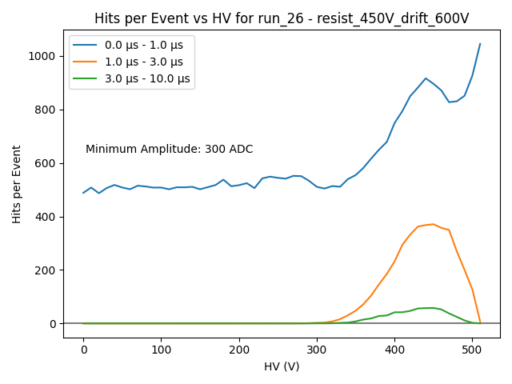
Run 28: Lead target with He gas. Changed from 600fC to 200fC for 5 minutes at 420V. Also had the usual drift scan in the config file, so ran that until we call for access.

Access to swap the lead for B4C.

Run 29: B4C target with He gas. Back at 600fC. Quick HV scan

Run 30: B4C target with He gas. Overnight HV scan.

Friday February 6
Plan for day:
- Morning Access
  - Remove B4C target and stack polyethylene under detector to see if we reduce background. Hopefully will produce gammas that we will be blind to.
  - Try the noise generator
    - Need to figure out why dream isn’t triggering on oscilloscope trigger scheme.
- Go to Electronics Pool
- Evening Access
  - Mount carbon target
- Fix stop run button
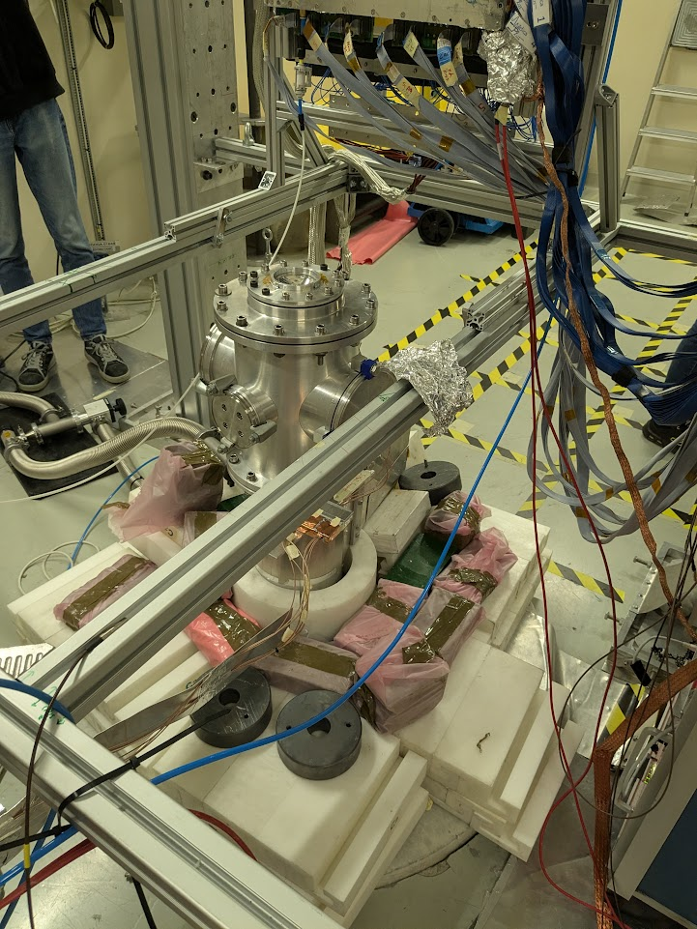
Made access to stack polyethylene and lead with the help of Pablo. Removed the B4C target, leaving the target structure. Want to see if this at all reduces the no-target background we saw previously with Helium gas.

Run 31: Quick HV scan. He gas with no target after stacking polyethylene and lead around beam pipe.

Some DAQ testing between runs. Try to fix stop run and make sure pedestal.txt is written correctly.

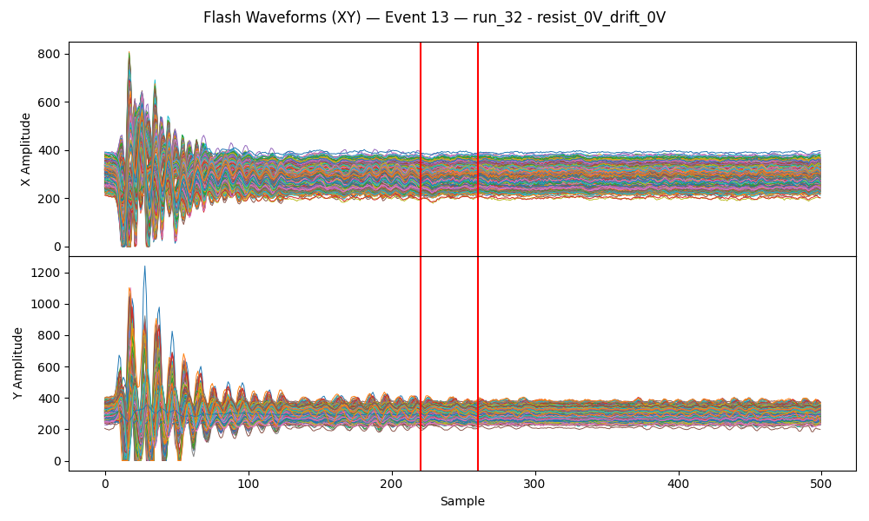
Run 32: Long HV scan in 5 minute subruns. He gas with no target after stacking polyethylene and lead around beam pipe.

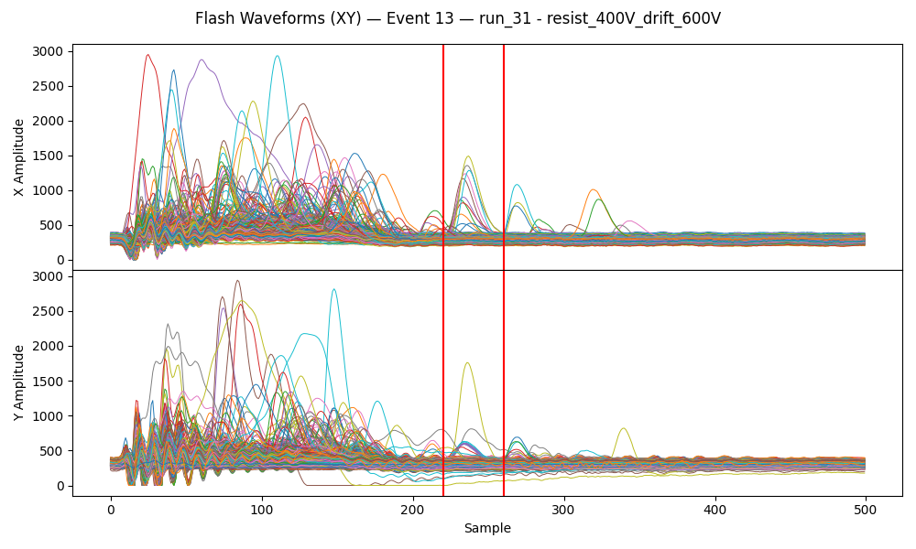
It seems that new noise was somehow introduced after stacking the polyethylene and lead this morning. It’s possible that cables were displaced – especially the poor grounding scheme for the HV cables. If this is not the case, unclear why the stack of polyethylene and lead causes increased noise. Possible that it could be due to inducing gammas which hit the detector?

It also doesn't appear that the number of signals during the 1MeV neutron peak has significantly reduced with the shielding, if at all. Possibly implies that the no-target background is not neutrons coming from below the detector.

Below plotting the hit rate per event for the various runs over the past few days as a function of HV. Split into different time regions (0-1 us during the gamma flash, 1-3us around the 1MeV neutron peak, 3-10us after the peak).

Significant observations:
- B4C sees almost double the hits per event after the 1MeV neutron peak (3-10us) compared to no target.
- B4C sees slightly more hits even in the 1MeV than no target.
- The B4C peak is shifted lower in voltage. This could be due to more signal saturating the detector sooner.
- Lead looks identical to no target in all time windows.
  - Lead produces mostly gammas, not many neutrons? Would suggest that He is really transparent to gammas. Though Riccardo says lead should produce both gammas and neutrons, so why we don’t see more hits is a mystery.
- Adding the polyethylene + lead didn’t seem to reduce the number of hits in any region. Seemingly increased in the gamma flash region (0-1us), though this may be due to the new noise generated. Also increased in the 1MeV neutron peak region (1-3us). Not clear what is happening.
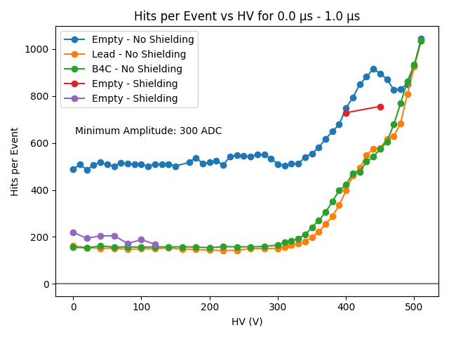
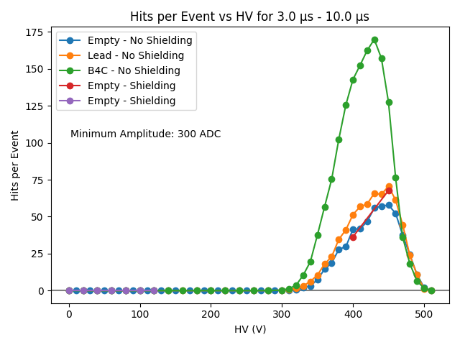
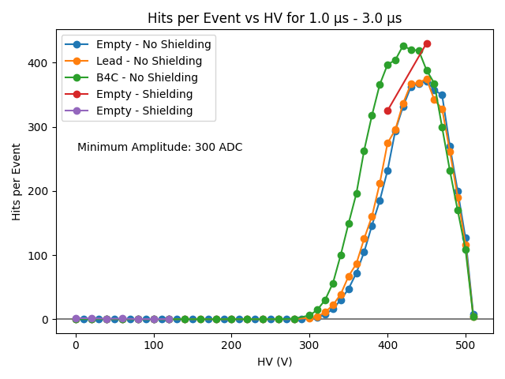

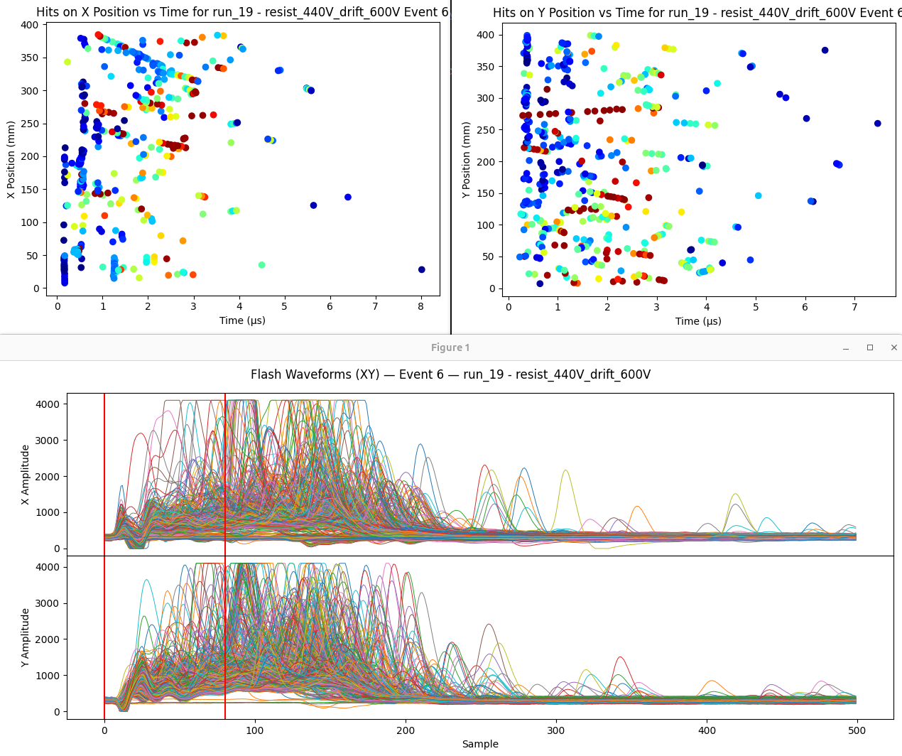
Plotting hit x and y positions vs time, color coding by the max of the hit, can pretty clearly see tracks in this run with Helium and no target.

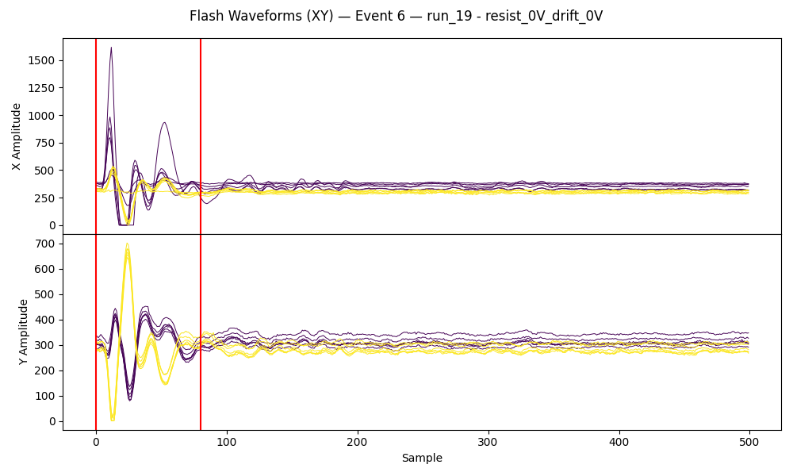
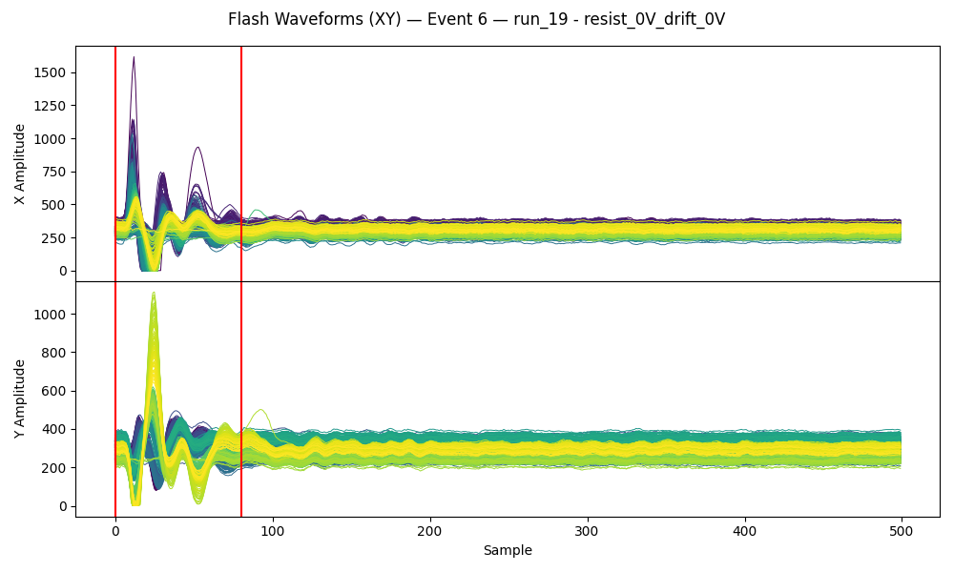
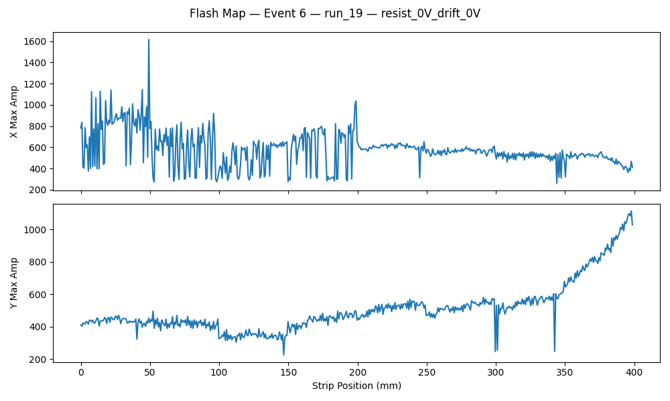
Investigating noise, I find that some channels are out of phase with the others. This means that common noise subtraction won’t work globally. It looks like nearby channels are similar, so maybe the usual connector-by-connector common noise subtraction will be ok?

Before common noise subtraction
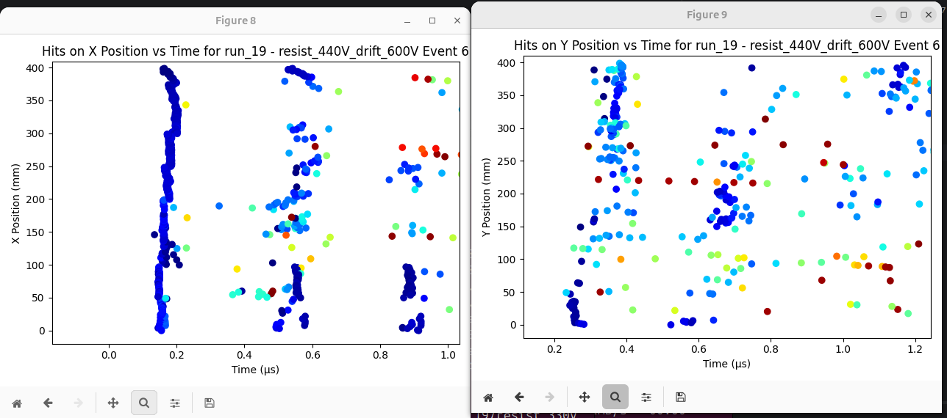
Testing common noise subtraction.
Common noise subtraction in mirco-TPC mode can be very problematic. A track can light up a whole connector, which would get subtracted away or induced.
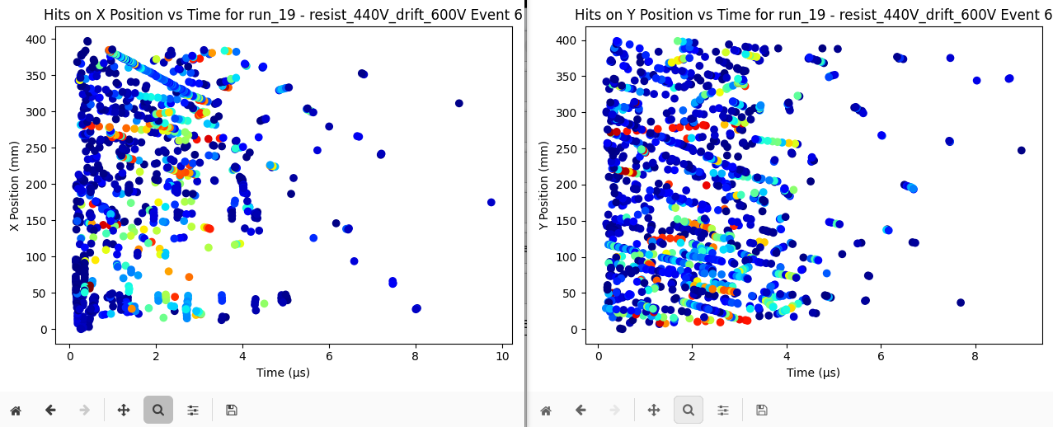

Made an access around 6:30 PM. Improved (hopefully) the HV grounding with thin grounding braid wrapped around each HV cable and then paper clipped, then clipped to the copper braid. Increased the flow rate of Helium gas from ~3 ln/h to ~5 ln/h in anticipation of switching back to Argon tomorrow. Finally, put the carbon target in place.
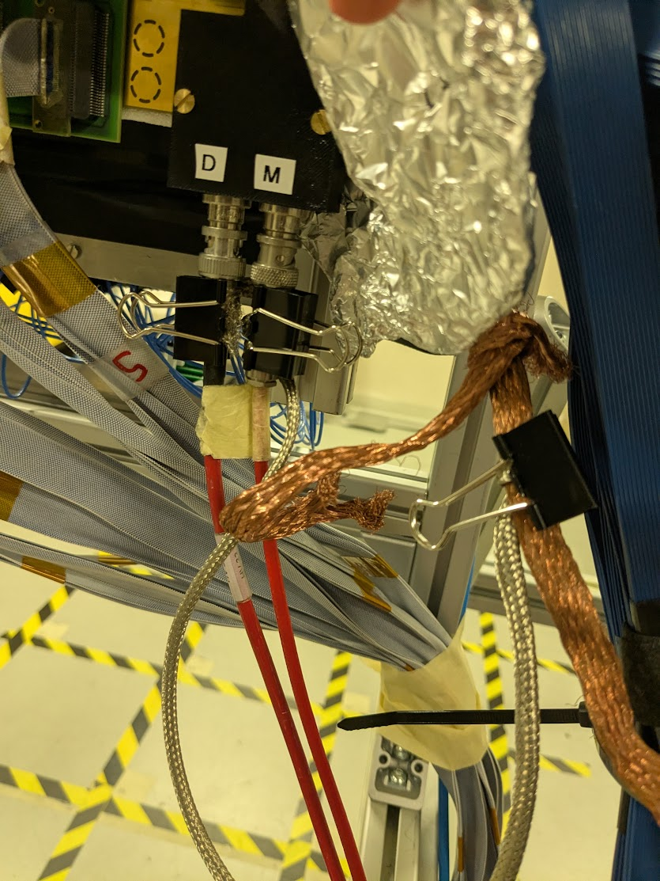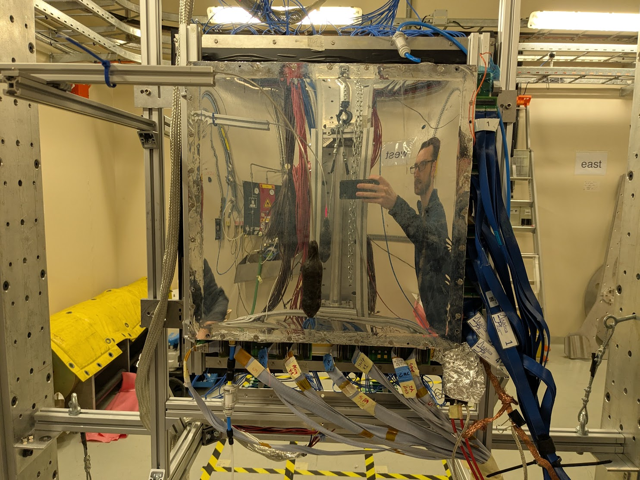

Run 33: Long HV scan with carbon target and Helium gas, 5 minute subruns.

Looks pretty noisy with the carbon target. Will have to see if we can pick out tracks or if we’ll have a real problem once we actually have the He3 in there.

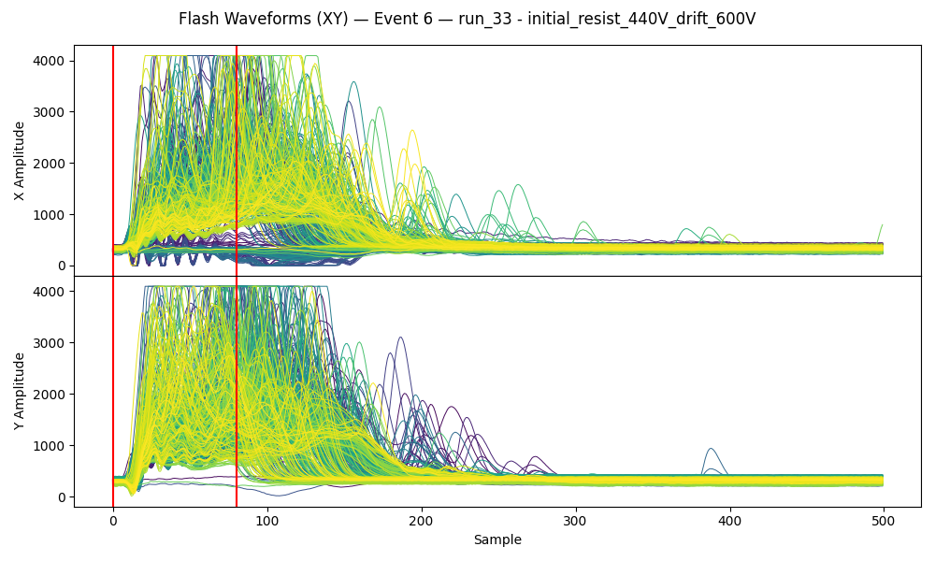
Run 34: Run in self trigger mode with carbon target and Helium gas. Small hv scan: 400V, 425V, 450V, 475V for 2 hours each. Then a long run at 440V. Idea is to look for cosmics to get an idea of gain with MIPs. Also hopefully a test of possibility to just self trigger for actual measurement. No masking so probably a lot of sparking seen.

Idea of the night: Long drift time might actually be a benefit. Neutrons/gammas should produce isolated hits. Our signal should be electron/positron tracks. A mess in the first microsecond or two, but full tracks should survive until the more sparse times when things have died down. To be tested/demonstrated.

Saturday February 7

Ran all morning with good beam. Beam was down at ~3PM when I arrived (maybe for an hour or two before). Changing gas from He back to Argon/CF4/Isobutane 88/10/2 at around 3:20PM.
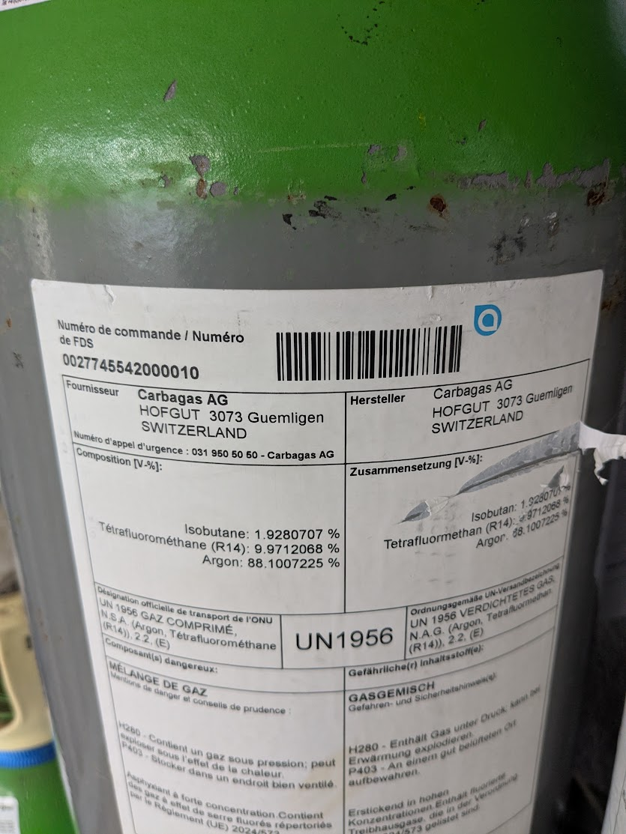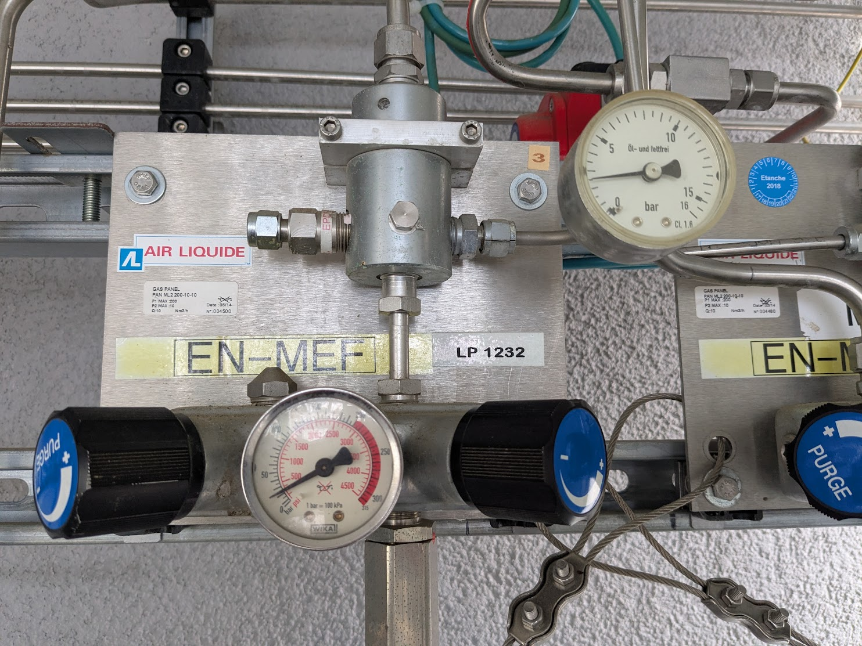
Bubbles right after I changed. No beam so leaving HV off. Will start a run when beam is back in an hour or two.

Got back to control room around 6PM, beam was back. Bubbles on monitor so gas seems good.

Run 35: Run with PS trigger with argon gas now flowing. 1.5 hour run to start at 440V to let the gas flush a bit longer. Then the usual 5 min/subrun HV scan.

At the end of Run 34 the beam went down, so functionally cosmic time. However, not seeing nearly as many as would be expected.
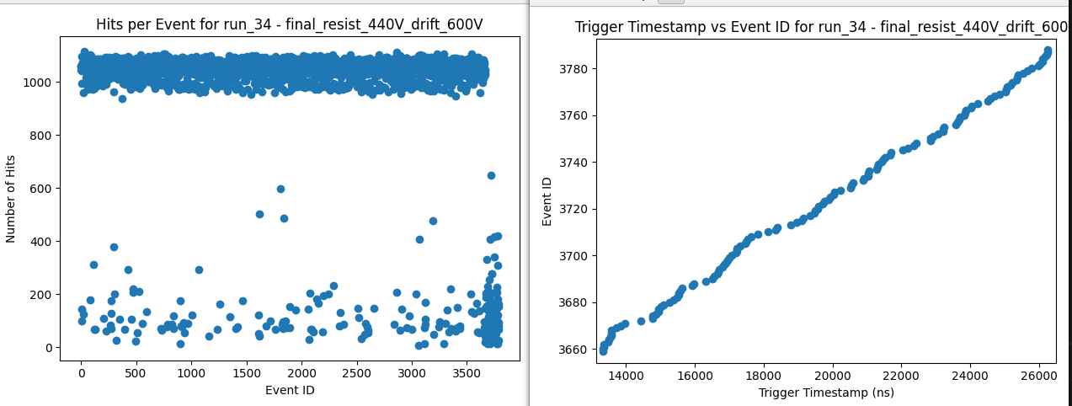
From Saclay cosmic bench, we have 2 60x60cm scintillators roughly 2 meters apart. There we see ~5Hz in cosmic coincidence rate, so say true rate on 60x60cm surface is ~10Hz. For our vertical detector, we would expect roughly 40x3cm of surface area. Taking the ratio, we would still expect between 0.2 and 0.5 Hz of cosmics. In the ~3.5 hours of no beam time, we saw only ~130 events – a rate of 0.01Hz. This is an order of magnitude less than we would expect. We must not be at high enough gain to see MIPs at 440V in Helium.

Run 36: Run with self trigger with argon gas and carbon target. 2 hour voltage scan steps, followed by 24 hour run at 490 V. Hope to see some cosmics between pulses.

Need to meet multiple constraints to make the measurement
- Need gain high enough to see MIPs
  - Electrons/positrons at 8 MeV should be MIPs, behave almost identically to 1 GeV muons (cosmics). If we don’t see cosmics, we won’t see signal.
- Can’t be blind during signal time.
  - Peak of signal should be around 1-2 us, right after the flash. Flash seems to put detector in dead state at higher gain, killing the signal region.

Need to find some optimal between high enough gain to see MIP tracks and low enough gain to not be blind after flash.

Sunday February 8
Still running run 36. Should probably take a look and change for the night.

From the Helium gas carbon target self trigger (run 34) it looks like different types of triggers. Bottom line at zero just common noise mostly. The few above look like isolated tracks, not sure if cosmics or thermals. The top band is gamma flash with full saturation, doesn’t look like any recoverable tracks and detector is dead after. The middle band (~900 hits/event) looks like gamma flash as well but less intense. Riccardo says there should be 3 types of pulse with intensities 850/600/350 e10 protons. Maybe middle band is the 350 e10.

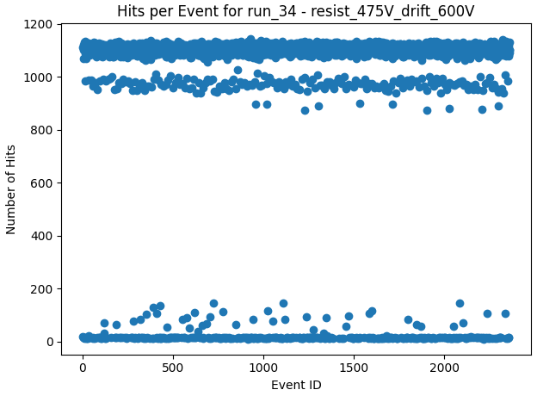

Monday February 9
Plan for the Day:
- Quick runs with various DREAM gains to see if post-flash dead time is affected. If so, a faster death at higher gain would suggest the dead time is due to DAQ rather than detector.
- Noise test with Simone?
- No beam at noon. Run cosmics HV scan.

Run 37: No beam until noon. Run HV scan in 10 minute steps in self trigger mode for cosmics. No masking at this point. Didn’t finish! Made access to put sources.

Access with Pablo to put Cs137 source on detector. This should produce mostly <0.5 MeV betas along with ~0.6 MeV gammas. Hopefully the betas get through to active gas volume and we see tracks. Riccardo came after and we added a Yttrium-88 source as well. Realize now that Y88 is only gamma, no beta (Y90 has beta). Between the 3 gammas from the 2 sources, maybe can calibrate energy?

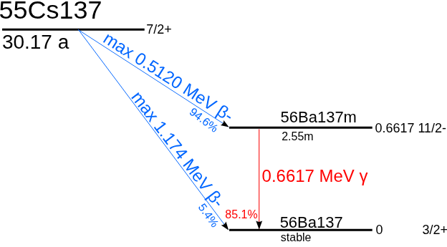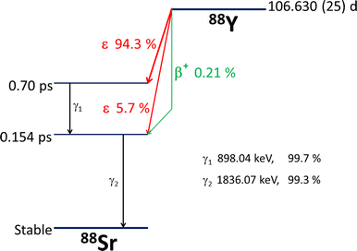

Run 38: Cs137 and Yittrium from top.
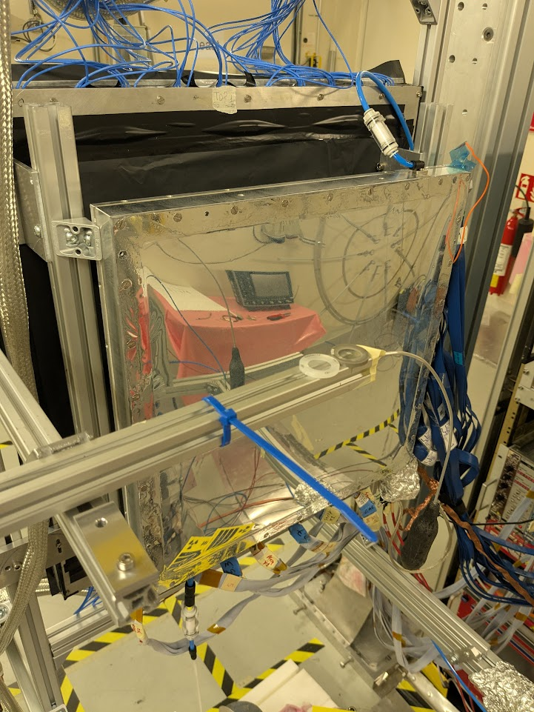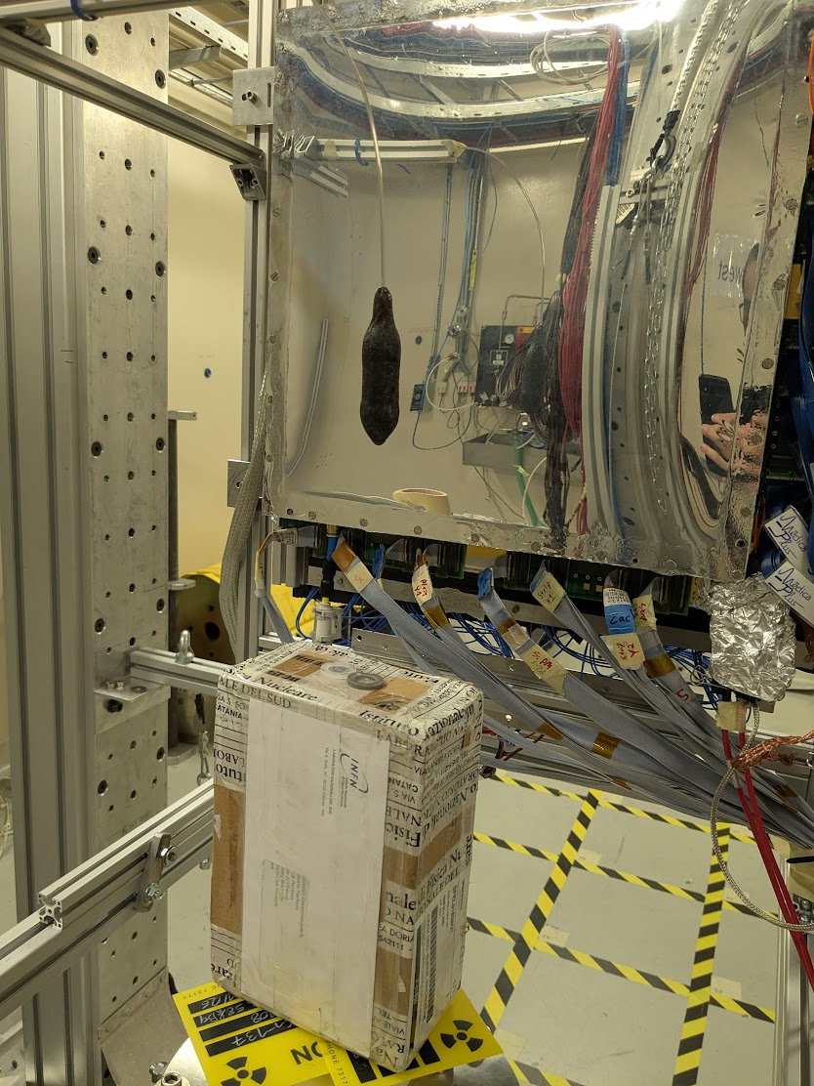

Maybe better from bottom. Worried aluminum bar on top is blocking a significant portion of especially the betas from Cs.

Sr 90 would be a good source of betas. 0.5 MeV max to Y90 which is then 2.5 MeV max.

Run 39: Cs137 and Yttrium from bottom

Ran noise tests with Simone. Resist was at 490V and drift was at 600V.

LEFT TCM TRIGGER UNPLUGGED AFTER NOISE TESTS!

Run 40: Back to cosmics at higher end of HV range.

Run 41: Back to beam with Self trigger, Ar/CF4/Iso 88/10/2 gas, and carbon target. Quick HV scan, mostly to check noise with ferrite on dream cable.

Switched gas from Ar/CF4/Iso 88/10/2 to Ar/CF4/CO2 45/40/15. Turned out to be a bit of work, as apparently the Iso bottle had flammable connector which turns the opposite way. Got it connected and gas flowing around 5:00 PM.
Plugged TCM trigger back in

Running quick tests of masking. Found from the source runs (run_38 left (source in top left of detector), run_39 right (source directly below detector)) where the spark is.

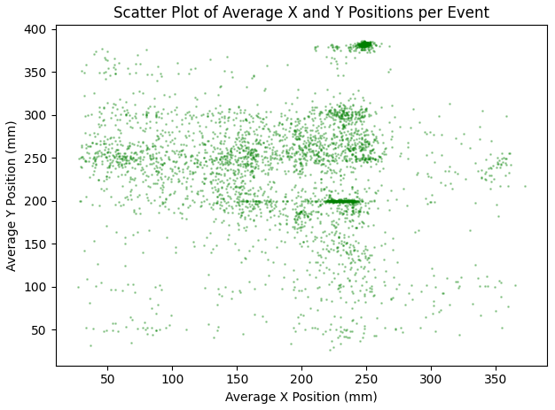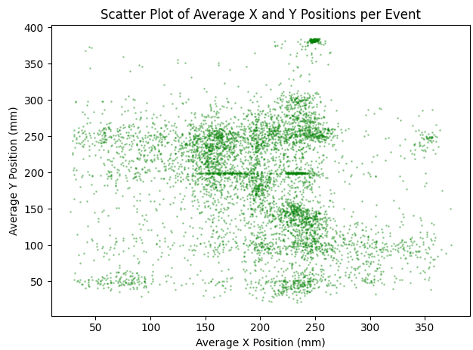
Run test without masking, and then one with masking. Gas still flushing but should be fine. Set Drift to -600V, Resist to +510V. Ok this didn’t see anything. Having to push the resist quite high.

Rate without masking: N/A
Rate with masking: N/A

Run 42: Still flushing new Ar/CF4/CO2 45/40/15 gas. Ran in self trigger, described below.

Didn’t end up doing the test. Started a self-trigger run and pushed the voltage so I could watch current and rate together. Started to just barely get counts around 650V, around 670V seems to have roughly gotten to 0.1 Hz, not much increase after that, around 0.2Hz at 710V when I saw some current fluctuations I didn’t like and went back down to 700V. Hoping these are cosmics. I don’t think the gas is stable yet, so want to be a bit cautious. But may start a cosmic run, still no beam. Beam returned as around 20 minutes in, stopped the run a few minutes later.
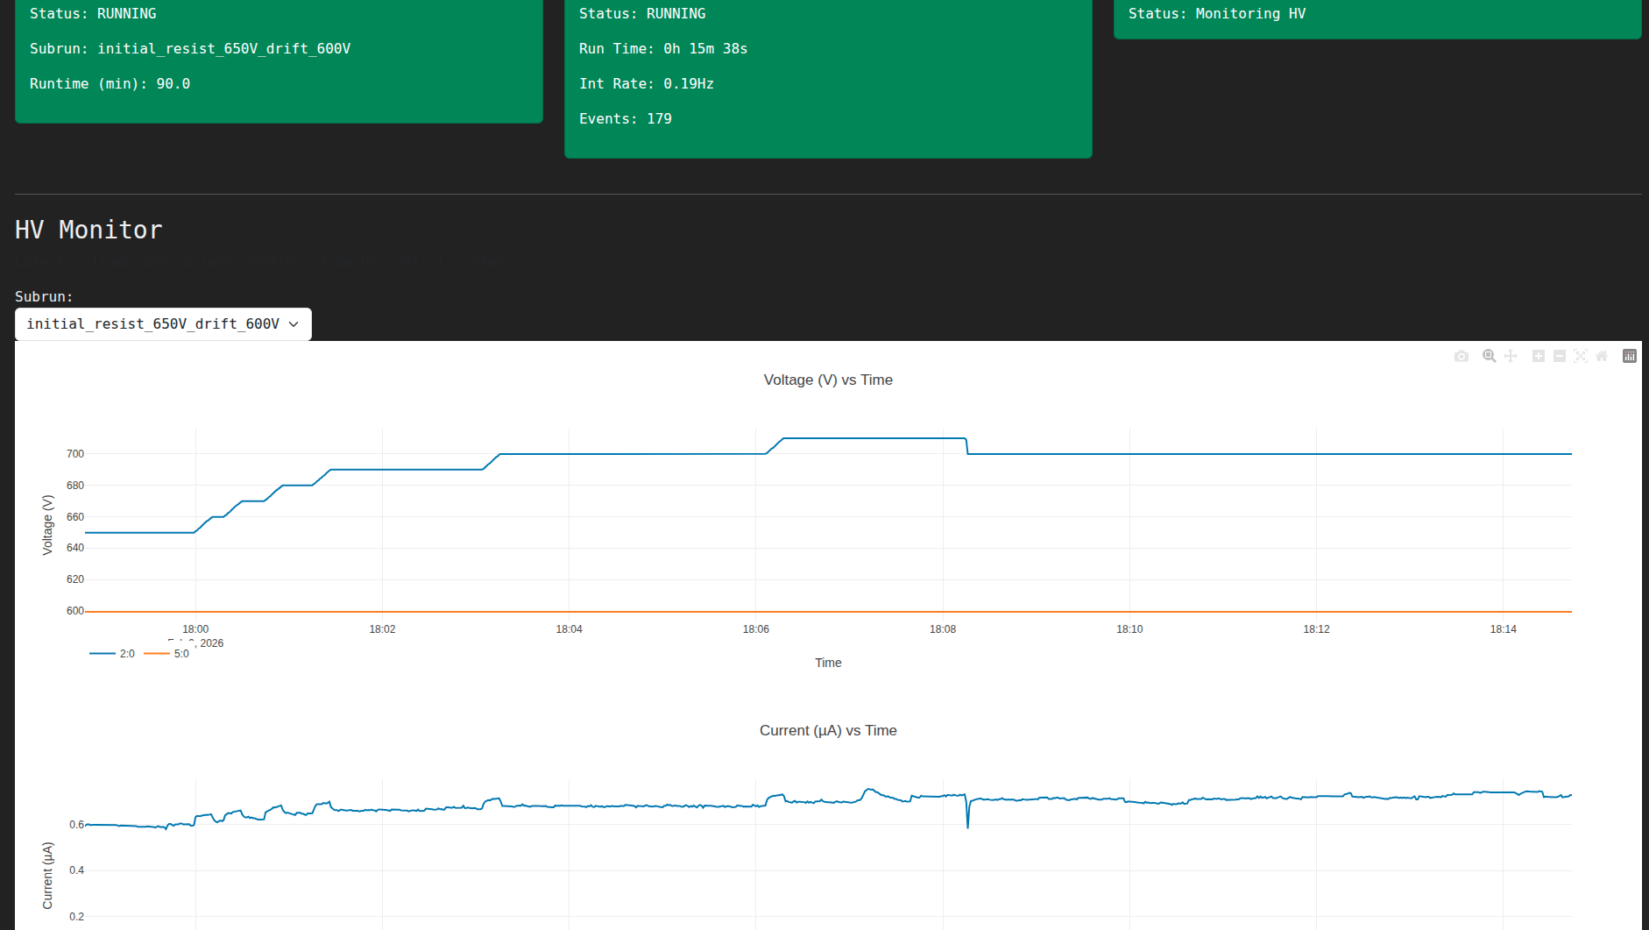
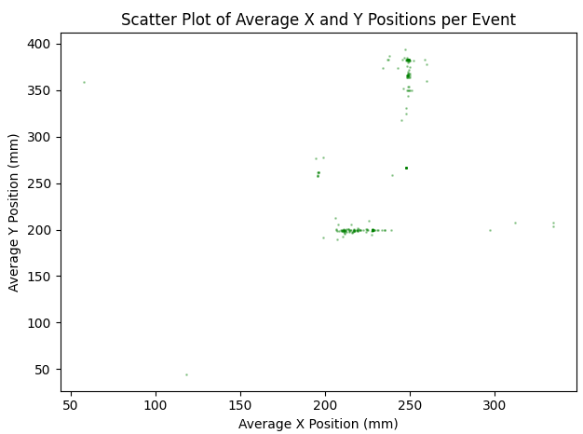
:(
Looks like in self trigger mode just sparking

Run 43: New Ar/CF4/CO2 45/40/15 gas. TCM trigger with carbon target. Set 2 hour at 680V to finish flush

Run 44: New Ar/CF4/CO2 45/40/15 gas. Self trigger with carbon target. Just a single subrun that I used to ramp HV up to 800V and check current/rate as I went. Put in masking without testing, not sure how that will go.

Run 45: New Ar/CF4/CO2 45/40/15 gas. Self trigger with carbon target. Overnight HV scan from 800V down to ~600V. Used untested mask.

Disturbance test on X17 setup (from Simone)
Today (09/02/2026) we tested the setup mounted in EAR2 with the noise generator.
The antenna was placed close to the chamber and the DAQ was triggered with an antenna (open cable) plugget in the oscilloscope. Due to cable length Oscilloscope->Rack->Bunker we were able to acquire mostly the tail of the disturbance.
Sampling rate was 60 ns (to be verified).

Configuration 1 (file test 17)
V(noise generator) = 200 V
On detector Dream0 we observe an oscillation of about 120 ch peak to peak amplitude.

Configuration 2 (file test 18)
V(noise generator) = 400 V
Oscillation on detector Dream0 increased from 120 to 220 channels (about a factor x2), we are confident that the oscillation is induced by the noise generator.

Configuration 3 (file test 19)
V(noise generator) = 400 V
Detector unplugged, end of the cable in a aluminum envelope (to try a bit of shielding), oscillation of few channels is observed, peaked up from the cables.

Configuration 4 (file test 20)
V(noise generator) = 400 V
Cable unplugged from module, we don’t see nothing, the module is not sensitive.

Configuration 5 (file test 21)
V(noise generator) = 400 V
Top cable (grounding inside the detector) was roughtly shielded with aluminum foil, no benefit is observed

Configuration 6 (file test 22)
V(noise generator) = 400 V
One ferrite placed just before the module, with two spired on the cable of Dream0. Oscillation around 100 channel, the ferrite is good, but the reduction is about a factor 2 only (not solving the problem).
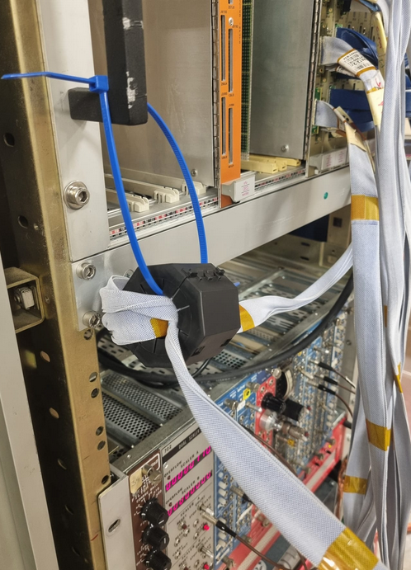

Configuration 7 (similar config 1) (file test 23)
V(noise generator) = 400 V
Ferrite removed, noise back in 150/200 channel amplitude. The ferrite is confirmed to be beneficial.

Test with beam
Ferrite placed back on Dream0 (configuration 6), test with beam.

Tuesday February 10
Looking into cosmics with Ar/CF4/Iso 88/10/2 at 510V (highest on resist). Hit distribution not uniform, similar to what I saw from source test. Sparking areas.
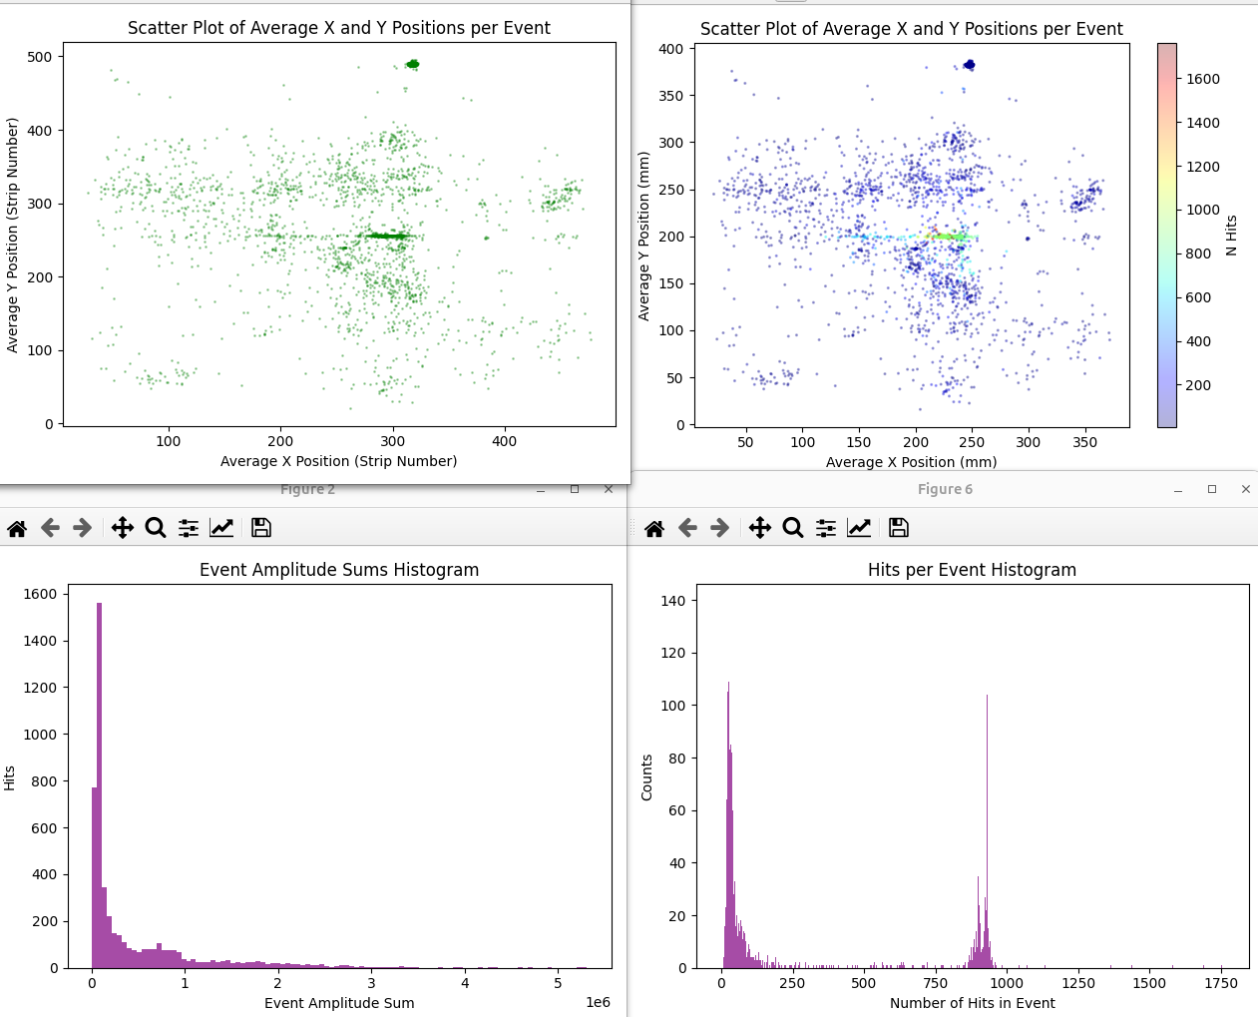
It looks like there’s a spark and the charge spreads in the x-direction (direction of resistive strips). Also looks like the latency is not good for self trigger mode. Maybe try to fix that today.
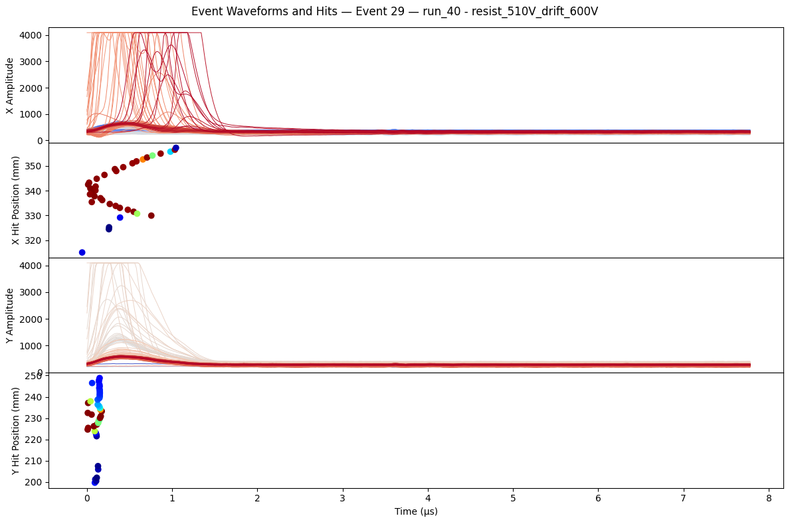
Killed Run 45 around 12:15. Now trying the masking test from yesterday. Set Resist HV to 800V. There is also beam.
Rate without mask: 81 events in 60 seconds → Hz
Rate with mask: 72 events in 60 seconds → Hz

Pushed HV up to 860V, see current fluctuations.
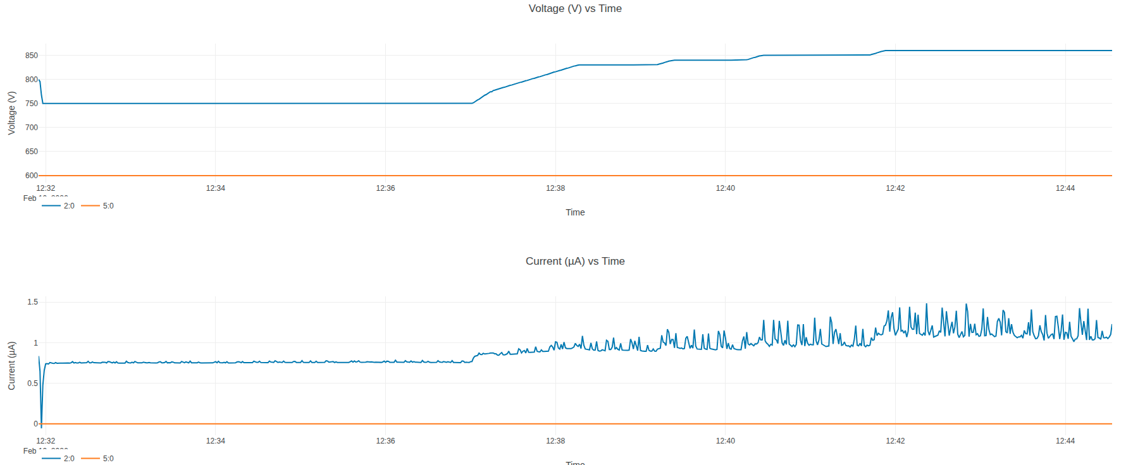
Redo mask test at 860V, still beam:
Rate without mask: 898 events in 61 seconds → Hz
Rate with mask: 871 events in 60 seconds → Hz
Not clear if masking does anything for us here.
Electrons at 8MeV should make it through window and gas volume (He/Ethane 96.5/3.5) but angle is significantly distorted – won’t point directly back to source. Same for positrons.
1 MeV electrons also get through window and end up at some random angle in gas – fine.
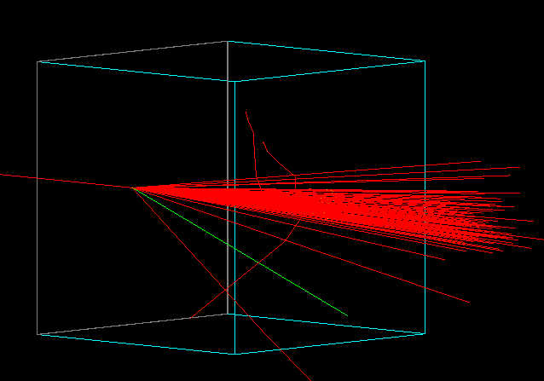
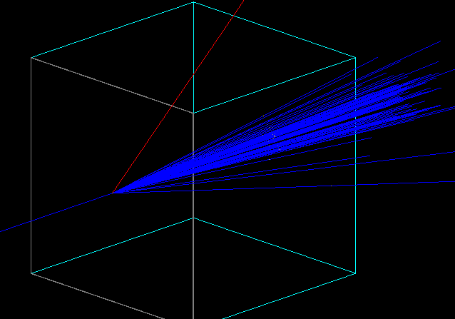

Run 46: Run single subrun while pushing voltage with Ar/CF4/CO2 45/40/15. Got up to 860V, large current fluctuations of hundreds of nano-amps past ~830V, looks like in sync with beam. Beam was on and carbon target still in. Self trigger with mask.

Run 47: Run HV scan from 860V down to 760V in steps of -10V for 5 minutes each. Carbon target in, Ar/CF4/CO2 45/40/15 gas, self trigger with mask.

We switched gas to Ar/CF4 90/10.

Beam off running source tests.

Run 48: New gas, manually pushing HV with bi-207

Run 49: New gas, testing different source rates for subruns @ 680V
Subrun 0: No source 12.5Hz at 2:45 run time
Subrun 1: Bi-207 source 16.5 Hz or so when hanging away from detector
Subrun 2: Riccardo holding source in front of detector. ~19Hz
Subrun 3: Pause
Subrun 4: Cs-137 source Riccardo holding on the detector. ~35 Hz.
Subrun 5: pause
Subrun 6: Cs-137 hanging from the top left of detector. ~23.3 Hz. HV stable at 680V ~0.86 uA
Subrun 7: Still Cs-137 hanging from top left of detector. Upped HV from 680V to 690V ~1.09uA. ~23.7 Hz.
Subrun 8: Still Cs-137 hanging from top left of detector. Upped HV from 680V to 700V ~1.55uA. ~23.9 Hz.

Saw gas changing during this test ~3 hours after the switch at 2 ln/h. Really need to replace the volume a few times. Riccardo increased flow from ~2 ln/h to ~3 ln/h.

I think daq_running check doesn’t get reset somehow? Stop Sub-Run only works once.

Distraction: Beautiful cosmic shower from Saclay data. → Now skeptical that this is real…
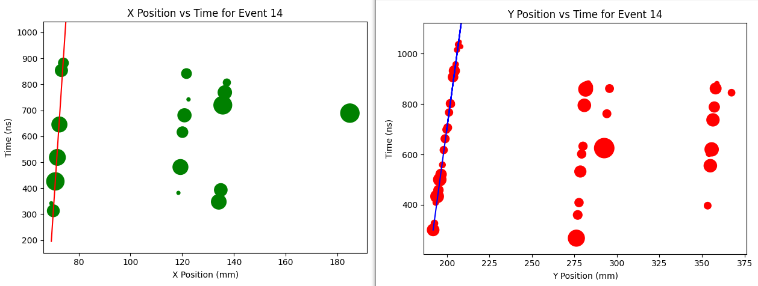
Run 50: After flushing for ~10 hours, starting HV scan with beam, carbon target, and new Ar/CF4 90/10 gas. Using TCM trigger.

Wednesday February 11
We dismounted the MM + Scintillator stand and put horizontally on table for cosmics during maintenance day. Not exactly horizontal, probably at 10 to 20 degree angle.

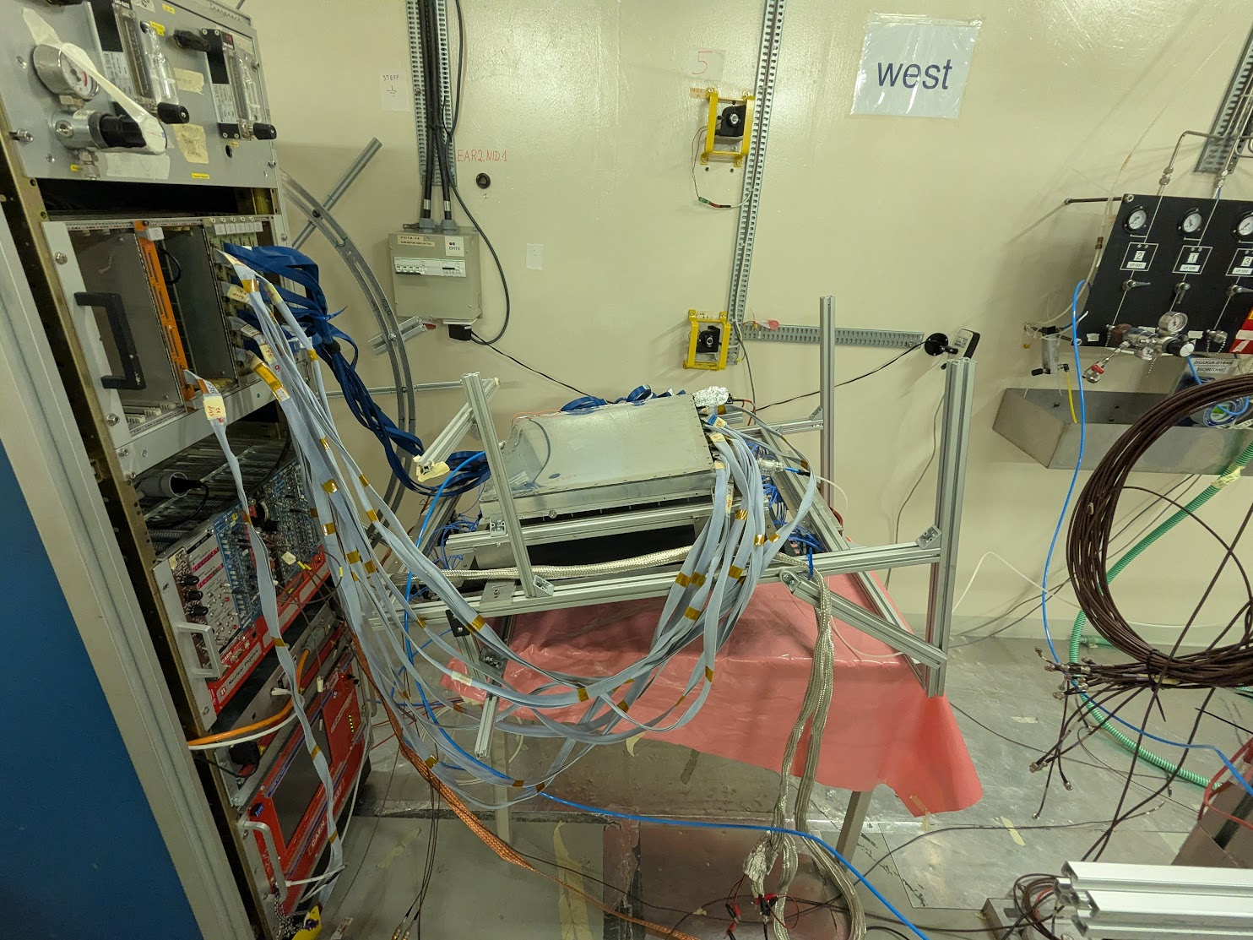

Run 51: Detector horizontal, taking cosmics HV scan with self trigger.

Connected one half of SiPM wall to bias. Connected two adjacent channels there to Marco’s amplifier and from there to MCX to dream board.
Originally had two adjacent channels connected and saw a lot of cross-talk – unshaped on left, shaped on right.
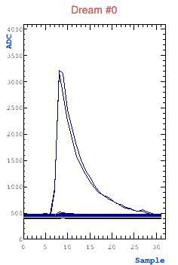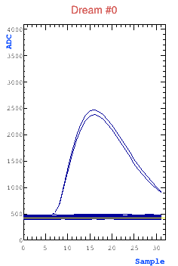
Changed to two more separated channels.

Run 52: Detector horizontal and taking data with trigger from oscilloscope on SiPM amplifier sum of channels. MM Resist at +610 V. Ran for ~5 hours. Beam was off at very beginning, turned on some ~30 minutes into run, I think.

Run 53: MM resist scan with cosmics, 1.5 hours per step. Detector horizontal and taking data with trigger from oscilloscope on SiPM amplifier sum of channels. This didn’t run! Instead, it just ran a single run at 610V, I think a 13 hour repeat of Run 52. Unfortunate. Rerunning a quick version in Run 54. (Note from future 2/24: I’m pretty sure beam was on)

Thursday February 12
Want to think about/investigate SiPM attenuation. I think signals from SiPMs were a few tens of mV unamplified, maybe 100 ns wide (50 ohm impedance, I think). Rough estimate of charge is around ~10-100 pC. DREAM has charge sensitive amplifier, with max dynamic range of 600 fC. Will need to attenuate by a factor of ~20-200 → 2-4 dB.
Want to get an attenuator today from CERN pool. Looks like max attenuation of ~40 dB, adjustable.

Hijacked x-strip plotting and put SiPMs in instead. From file 15 last night, should have had beam at the time. Not seeing the gamma flash. In fact, looks like we see good coincidence with MMs, at least in this event for y strips. Also follow up pulses later, maybe from beam?
Not sure, but the event in bottom right probably flash?
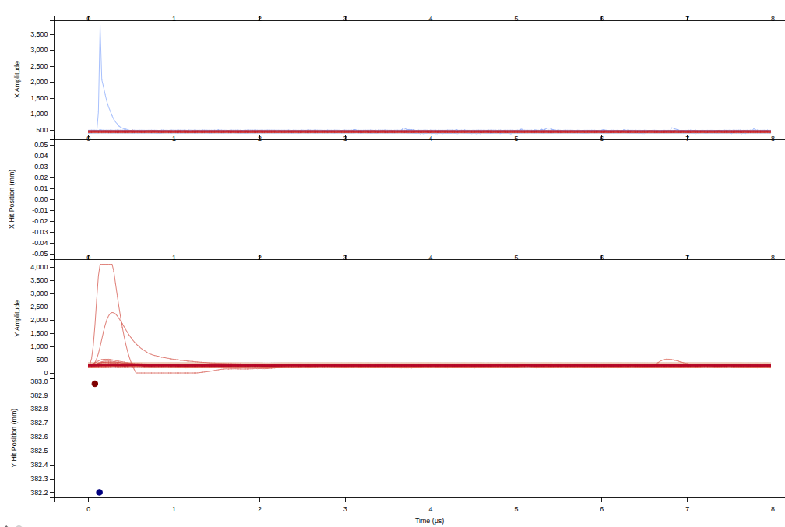
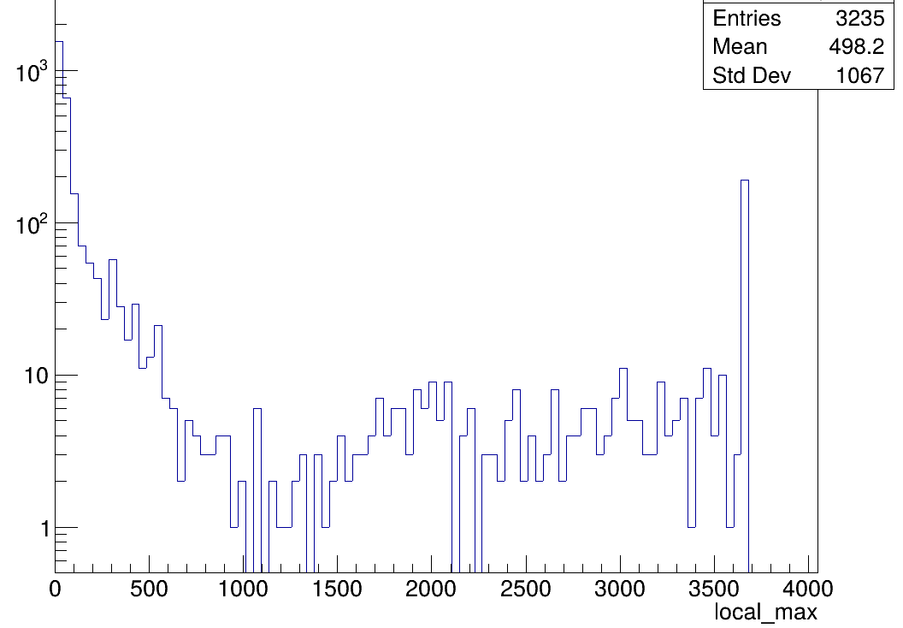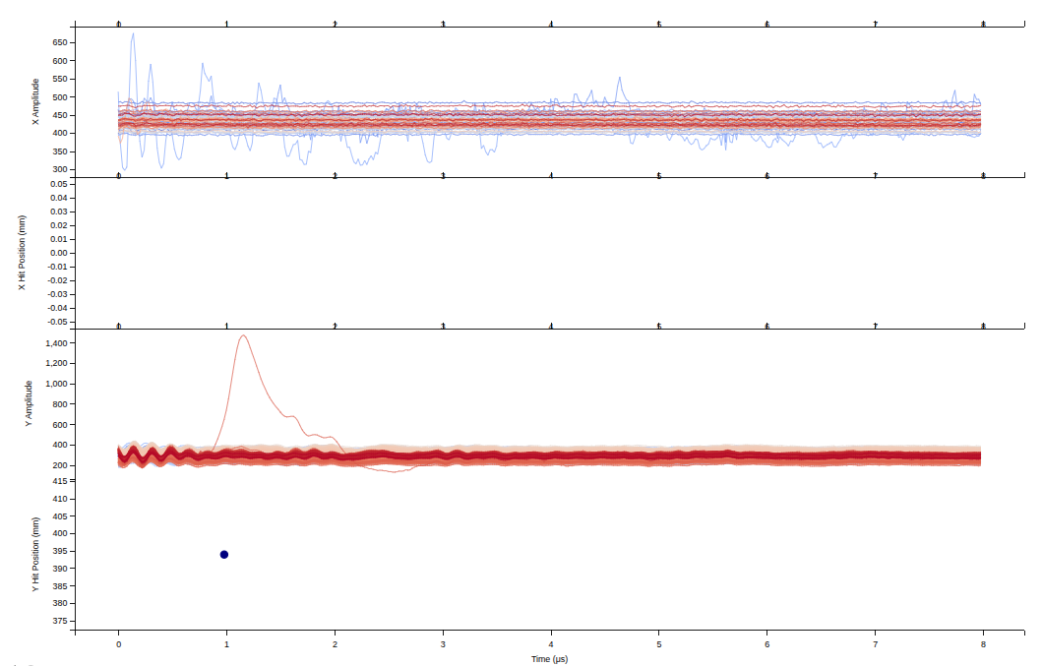
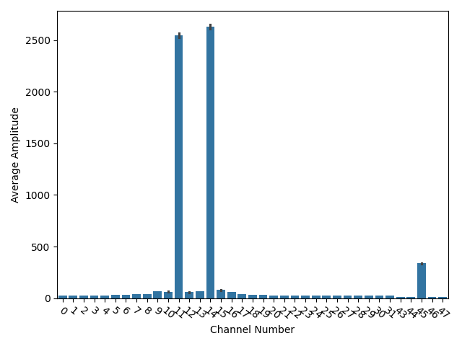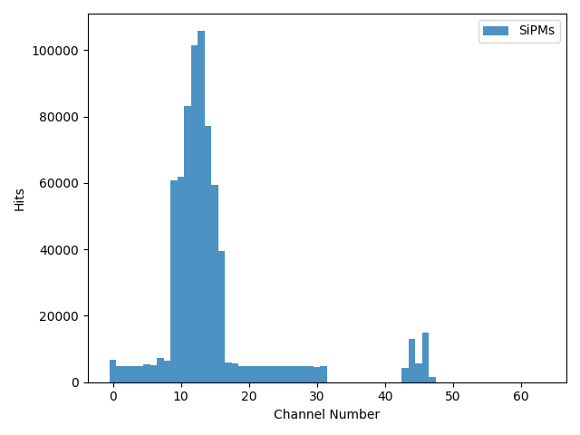
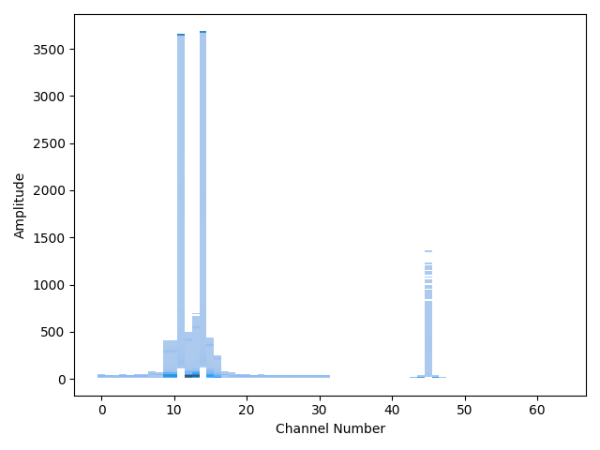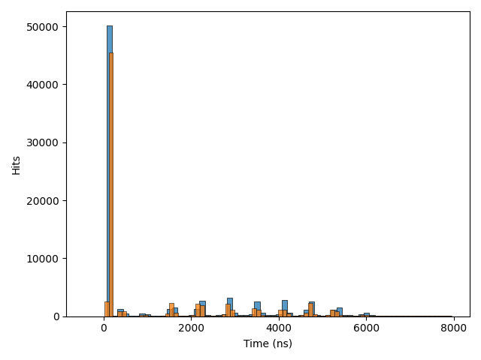

SiPMs channels 11 and 14 plugged into the amplified signals. This means there is some cross talk on the board itself. Channel 45 is plugged into an unamplified bar.
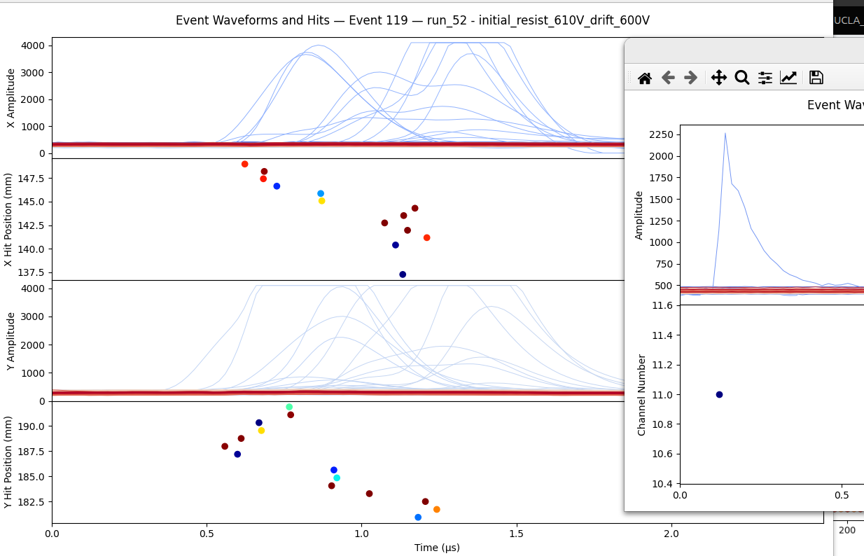
This should be a cosmic event, no beam. SiPM signal on single bar is clear. MM response is confusing.
Can get an idea of MM efficiency by looking at strip amplitudes vs even

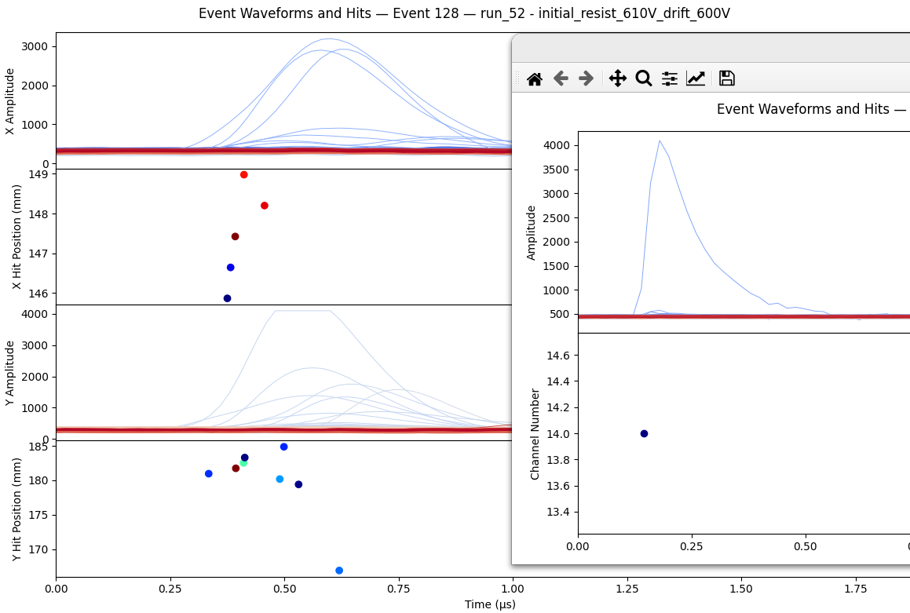
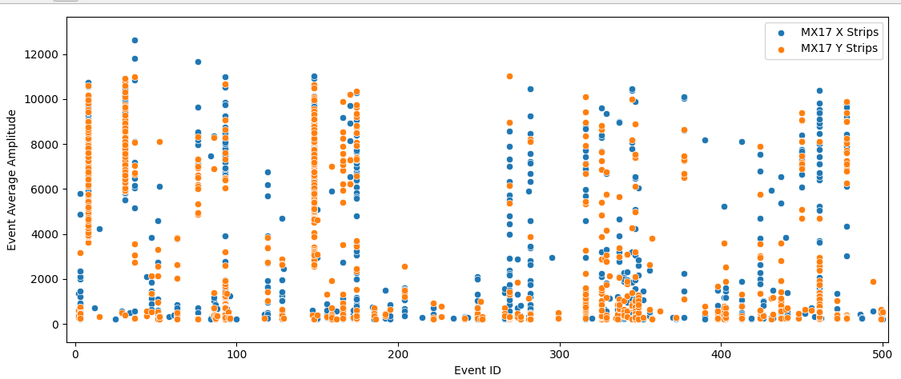
Another event that is not entirely clear. Looks like x might be reasonable, a line starting at ~146mm (on mesh) and ending at ~149mm (at drift). Red point at ~148mm could be delayed signal from spreading of charge on resistive strips.
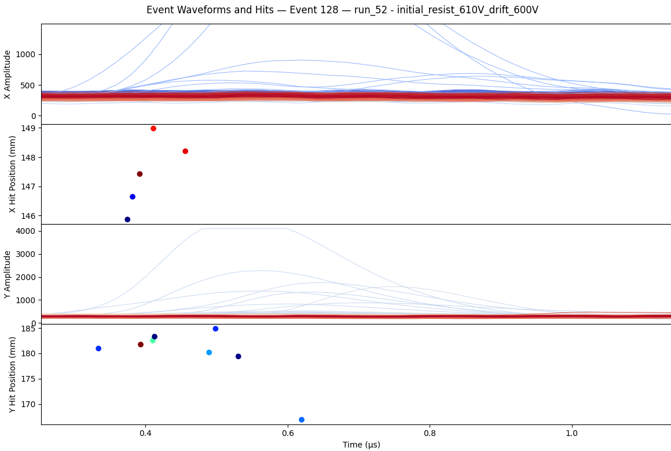
The y distribution is not as clear. Can imagine a line on top, starting from ~180mm and going to 184mm, roughly matches timescale for x. But what are the rest of the hits after 0.45 us? Shouldn’t be resistive spreading in this direction? Possible that the same low amp strips in x are firing again and the algorithm doesn’t pick them up?
Lowering amplitude threshold for hits in plot below, even more confusion.
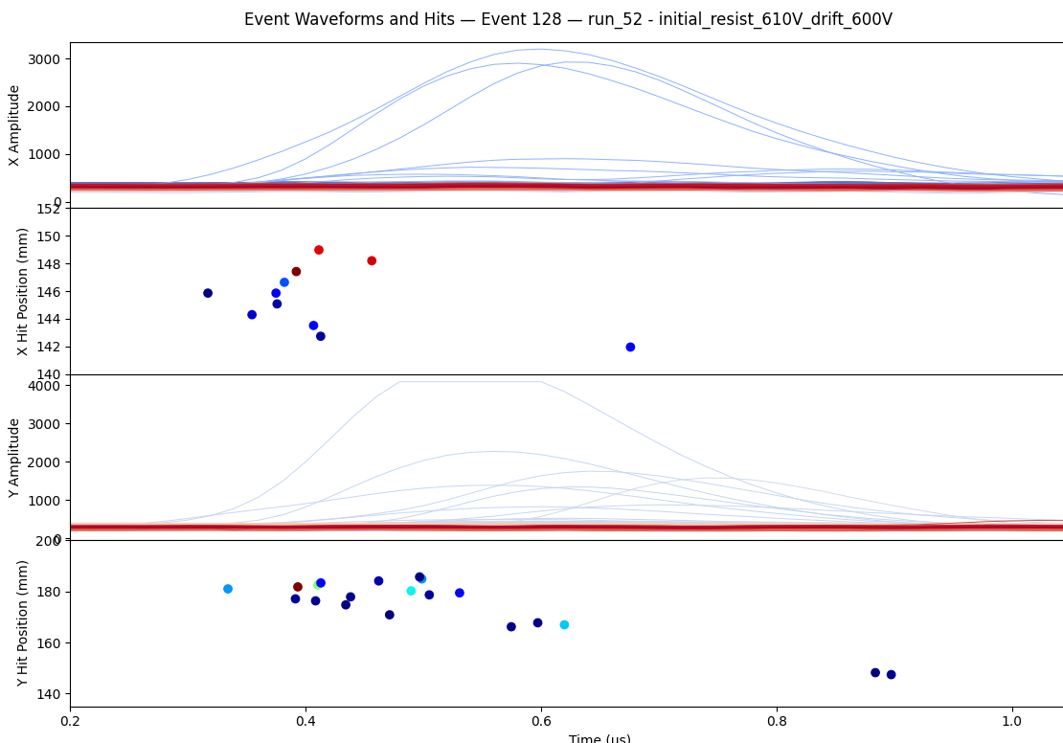
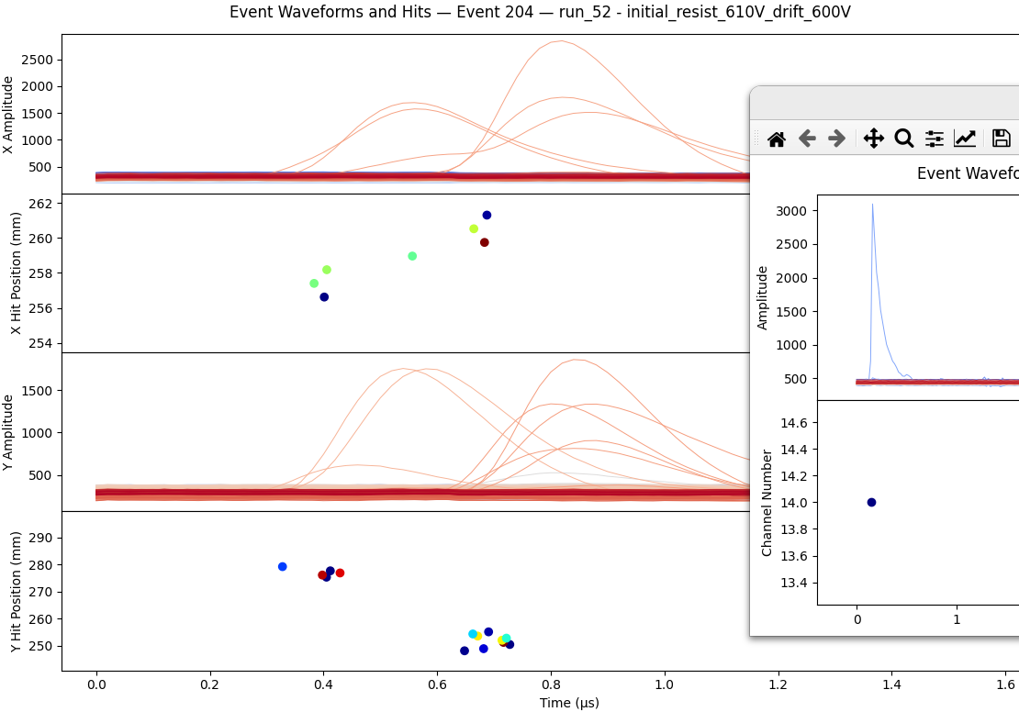
In new event can also imagine a line in both x and y, maybe passing over a dead area in the detector between ~ 0.45 and 0.6 um?
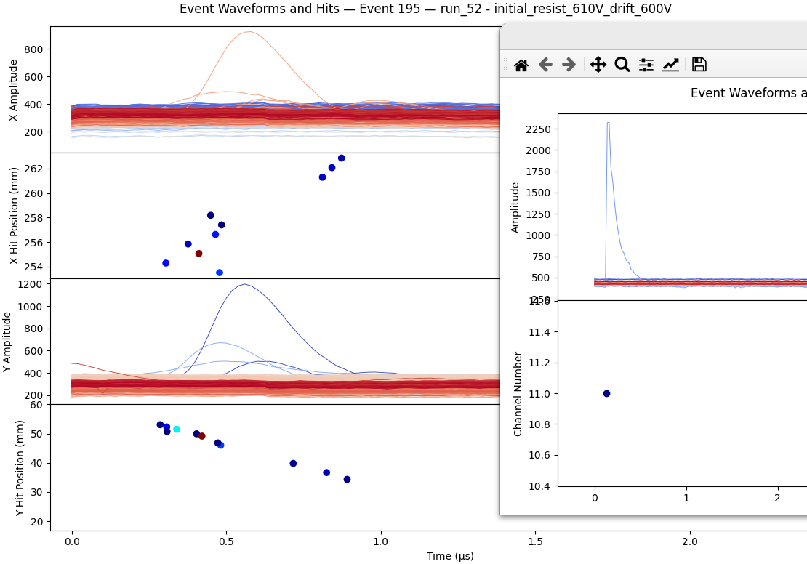
Ok found what’s probably a good one. But even here some junky signals in x, probably spreading on resistive strips? Y looks good.

Before lunch Riccardo and I went to electronics pool and got 2 NIM form factor attenuator modules, going from 5dB to ~40dB. Hopefully those can put the SiPMs in range for DREAM.

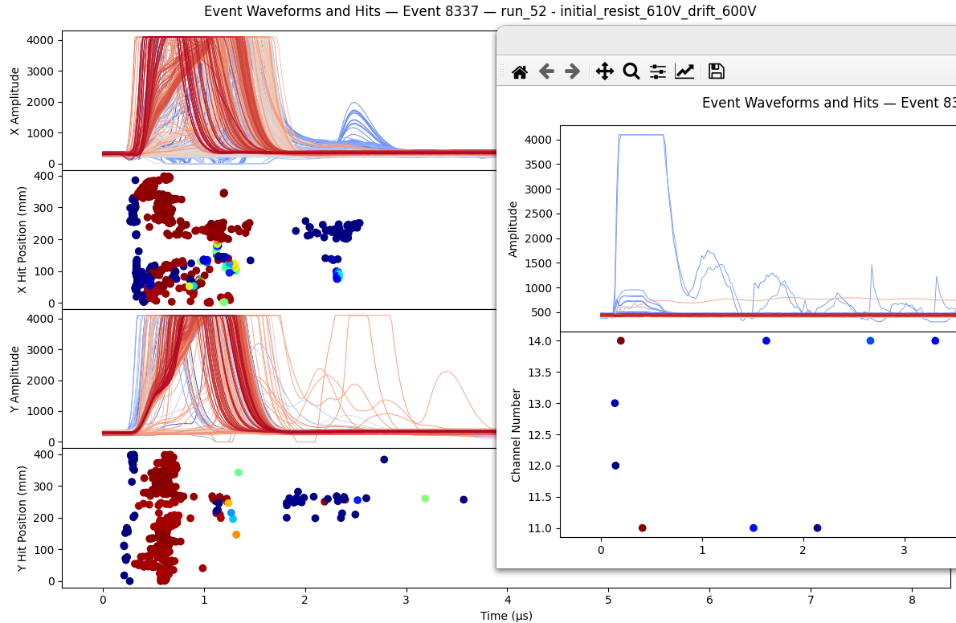
Around 3PM made an access to try to send one SiPM signal out of the area to attenuate and send back in. See if we can find an attenuation that DREAM can read through its internal amplifier.
Sent one of the two SiPM signals out of the area, attenuated, and sent back in to the mcx to mec8 board (to DREAM). Made the mistake of leaving the amplified channel plugged in, so this saturates everything when FEU 6 put through the DREAM CSA. Will have to unplug and try again.

In the process, saw that SiPM signals on the oscilloscope were huge when beam returned. Prompted me to look at beam data from last night, triggered on the SiPMs. Found that even in the corner, both MMs and SiPMs saturate. SiPM saturation not as bad as November when on beam, but not ideal.
Run 54: MM resist scan with cosmics, 10 minutes per step – not very good statistics but don’t want to waste time. Detector horizontal and taking data with trigger from oscilloscope on SiPM amplifier sum of channels. Beam is on.

Run 55: MM resist scan while in the corner of the room. Triggering on the PS pickup, so should be seeing the gamma flash. Want to get an idea of how bad it is away from the actual beam – no way we can make things better than this.

Make access around 6:20PM to put detector vertical. Before doing so, quick test to see if attenuator works after unplugging the amplified channel:
- Unplug amplified channel
- Run without attenuation in attempt to check latency
- Time in
- Increase attenuation until dynamic range is matched.
- Record said attenuation.

No dice. Baseline is shifted. Will try again tomorrow.

Realized after I left n_Tof that I left the trigger as the oscilloscope trigger out. Not ideal, but we’ll run with it in a quick HV scan tonight and run with the PS trigger tomorrow.

Run 56: HV scan with Ar/CF4 90/10 and no target LEFT CAP ON BEAM PIPE. Triggering on SiPM channel which comes directly from SiPM to oscilloscope. This should be almost always triggering on the flash.

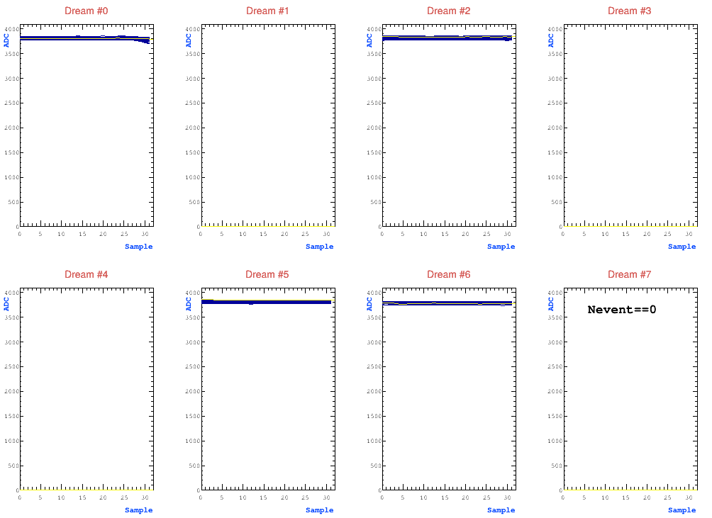
Friday February 13
Tried playing with attenuator and SiPM signal this morning. Seems that whenever the signal goes through the CSA, the baseline get shifted to almost max. This occurs in all DREAMS, even those unplugged. Maybe a hint of a mistimed signal in DREAM 0 where the one heavily attenuated SiPM channel is plugged.

Run 57: HV scan with Ar/CF4 90/10 and no target LEFT CAP ON BEAM PIPE. Triggering on PS.

Discussing with AI gemini, it sounds like this baseline shift is likely due to a grounding issue between the SiPMs bias and DREAM? Suggests some tests once Run 57 ends:
- Unplug attenuated signal cable (outside the area). Make sure baselines return to 0.
- Measure DC voltage on lemo coming out of attenuator. If more than a few mV probably DC current leak into DREAM.
- Turn off SiPM bias, see if baseline still shifted.
- If not shifted in previous step, apply some bias below the turn on voltage, see if baselines shifted.
- Try to add capacitor

After testing, run a HV scan in self trigger mode for some hours. Later tonight, add the B4C target and over the weekend run HV scans with PS and in Self Trigger.

After Run 57 played with SiPMs a bit. From #1 in test above, realized that with the config I had signals had that high baseline even with everything unplugged. Just a bad config file. Read into the DREAM documentation and realized I need to change polarity in two places, I guess the first one was for the FEU but the other one is in the DREAM config itself. Will test tonight before going to B4C.

Run 58: HV scan with Ar/CF4 90/10 and no target LEFT CAP ON BEAM PIPE. Self triggering on MMs. Only 20 minute runs and in large manual steps of voltage ~10-40V per step. Idea is to get an idea of background in the thermals before running with B4C.

Success at last with the attenuated SiPMs. After fixing the DREAM config to put FEU 6 in positive polarity in both the DREAM and FEU configs, looks like the attenuated signal at least gets through to DREAM. Will try to take some data to calibrate to the correct attenuation.

Note from the future 2/24: I don’t think I had a lot of success with the attenuation tests. I saw the signals, but on multiple channels, as if there was a lot of cross-talk. Also wasn’t clear if the attenuation was scaling the amplitudes as expected. Also tried self triggering on the attenuated signal going through the CSA, but don’t think it was successful.

Now making an access to put B4C target on, leaving everything else the same.
FOUND THAT WE HAD LEFT CAP ON THE BEAM PIPE!
Put B4C target on beam. Used the thinner sample, I believe 2 mm.

Run 59: HV scan with Ar/CF4 90/10 and 2mm B4C target over night. Trigger on PS.

Saturday February 14
Run 60: HV scan with Ar/CF4 90/10 and 2 mm B4C target over night. Self trigger.

Sunday February 15
Run 61: HV scan with Ar/CF4 90/10 and B4C target over night. Self trigger. 2.5 hour runs at higher voltages in 20V steps. This run didn’t finish! Ran out of disk space after first two subruns.

Monday February 16
Found that we ran out of disk space on the 4Tb test. Roberto made space on eos for x17:
/eos/experiment/ntof/data/x17
Transferred tests and it looked good. Started transfer of dream_run with xrootd:
kinit dneff@CERN.CH
xrootd -r --parallel 8 dream_run/ root://eosuser.cern.ch//eos/experiment/ntof/data/x17/feb_beam/

Made access at 9:40 AM to remove the B4C target. Sounds like gas is low, need to check.

Gas too low. Wanted a run with no target with Ar/CF4 90/10 but not enough to be a good test. Put at 600V and got ~2 uA, which was very different from before.

Switched to Ar/CO2 70/30 at around 11 AM. Will start a run with TCM and a single Resist voltage to track the current.

Run 62: Changed from Ar/CF4 90/10 to Ar/CO2 70/30. Running with PS trigger, mostly just to track current while gas flushes. Set single 24 hour run with resist at 610V. Think this eventually ran out of storage space.

Beam down from 1:30 to 4. Went in and put a Cs-137 source on the target holder. Want to do quick check of Feu_InterPacket_Delay rate. Resist voltage t 735V, still probably changing from the gas switch.

Rate with Interpacketdelay of 100: 159 Hz
Rate with Interpacketdelay of 10: 159 Hz

Ok interpacketdelay doesn’t seem to matter much at our rates.

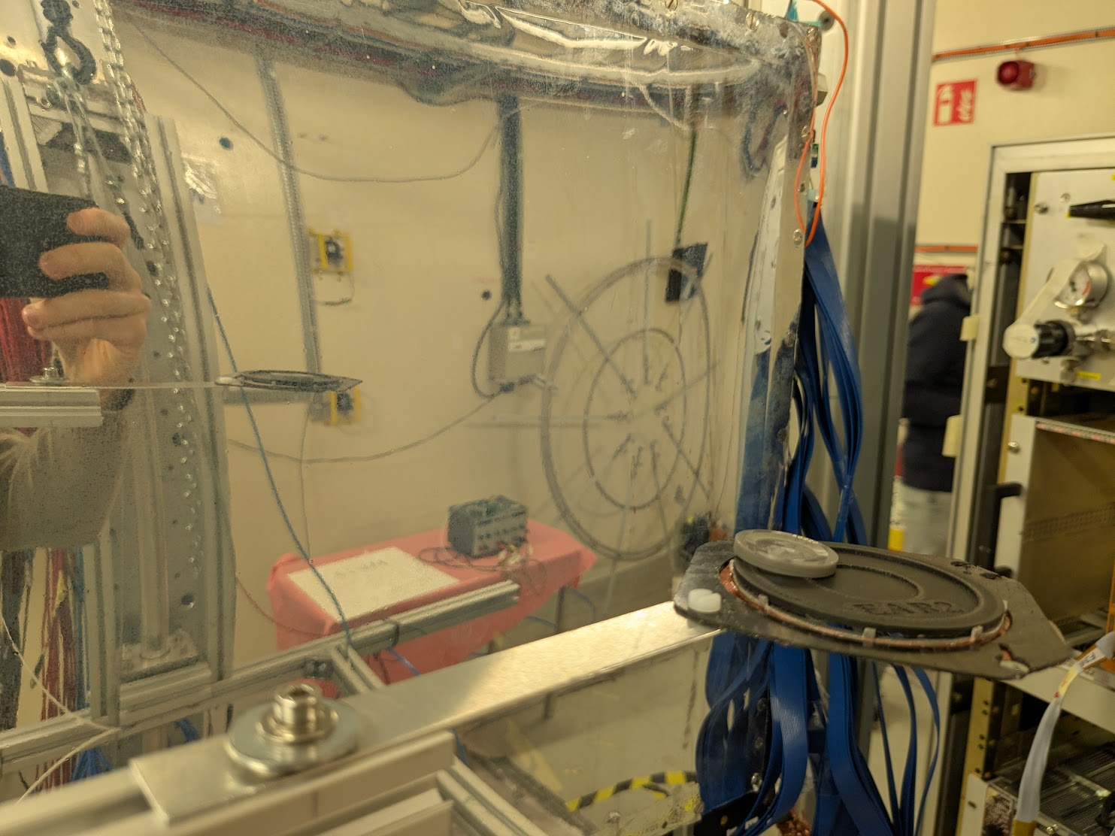

Run 63: Beam off for an hour or two. Still flushing to new Ar/CO2 gas. Put Cs-137 in target holder and running HV scan, see if it can be useful later. 5 minute subruns starting from 740V and going down in steps of 10V until beam is back, probably.

Re-installed the thin (2mm) B4C target as beam seemed like it would start to return.

Run 64: Beam seems to be coming back. Thin (2mm) B4C target with Ar/CO2 70/30 gas (probably still flushing). Set for HV scan from bottom up with PS trigger, 5 minutes each.

Run 65: Thin (2mm) B4C target with Ar/CO2 70/30 gas (hopefully totally flushed). Set for HV scan from top down with self trigger, 10 minutes each.

Tuesday February 17
Still running with self trigger and beam at 700V. Ran around to pick up the new drift window for tomorrow. Trying to decide what to run next. Empty target tonight but before that some more self trigger with B4C.
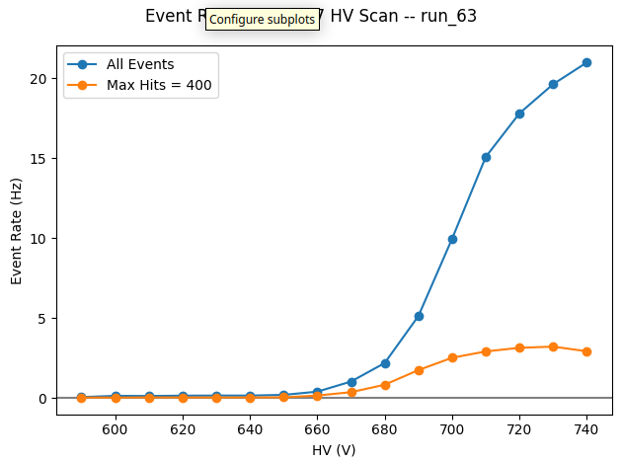
Looking at Cs-137 source HV scan from yesterday, just quickly plot event rate vs resist HV. The curve is probably dominated by sparking, since it was in self trigger mode.

Looks like it’s almost all sparking. Plotting rate from all events as well as rate for only events with fewer than 400 hits in the event (a lot). Looks like the filtered rates might be more reasonable, could represent more true Cs-137 rate. However, probably still a lot of “sparking” (discharging).

Run 66: HV scan in efficient range with better statistics at each step. Thin (2mm) B4C target with Ar/CO2 70/30 gas (hopefully totally flushed). HV scan from top down with self trigger, 1 hour each.
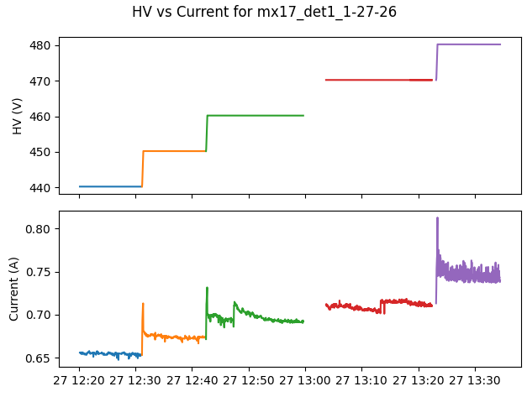

Looks like I ran a HV scan on the cosmic bench at Saclay over lunch. Could be good to see if I can get efficiencies for each.

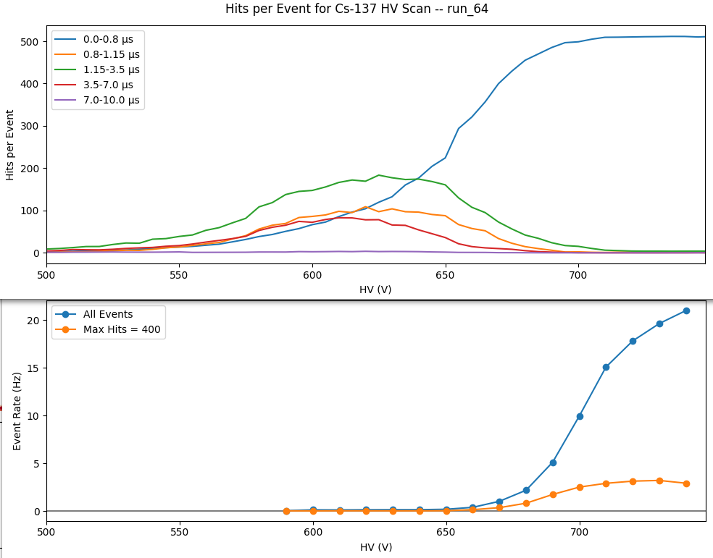
Looking at proxy for efficiency curves in the two systems: beam on top and Cs-137 on bottom in Ar/CO2 70/30, apparent that regions of operation do not overlap.

Put below some “spectra” of number of hits vs time. Hit reconstruction algorithm was built for cosmics, not beam, so the pile-up is not well treated. A hit has to drop back to threshold before another can be reconstructed, so

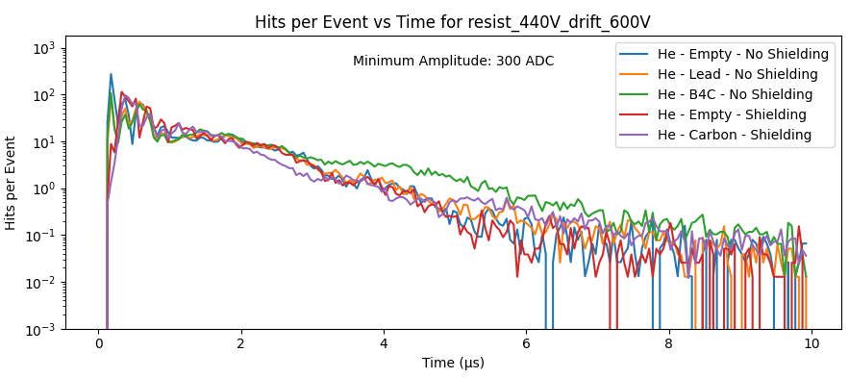
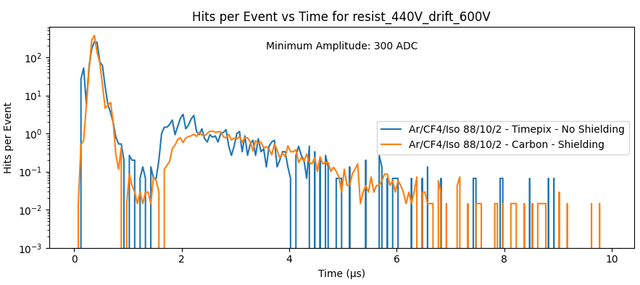
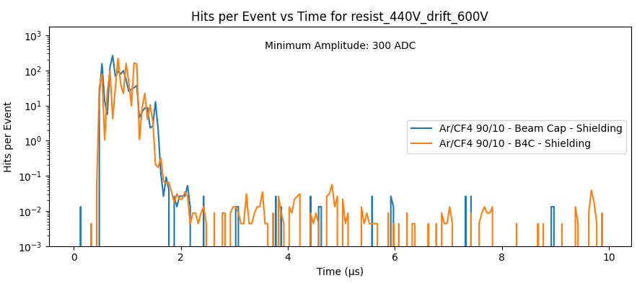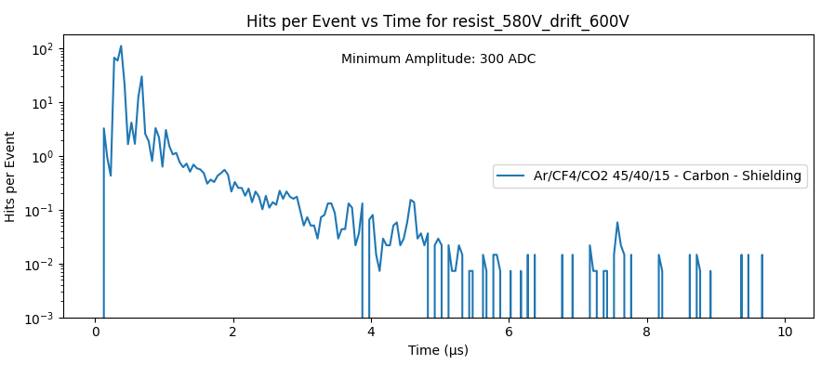
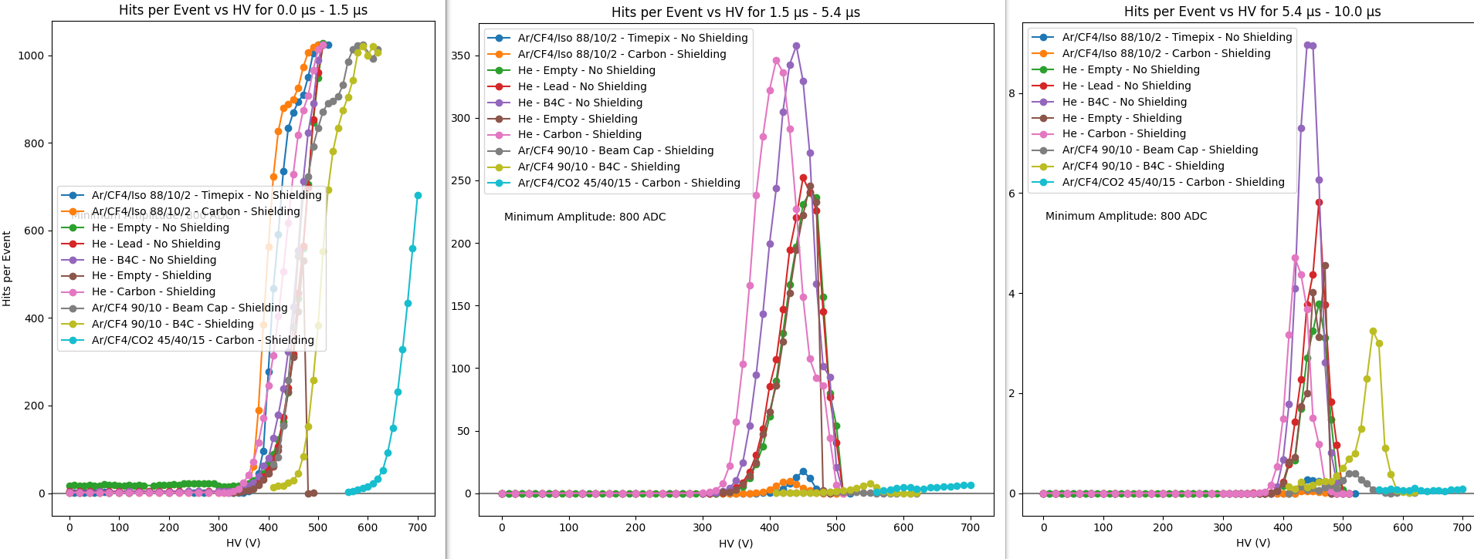

Run 67: HV scan with PS. No target, just target holder, with Ar/CO2 70/30 gas. HV scan from 730V to ~450V, 5 min each in steps of -5V.

Run 68: HV scan with self trigger. No target, just target holder, with Ar/CO2 70/30 gas. HV scan from 730V to ~670V, 90 min each in steps of -10V.

Wednesday February 18

Spent the day in the GDD clean room putting in the new drift.

Summary So Far

Does the MicroMegas Detector work?
From the cosmic bench at Saclay, yes. We see from the data there that using Argon/Isobutane 95/5 and triggering externally on cosmics, most of the detector is alive and seems to be rather efficient. It’s not quite clear yet how well the micro-TPC mode works to measure the angle of the cosmic – need more analysis time. (Caveats, the analysis has been done fast and not carefully, needs more attention).

The Main Problem – Can we see ~7 MeV Electrons?
The main problem is that I am not confident that we will be able to see 7 MeV electrons after the gamma flash. Electrons at this energy should be close to MIPs, and will therefore deposit a smaller amount of charge in the active volume than other particles.

For each gas, what we need is a calibration to tell us at what Resist voltage (amplification field) we need to operate in order to be confident that if an electron passes, we will see it. The best way to do this is with an external reference – the cosmic bench at Saclay or a beam test with tracking detectors.

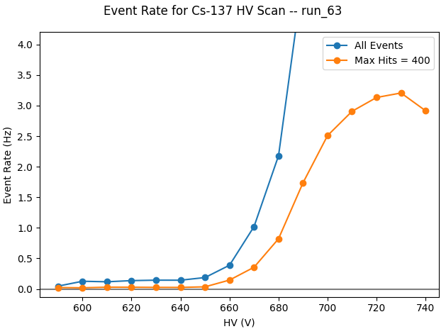
We’ve been trying to find some way to do this characterization at n_Tof. We have tried cosmics, coincidence with the scintillators, and radioactive source tests. The MMs tend to “spark” (discharge randomly in the same place on the detector), so it is difficult to differentiate this noise from signal.

On Monday, we had time to do a HV scan with a Cs-137 source. This should produce ~600 keV gammas along with electrons (what we really want) around a few hundred keV (beta spectrum plus conversion electrons). Attempting to filter out sparks, we get the efficiency curve here. It shows that we are only fully efficient with this gas (Ar/CO2 70/30) around 720V (start to be efficient around 680V).

We then look at the beam data with the same conditions (same gas). Looking at the point at 680V, we find that we already have very few counts in the time bins where we expect to see signal (1.15-3.5 us should roughly be the region around the 1 MeV neutron peak).

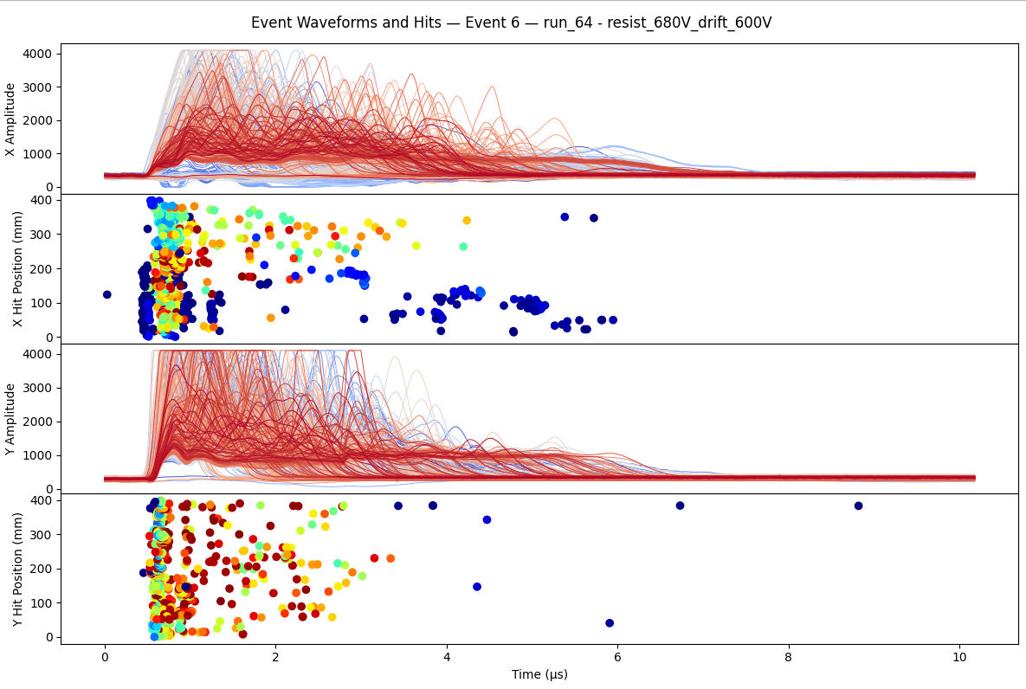
We can see this more visually by looking directly at the waveforms at these voltages (below). At 720V the detector is not producing reasonable signals after the flash. At 680V there seem to be some signals after the flash, but it’s unclear if we would be able to see electrons here. From the Cs-137 scan, we see that we are just barely beginning to be efficient at this voltage. If the MMs saturate, we would likely expect that the signal amplitudes are depressed at this point, so if an electron came through it’s amplitude may be very small.

This mismatch between the
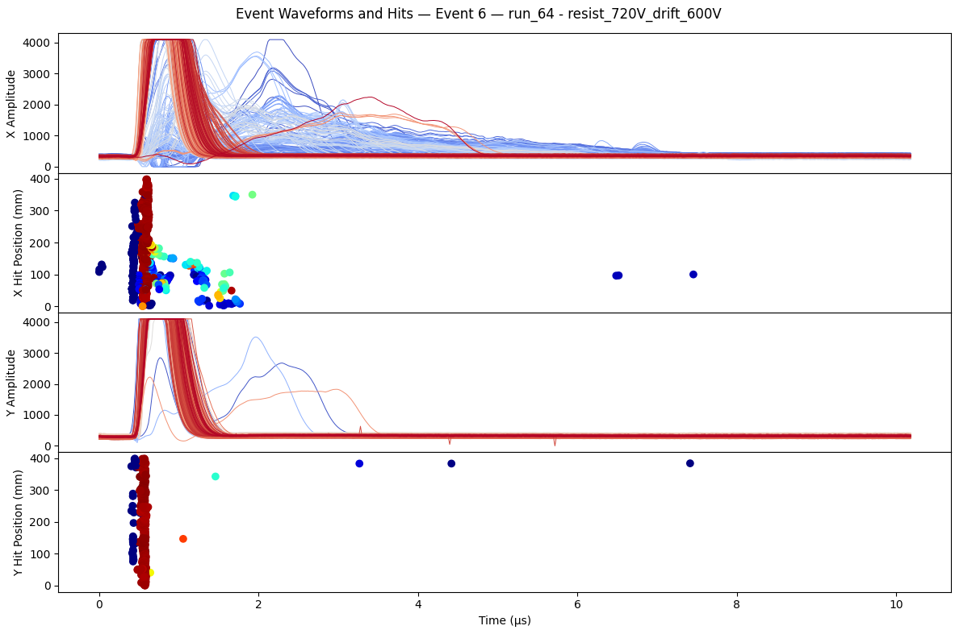

Run 69: Problems. With the new 6mm drift mounted, 2.5mm B4C target, and Ar/CO2 70/30 gas, set to run on PS trigger. Should have been a drift + resist HV scan from low to high. However, it tripped on the first drift iteration (0V) when going to 730V on the resist. So only have the 0V drift points.

Run 70: More problems. With the new 6mm drift mounted, 2.5mm B4C target, and Ar/CO2 70/30 gas, set to run on self trigger. Ran a drift + resist HV scan. However, ran out of disk space half-way through the 500V drift. 1000V seemed to finish, so that’s good.

Thursday February 19

Run 71: Quick run to get the most important points due to failures last night. With the new 6mm drift mounted, 2.5mm B4C target, and Ar/CO2 70/30 gas, set to run on PS trigger. Ran just 0V and 1000V drift, and 690V and 710V resist.

Whatsapp Messages:
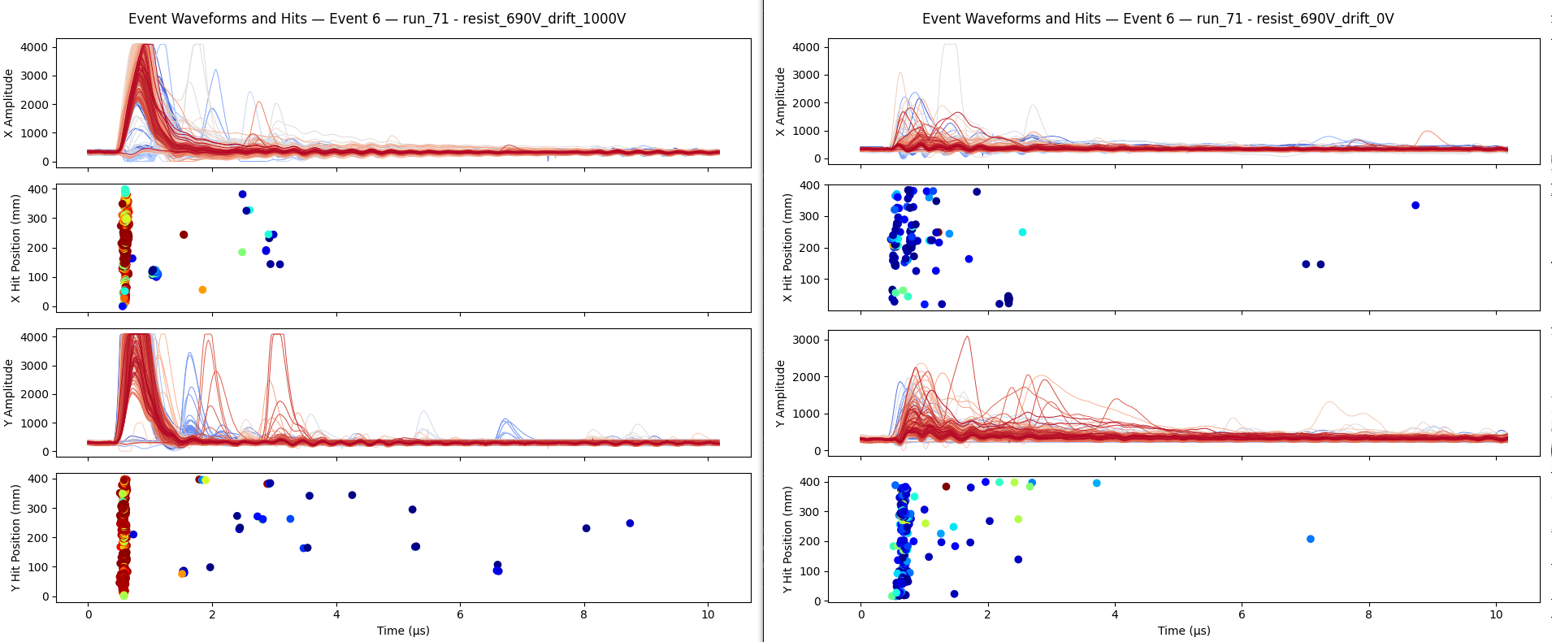
Ok so it looks like the 6mm drift is at least alive. The right plot is the flash with no drift field applied (0V), so no primary electrons drifting toward the mesh. The left is with 1000V, so normal operation. Clear difference tells us that the drift is at least turning on/off as expected. It also looks like the signals are tighter in time than for the 30 mm drift, as we would expect and more similar to what we saw in November with the EIC detectors.
However, as always, we don't have a good idea of the true gain here, so it's not clear if it's even possible to see electrons on the left. I have reason to believe that the gas won't respond exactly the same as without the new drift inserted. We can try to run another Cs-137 scan if we have time during access, but other ideas also welcome!
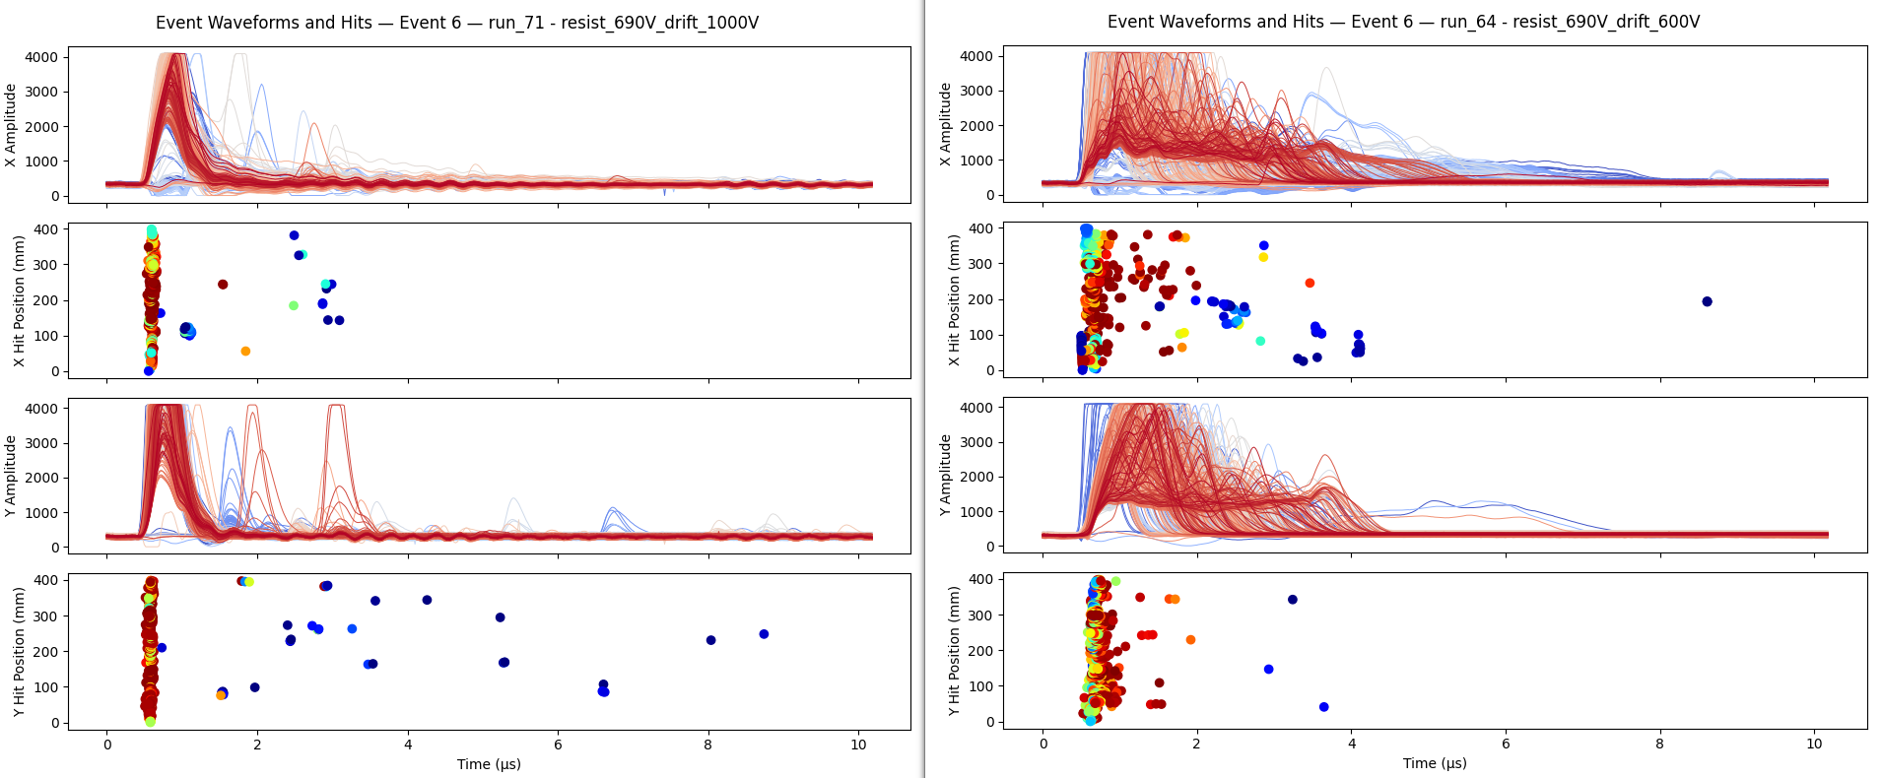
Another comparison, on the left is the same from today with the 6mm drift gap. On the right is the same resist voltage and target (B4C) with the 30 mm drift gap. With the large drift gap the gamma flash signals produced far from the mesh (near the drift) can take micro-seconds to drift to the mesh and produce a signal. You can see this clearly in the much longer tail.

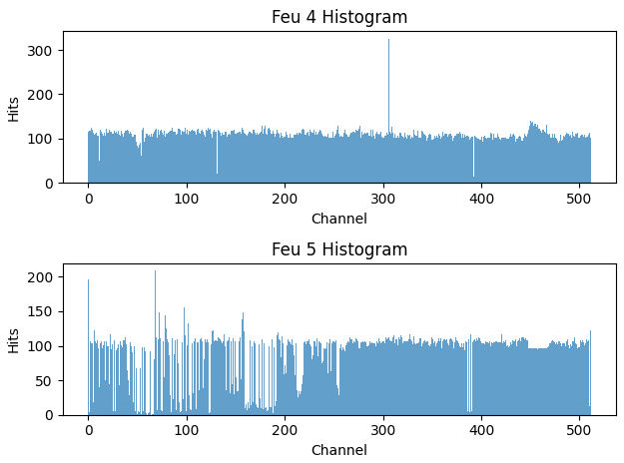
During access in 15 minutes we will try to remove this Dream cable which has many disconnected strips and send it to the ntof daq. From this hit map we should be able to select a channel which is not disconnected.

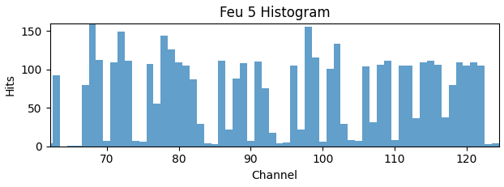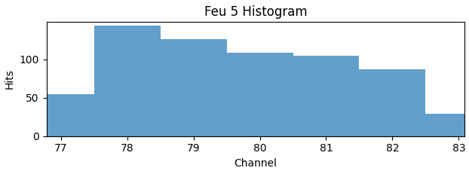
Aim for channel 80 here, expect to probably be off by 1 at least. Histogram starts at 0, so first dream cable go from 0-63, second goes from 64-127. Then 80 - 64 = 16, so channel 16 starting from 0 on the second dream. Looks like numbering on mec8 to lemo boards starts from 1, so channel 17.

Run 72: HV scan with Cs-137 source hanging from sample holder. Ar/CO2 70/30 gas with 6mm drift gap. Could have been highly problematic run. Had one dream unplugged (FEU 5 Dream #2 counting starting from 1). Was applying bias through the pre-amp while bias was already applied via the CAEN unit for the HV scan. Doesn’t look like any permanent damage but probably screwed up at least some of the scan.

Unsuccessful attempt to read dream from pre-amp. Lack of thought beforehand, I had applied bias without thinking much about what I was doing. Never saw any signal on oscilloscope. In hindsight, did not need to apply bias since detector was already on with HV on resist. The pre-amp bias was just to bias the detector if needed. Still odd that I never saw anything, could be due to the bias already being low from parallel Cs-137 scan.
Marco and Riccardo worked on the SiPM HV gate. Sounds like they need a larger gate (earlier turn off of the HV). Will access later to do this.

Run 73: Failure, git didn’t pull and ended up running Cs-137 configuration with beam and no target. Probably not useful. With the new 6mm drift mounted, empty target holder, and Ar/CO2 70/30 gas, set to run on PS trigger.

Run 74: With the new 6mm drift mounted, empty target holder, and Ar/CO2 70/30 gas, set to run on PS trigger. Ran resist HV scan in steps of -10V (not so much time due to mistake in previous run) from 720V to 560V and drift at -1000V.

Run 75: With the new 6mm drift mounted, empty target holder, and Ar/CO2 70/30 gas, set to run self trigger. Ran resist HV scan 710V, 700V, 690V and drift at -1000V.

Plan to access around 5PM to change gate for SiPMs and maybe run signal cable out of area to test the terminators externally. If there is time, plan to test reading Dream through pre-amp again:
- Unplug Dream cable (Feu 5 Dream 2) and plug into lemo board. Lemo to input of pre-amp. Pre-amp LV powered through amplifier on NIM rack. No bias. E output to oscilloscope.
- Apply bias to MMs: -1000V on drift, +720V on resist → should hopefully see sparks.
- Check on oscilloscope, triggering on falling edge of negative pulse. If nothing, check for positive signals triggering on rising edge.
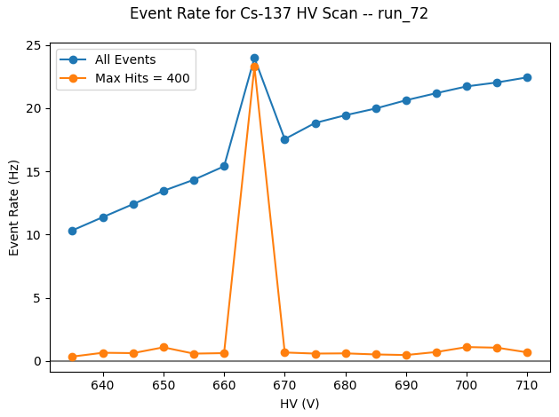

Run 72 Cs-137 scan does not appear to have gone well. Spike at 665 is almost certainly

Df

Need to remember to run pedestals before beam comes back!
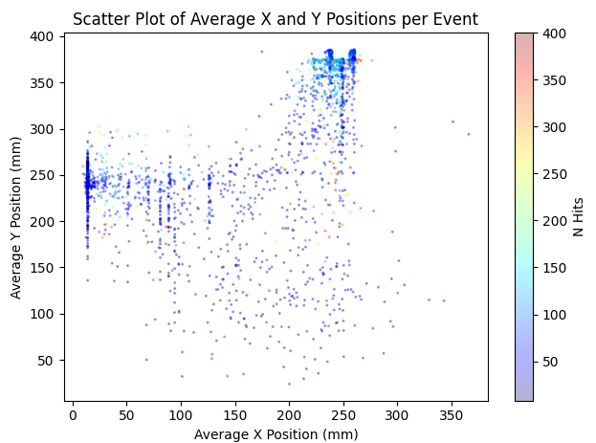
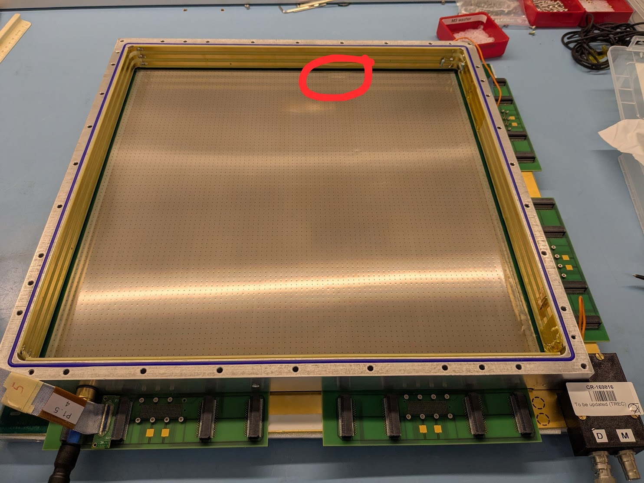

Made access around 6PM. Riccardo and Marco worked on the SiPMs. I tried to get a dream readout through the pre-amplifier again. Looked like I had something at one point, but may have just been noise. Will have to try some other time, maybe next Wednesday.

Run 76: With the new 6mm drift mounted, lead target, and Ar/CO2 70/30 gas, set to run with PS trigger. Ran resist + drift HV scan, resist from 720V down to 520 (non-uniform steps) and drift at 1000V, 500V, 2000V. Ran up to the 2000V, but the max on CAEN was 1500V so the 2000V never ran.

Run 77: Overnight run. With the new 6mm drift mounted, lead target, and Ar/CO2 70/30 gas, set to run with self trigger. Ran resist HV scan at 1 hour per point, from 720V to 630V.

Friday February 20
Made access around 10AM to work on SiPMs while PS had a problem with beam. Looks like Marco and Riccardo successfully inverted the SiPM bias dip logic, now can hopefully time in outside of area.

Used the time to try to run another Cs-137 scan with the MMs. After starting with configuration as before, found that the current at 720V (where it had tripped on Wednesday night) was now lower than expected. Found that I could push up to 745V, so started a scan from there.
Not good that the gas seems to take so long to flush. Need to really think about how much we can trust the resist voltage on the data we’ve gathered. Maybe correlate with current rather than HV?

Run 78: Only 10 minutes of a Cs-137 scan before I realized that I should go to higher resist voltage. Cs-137 resist HV scan with the new 6mm drift mounted Ar/CO2 70/30 gas, set to run with self trigger. Drift at -1000V. Started resist at 720V.

Run 79: Cs-137 resist HV scan with the new 6mm drift mounted Ar/CO2 70/30 gas, set to run with self trigger. Drift at -1000V. Started resist at +745V and did 5 minute subruns in steps of -5V. Only got down to 730V before beam came back and we had to leave.

Took a new pedestal run (finally) after closing the area and before beam returned.

Found that the DAQ machine was putting OS stuff in swap space for whatever reason. Changed some system parameters to reduce how quickly it starts going to swap, should have quite a lot of space in the 16 GB of RAM on the machine. Restarted the machine and things seem better with swap cleared.

Am constantly copying dream_run to eos and deleting once there. Have now copied all runs data there as well, and am selectively deleting some of these runs from the DAQ machine to manage space.

Switched to carbon target before leaving the area. Plan is to run with carbon and the Ar/CO2 70/30 gas until tonight and then switch gas to Helium.

Run 80: 6mm drift with Ar/CO2 70/30 gas and carbon target. Set to run with PS trigger. HV scan for both resist and drift. Resist from 740V to 610 in steps of -10. Drift from 1000V, 500V, 2000V. Probably won’t finish all of 2000V but hopefully can get a couple of points for comparison.

Run 81: 6mm drift with Ar/CO2 70/30 gas and carbon target. Meant to set self-trigger but ended up with PS trigger. 30 minute subruns for HV resist scan.

Changed from Ar/CO2 70/30 to He ethane gas. Starting run to monitor change.

Run 82: 6mm drift with new He/Ethane 96.5/3.5 gas and carbon target. Just to monitor as the gas changes. Manually changed HV to keep current under control.

Gas probably still not totally flushed, so running self trigger at -500V drift first.

Run 83: 6mm drift with new He/Ethane 96.5/3.5 gas and carbon target. Probably not totally flushed yet, so starting with a scan with drift at -500V first with self trigger. Then -1000V after. 4 points each, 60 minute runs each for statistics.

Found that the current in Helium for -1000V drift and +540V resist has a pretty characteristic pattern.
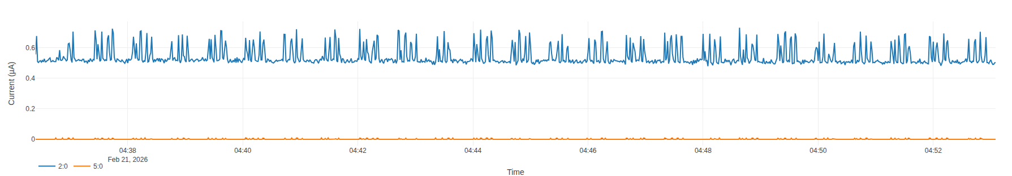

Saturday February 21
Run 84: 6mm drift with new He/Ethane 96.5/3.5 gas and carbon target. Probably still not totally flushed. Running longer HV scan with PS trigger before sample change around 4PM. 8 minutes each point, drift at -1000V, -500V, -2000V. Resist from +555V down to +400V.

Run 85: Previous run saw the drift trip around -1700V, so couldn’t do the -2000V run. Instead running at -1500V for a bit before we change the sample. 6mm drift with new He/Ethane 96.5/3.5 gas and carbon target. Probably still not totally flushed. 5 minutes each point, drift at -1500V. Resist from +555V down to +400V.

Example event from Run 84 at pretty high HV. Looks like could be a reasonable track in y?

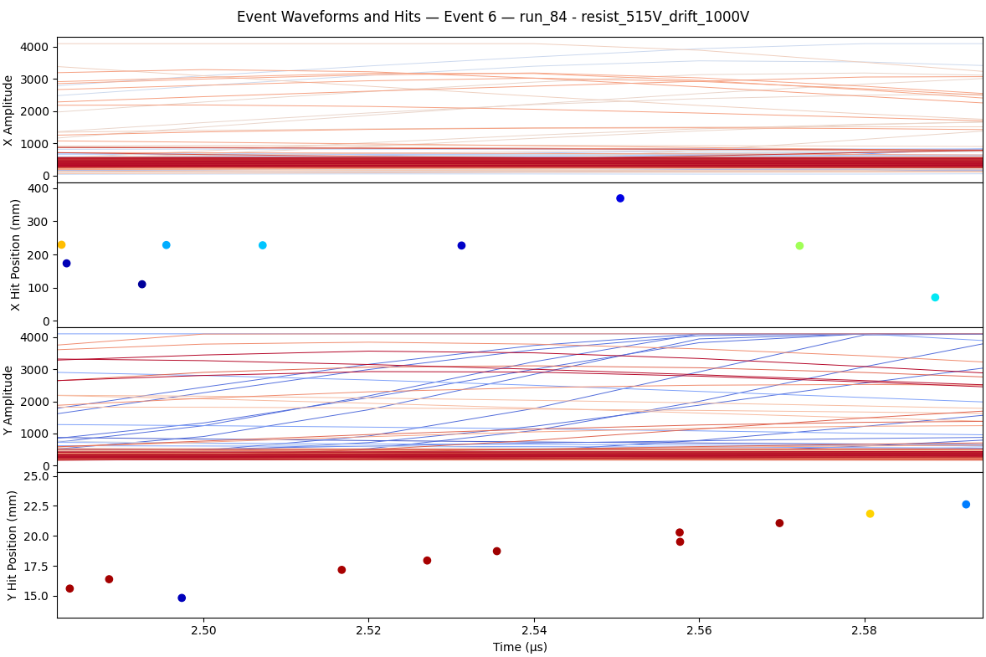
Access at 4 PM to change from carbon to lead sample.

Run 86: 6mm drift with new He/Ethane 96.5/3.5 gas and lead target. Probably still not totally flushed. Running longer HV scan with PS trigger. 8 minutes each point, drift at -1000V, -500V, -1500V. Resist from +555V down to +400V.

Run 87: 6mm drift with new He/Ethane 96.5/3.5 gas and lead target. Probably still not totally flushed. Running HV scan with self trigger overnight. 8 minutes each point, drift at -1000V, -500V, -1500V. Resist from +555V down to +400V. Was meant to be self trigger but was PS!
Looking back at self triggered runs with 3 cm drift gap. After heavy filtering of sparks see what look like a class of events with good tracks. Seem to be only around the edges of the detector, some effect of triggering/filtering? If in the center, does it induce a spark and get filtered with the large number of hits? If not, are there too few hit strips to trigger the self trigger?
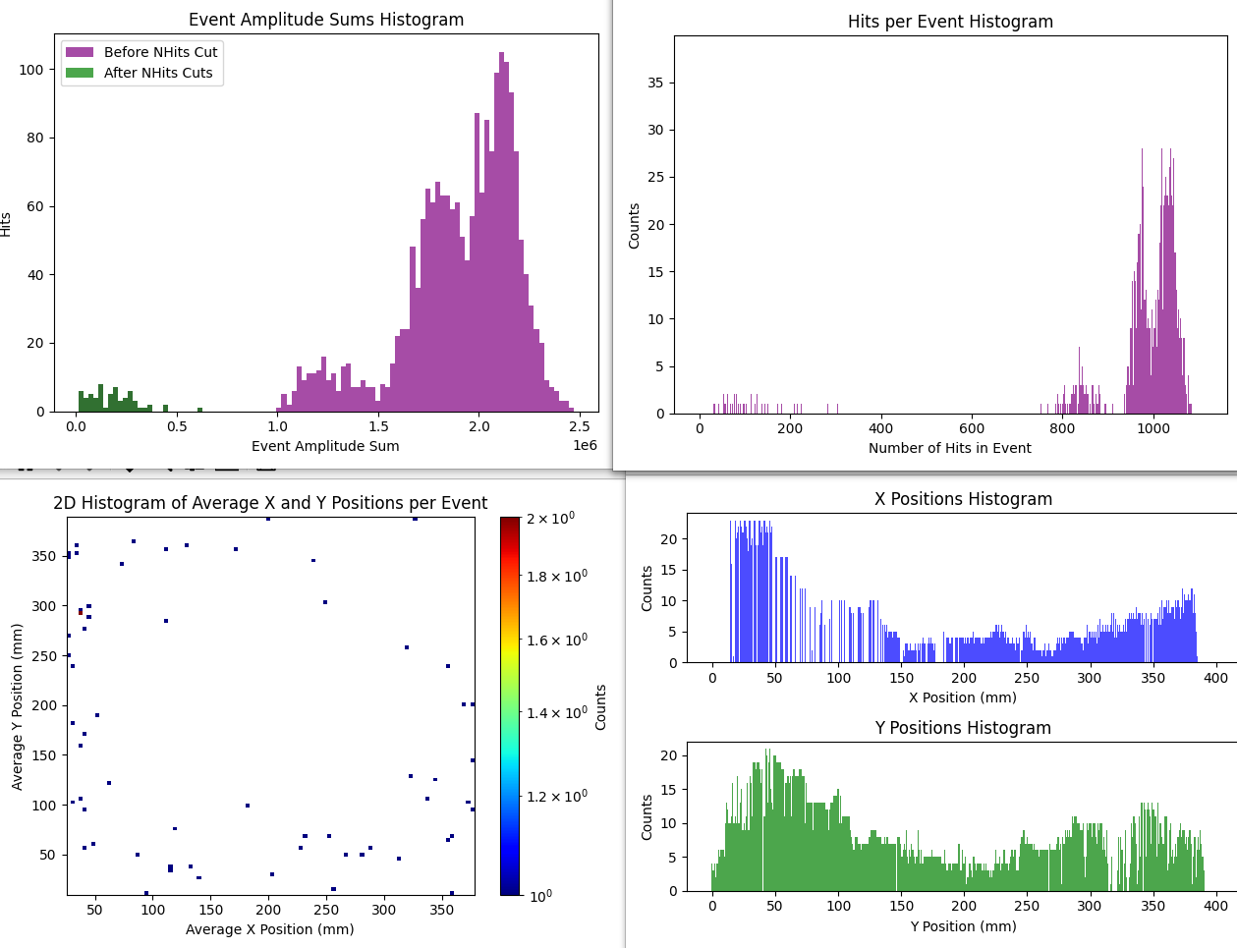
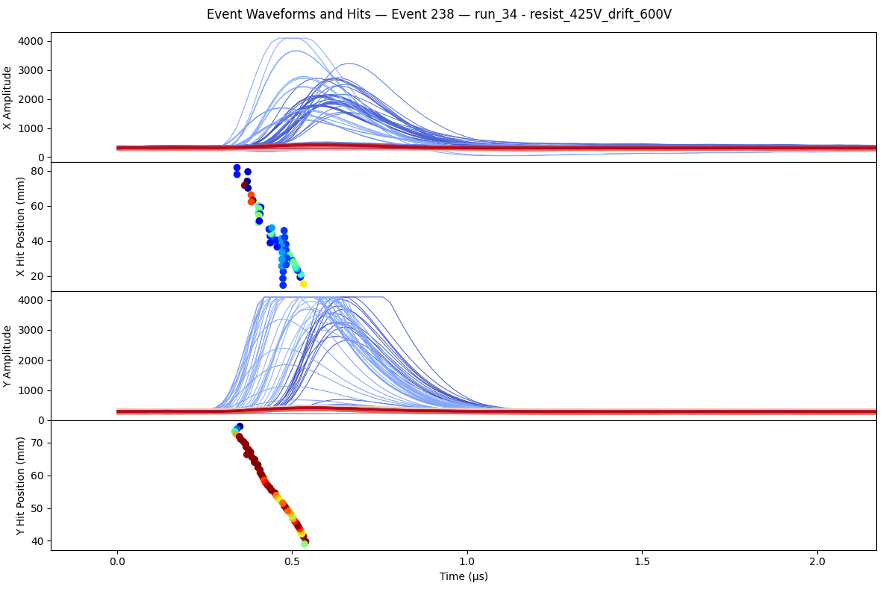

Sunday February 22

Quick testing of less than x. At 540V on resist ~0.8 uA, -500V drift. Less than 17 → 38 Hz
At 540V (~0.8 uA):
Less than 7 → 38 Hz
Less than 4 → 35 Hz
Less than 3 → 35 Hz
Less than 2 → 37 Hz
Less than 1 → 0 Hz

At 510V (~0.34 uA):
Less than 17 → 0.3 Hz
Less than 7 → 0.48 Hz
Less than 4 → 0.4 Hz

Ok so the Sys Trg MultLessThan parameter really doesn’t do much for us.
???
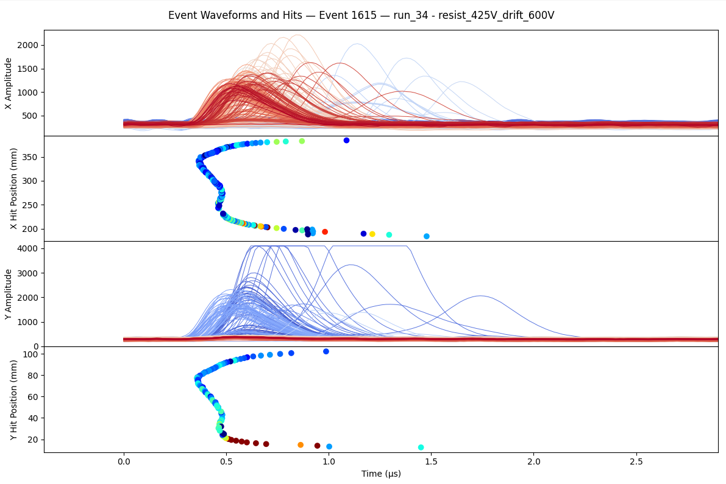
Good track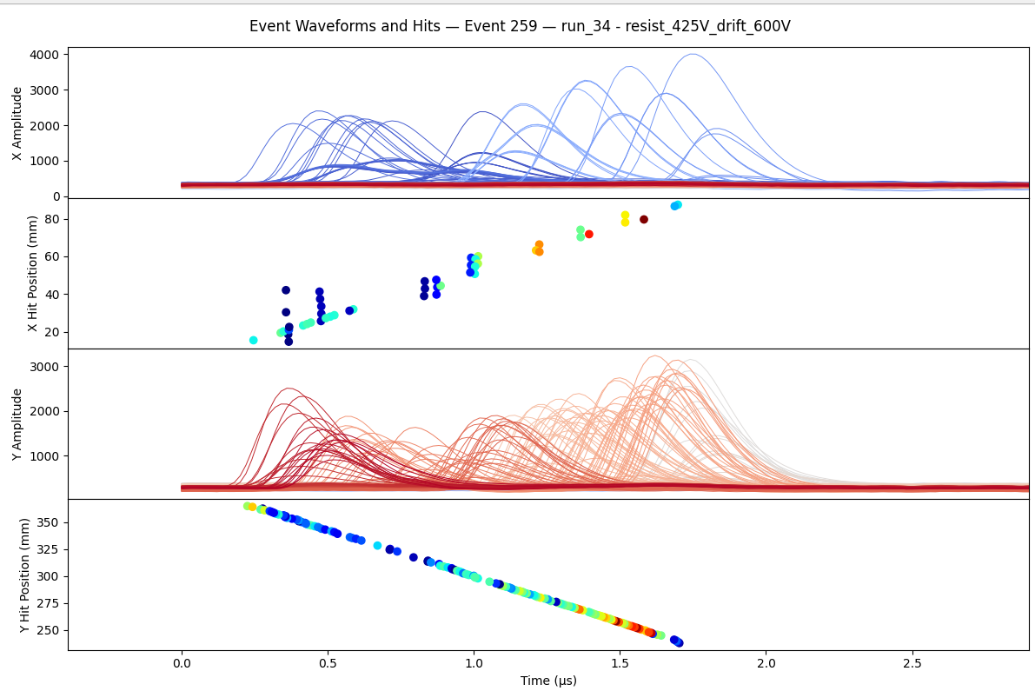

Track hits edge of detector where drift field decreases. Drift speed is slow, so curve in y-position.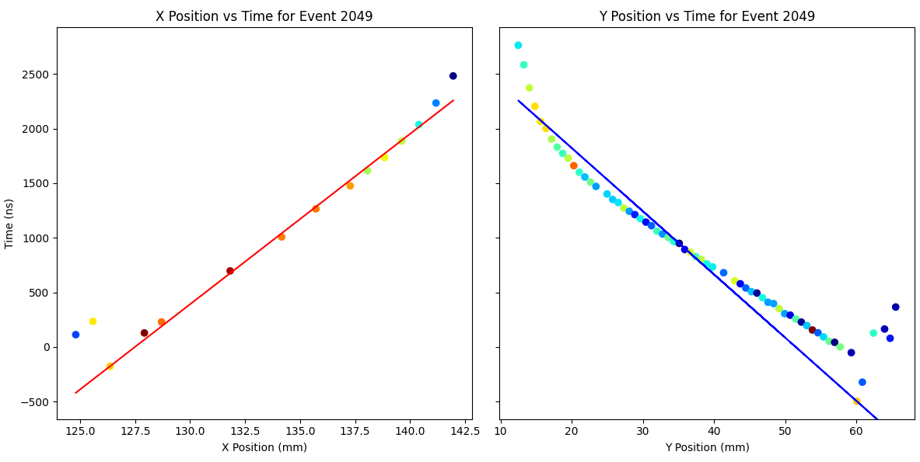
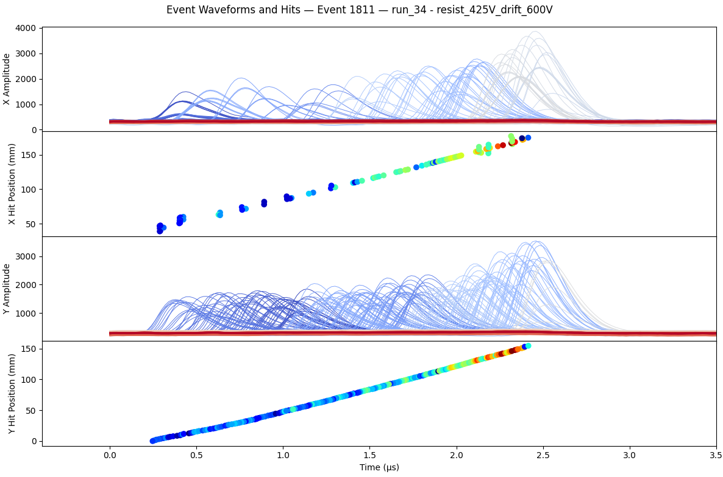

Changed sample from lead to B4C around 5PM.

Run 88: 6mm drift with He/Ethane 96.5/3.5 gas and B4C target. Running HV scan with PS trigger. 7 minutes each point, drift at -1000V, -500V, -1500V. Resist from +555V down to +400V.

Run 89: 6mm drift with He/Ethane 96.5/3.5 gas and B4C target. Running HV scan with self trigger. 90 minutes each point, drift at -1000V, -500V. Resist from +550V down to +490V.

Monday February 23
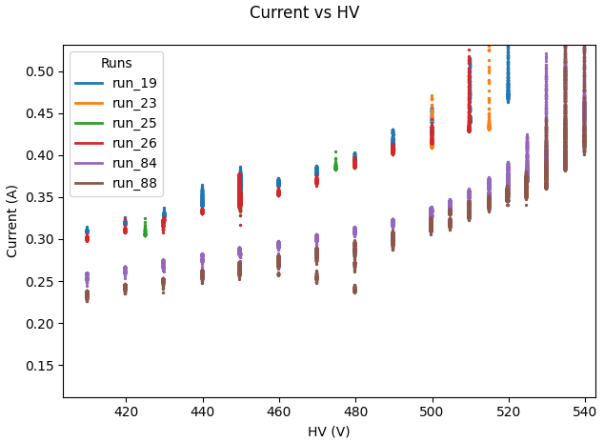

Current just different now than it was earlier in the run. With same He/Ethane gas, we have less current at the same resist HV. The difference is that the new 6mm drift window is inserted in Runs 84 and 88.

In Run 88 with He/Eth and 6mm drift with B4C target, looks like there’s a range where we might be able to operate. However, we still have no idea if we are efficient to electrons here.

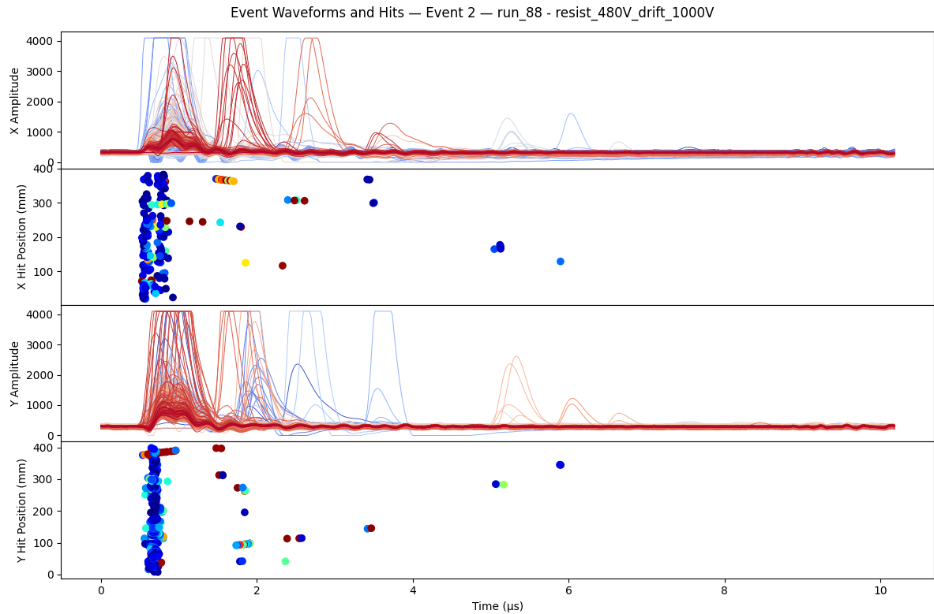

Still with B4C, trying to run with SiPM as trigger. Just take a powered SiPM channel out of area. Put it on oscilloscope and trigger at ~10 mV. Use the oscilloscope trigger to trigger Dream. Trying to ZS but not clear if it’s working. Timed in and testing at 500V.
Run 90: 6mm drift with He/Ethane 96.5/3.5 gas and B4C target. Running with SiPM trigger. Drift at -1000V resist at +500V.

Run 90 didn’t see much of anything. Try to increase resist to +520V.

Run 91: 6mm drift with He/Ethane 96.5/3.5 gas and B4C target. Running with SiPM trigger. Drift at -1000V resist at +520V.

Run 92: 6mm drift with He/Ethane 96.5/3.5 gas and B4C target. Running with SiPM trigger. Drift at -1000V resist at +530V.

Run 93: 6mm drift with He/Ethane 96.5/3.5 gas and B4C target. Running with SiPM trigger. Drift at -1000V resist at +540V.

Run 94: 6mm drift with He/Ethane 96.5/3.5 gas and B4C target. Running with SiPM trigger. Drift at -1000V resist scan from 550V to 410V.

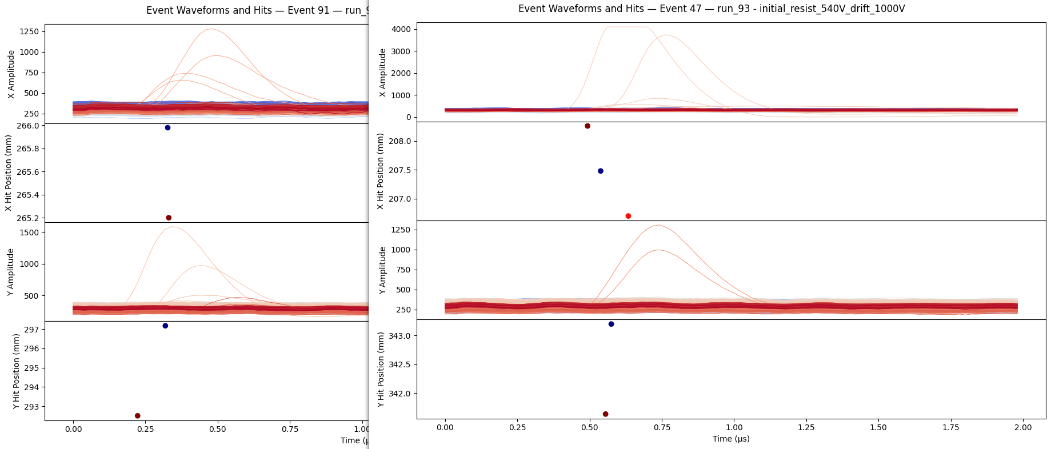
Hmm will be close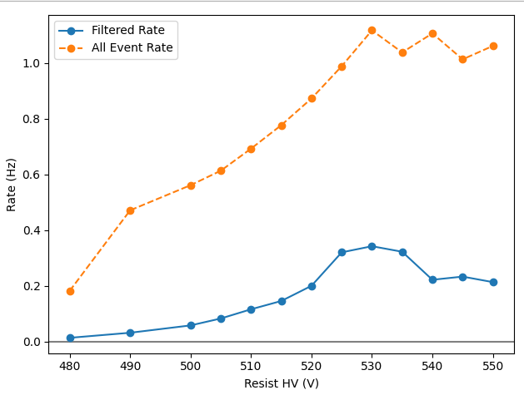
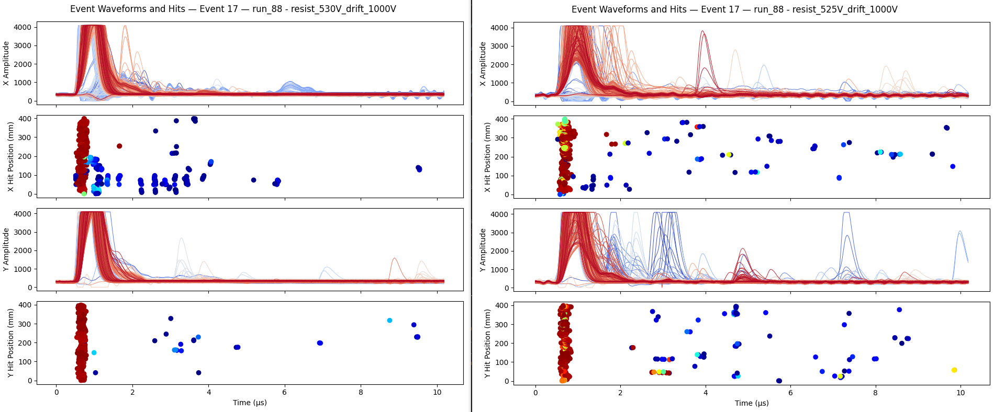
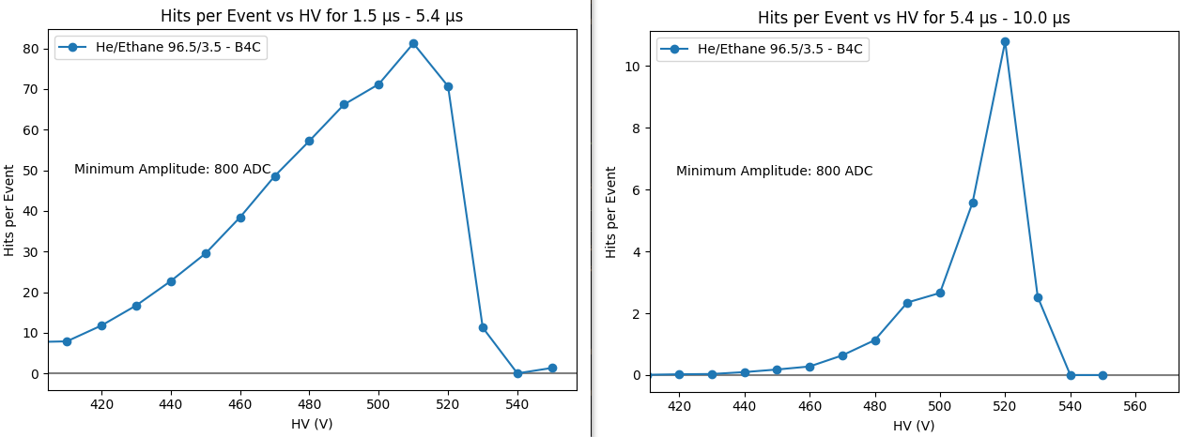

Run 95: 6mm drift with He/Ethane 96.5/3.5 gas and empty target holder. Running with PS trigger. Drift at -1000V, -500V resist scan from 540V to 480V. GARBAGE. PS delay was 0ns instead of 9400, from the SiPM triggering.

Run 96: 6mm drift with He/Ethane 96.5/3.5 gas and empty target holder. Running with self trigger. Drift at -1000V, -500V resist scan from 540V to 480V.

Tuesday February 24
Beam off at 9AM for PS access. Entered and put Cs-137 source on the target. Started a run before meeting but forgot that RP was coming to pre-check rack and detector for transport next week. Stopped run for Riccardo to remove source during RP check.

Run 97: 6mm drift with He/Ethane 96.5/3.5 gas and Cs-137 source on target holder. Running with SiPM trigger. Drift at -1000V resist scan from 545V to 450V in roughly steps of -5V, 10 minutes each.

Run another one with self trigger, shorter

Run 97: 6mm drift with He/Ethane 96.5/3.5 gas and Cs-137 source on target holder. Running with self trigger. Drift at -1000V resist scan from 545V to 450V in roughly steps of -5V, 5 minutes each.

Very interesting result from plotting number of hits with B4C and PS trigger against HV for different drift Voltages. Looks like a shift. However, opposite from what I would expect? If anything, would think that at higher drift field, we would have more pre-amplification and therefore more hits at lower resist voltage. However, see opposite – at the same resist voltage, see more hits across the board in 500V drift than 1000V drift. Something about slower drift making the mesh more transparent?
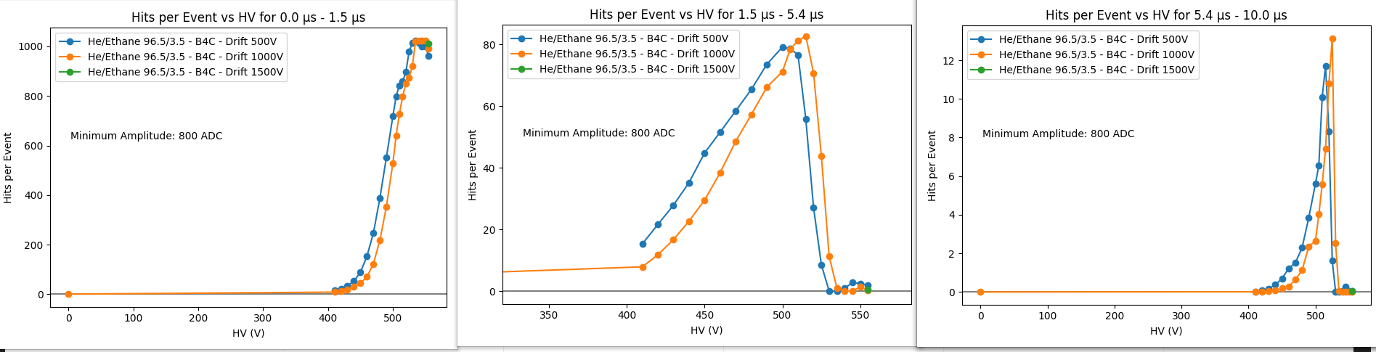
Want to utilize no-beam time today once this Cs-137 scan ends. Two things to do:
- Read out MMs into ntof DAQ – Need to see preamp signal on oscilloscope in area.
- Try to attenuate SiPMs to read out into dream – Probably need capacitor? Maybe Stephan can help.

When beam returns, probably keep same gas, since carbon frame swap should hopefully happen Thursday – not enough time to flush a new gas.
- Run PS HV scan with different gain on DREAM. If detector dies at a lower HV, tells us that it’s DREAM not the detector that dies.
- Run PS drift HV scan with smaller Resist range. See if this shift is significant.
Run 98: ???

Run 99: Quick test with gain of 200fC instead of 600fC. 6mm drift with He/Ethane 96.5/3.5 gas and B4C target. Running with PS trigger, drift -1000V, resist 530V.

Run 100: Quick test with gain of 600fC. 6mm drift with He/Ethane 96.5/3.5 gas and B4C target. Running with PS trigger, drift -1000V, resist 530V.

Run 101: Quick test with gain of 100fC instead of 600fC. 6mm drift with He/Ethane 96.5/3.5 gas and B4C target. Running with PS trigger, drift -1000V, resist 530V.

Run 102: Quick test with gain of 100fC instead of 600fC. 6mm drift with He/Ethane 96.5/3.5 gas and B4C target. Running with PS trigger, drift -1000V, resist 540V.

Run 103: Quick test with gain of 600fC. 6mm drift with He/Ethane 96.5/3.5 gas and B4C target. Running with PS trigger, drift -1000V, resist 54

Conclusion: Gain seems not to have much effect on when the DAQ saturates. Basically just a vertical zoom where 600fC zoomed out, 100fC is zoomed in.

Made quick access and put Dream 1 (starting at 0) from FEU 5.1 to FEU 6.6. See if unprotected makes a difference.
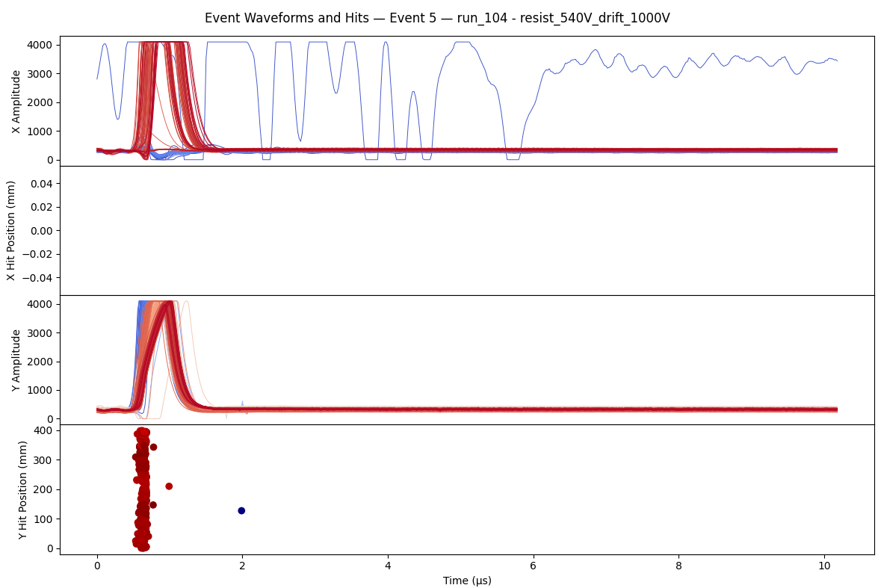
Run 104: Quick test with gain of 600fC and one Dream on Feu 6.6. 6mm drift with He/Ethane 96.5/3.5 gas and B4C target. Running with PS trigger, drift -1000V, resist 540V.

Feu 6 on top. Makes no difference.

The CSA input current was at 1.2 mA. Try changing to 400 uA.

Run 105: Quick test with CSA input current at 400 uA instead of the nominal 1.2 mA. gain of 600fC and one Dream on Feu 6.6. 6mm drift with He/Ethane 96.5/3.5 gas and B4C target. Running with PS trigger, drift -1000V, resist 540V.

This made no discernable difference (400uA and 1.2 mA).

Next try the integration time constant, change from nominal 50 us to 5 us.
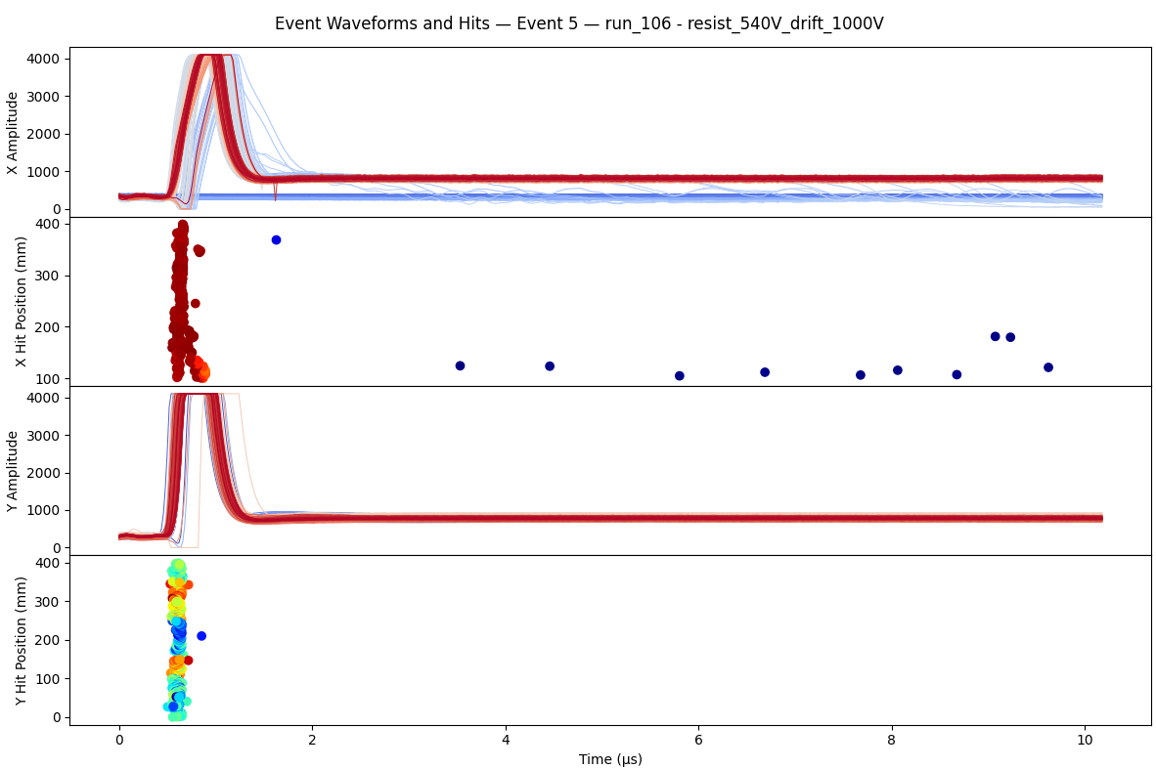
Run 106: Quick test with integration time constant at 5 us instead of nominal 50 us. CSA input current back at the nominal 1.2 mA. gain of 600fC and one Dream on Feu 6.6. 6mm drift with He/Ethane 96.5/3.5 gas and B4C target. Running with PS trigger, drift -1000V, resist 540V.

Hmm the 5 us (from 50 us) integration time change caused a baseline shift in the Dreams that were plugged in. Don’t know what that tells us.

Think I’m out of ideas on Dream configs.

Run 107: All Dream parameters back to nominal. One Dream still on Feu 6.6. 6mm drift with He/Ethane 96.5/3.5 gas and B4C target. Running with PS trigger, drift -1000V -500V -1500V, resist 535V through 520V. Then long run at drift -1000V resist 525V.

Wednesday February 25
To Do:
- Email Irakli
- Get pre-amps from GDD
- Install pre-amp
- Make DC block with lemos and capacitor
- Test SiPM with DC block

Quick access to swap the Dream cable in Feu 6.6 (unprotected) back to its nominal place in Feu 5. Still have one of Feu 5 dream cables unplugged (in ntof daq).

Run 108: Was supposed to be a single run at 520V but ended up rerunning Run 107 HV scan. All Dream parameters back to nominal. One Dream still on Feu 6.6. 6mm drift with He/Ethane 96.5/3.5 gas and B4C target. Running with PS trigger, drift -1000V -500V -1500V, resist 535V through 520V. Then long run at drift -1000V resist 525V.

Emailed Irakli about Dream, sounds like the issue being with Dream could be reasonable. Sent him a run to take a look at, maybe he’ll find some issue in the config. In the mean time, he was interested in how long the detectors were dead. Should be able to measure this in self trigger mode with a quick HV scan.
Need to reduce the number of samples and the interpacket delay to ensure that readout is not the limiting factor. From there, just put in self trigger mode and look for flash/blind structure.

Running with 32 samples 550V 100 interpacket delay. Rate starts at 80Hz then drops down to 35 Hz over 30 seconds.
Running the same with 10 interpacket delay, similar behavior. I don’t think interpacket delay limits us?

Run 109: Running with PS trigger and 32 samples. Interpacket delay of 10. 6mm drift with He/Ethane 96.5/3.5 gas and B4C target. 2 minute runs from 545V down to 500V.

At GDD today I found a nice looking bnc to bnc shielded box with nothing inside. Soldered a ~8pF capacitor inside, will try to use as DC block for SiPM.
Tried this, created a monstrosity. 50 Ohm resistor in T with

Run 110: Back to normal running over lunch. Drift -1000V Resist +520V single subrun. 6mm drift with He/Ethane 96.5/3.5 gas and B4C target.

Worked a lot on the SiPMs. Installed new amps from Marinko. Put two MM channels out through the amps: Channel 17 on lemo board (starts at 1 so 16 on Dream counting) goes to Ch 3 of ntof_daq. Channel 51 (50) goes to ch 0 of ntof_daq. Channel 51 (I think?) goes through amplifier first to integrate at 100 ns to smooth noise.
Stephan Timote and Pierfrancesco arrived. Installed nblms and got them working after some work. Nblm fast is just standard micromegas: 10x10cm with 1.7mm drift gap. That means we fit 16 of these in the footprint of the MX 40x40cm, and we have 6mm/1.7mm = 3.5 times more active volume per square cm.

Run 111: Tried to run overnight but no events taken! Drift -1000V Resist +520V single subrun. 6mm drift with He/Ethane 96.5/3.5 gas and B4C target.

Thursday February 26
The NIM crate was off last night after access, so run since then took no triggered data. Turned back on when we accessed today. At access, RP signed off on detector and we dismounted. Measured hole distances for the carbon mechanics.

Run 112: Quick run just to see flash with carbon frame. First run with carbon frame integrated. Running Ar/CO2 70/30. Drift -1000V Resist +720V single subrun. 6mm drift and B4C target.

Run 113: First real run with carbon frame integrated to track gas flush. Running Ar/CO2 70/30. Drift -1000V Resist +720V single subrun. 6mm drift and B4C target.

Run 114: PS HV scan with carbon frame integrated. Running Ar/CO2 70/30, probably not totally flushed yet. Drift -1000V, -500V, -1500V Resist +720V to +605V in -5V steps. 6mm drift and B4C target.

Friday February 27

Run 115: CSA test nominal. PS HV scan with carbon frame integrated. Running Ar/CO2 70/30, probably not totally flushed yet. Drift -1000V, -500V, -1500V Resist +720V to +605V in -5V steps. 6mm drift and B4C target.

Run 116: CSA test to shaper. PS HV scan with carbon frame integrated. Running Ar/CO2 70/30, probably not totally flushed yet. Drift -1000V, -500V, -1500V Resist +720V to +605V in -5V steps. 6mm drift and B4C target.

Run 117: CSA test to G2. PS HV scan with carbon frame integrated. Running Ar/CO2 70/30, probably not totally flushed yet. Drift -1000V, -500V, -1500V Resist +720V to +605V in -5V steps. 6mm drift and B4C target.

Switched from PS trigger at 9.4us delay to SiPM oscilloscope trigger with 0 us delay and threshold of 20 mV.

Run 118: SiPM trigger at 20 mV. HV scan with carbon frame integrated. Running Ar/CO2 70/30, probably not totally flushed yet. Drift -1000V, -500V. Resist +730V to +400V in -10V steps. Will not finish, but will run as long as possible to hopefully catch turn on curve. 6mm drift and B4C target.

Made access to move the detector further from the target and read out pulse generator through amplifier. Slid the MMs back from the target from ~20 cm from target center to front mylar window to ~55 cm. Disconnected one of the dream cables (Feu 5.1, starting at 5.0) and connected to lemo converter. Put this channel to the n_Tof Daq through amplifier. Next used the pulse generator with PS trigger to make a -10 mV square wave. Split the signal and sent one side straight to n_Tof daq and the other to the amplifier and then to n_Tof daq. Hope to use this to calibrate our amplified waveforms and get a measurement of charge produced by gamma flash.

Run 119: Still in SiPM Trigger Mode!! Garbage!!! Was supposed to be a HV scan with carbon frame integrated. Running Ar/CO2 70/30, probably not totally flushed yet. Drift -1000V, -500V. Resist +730V to +400V in -10V steps. 6mm drift and B4C target.

Very bad noise with carbon frame. At 0V drift 0V resist. Compare to run with He at 0V, 0V – noise significantly lower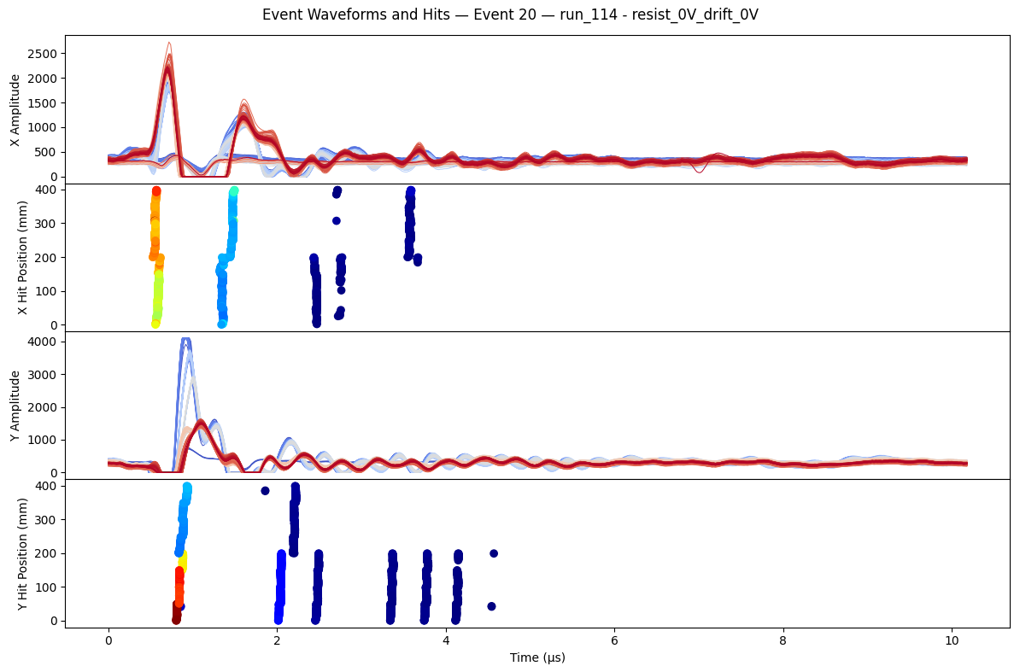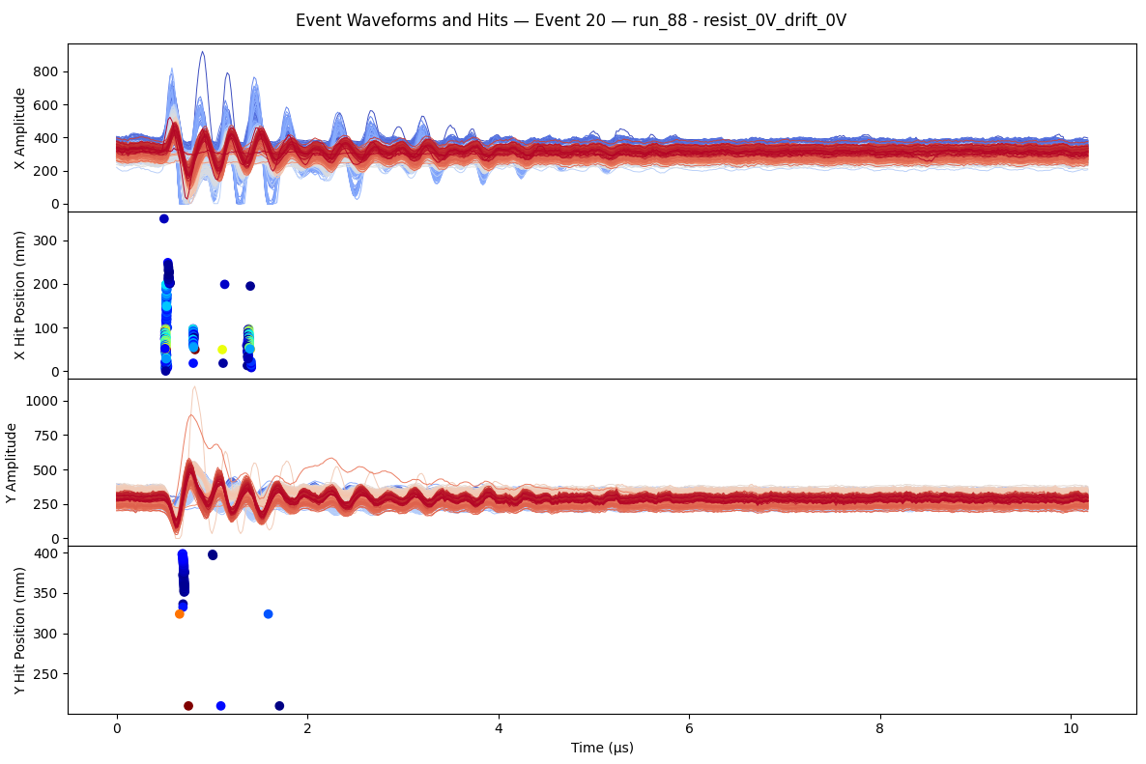

Not quite clear what is failing here on the analysis side, low statistics? But looks like some semblance of a peak around 660.
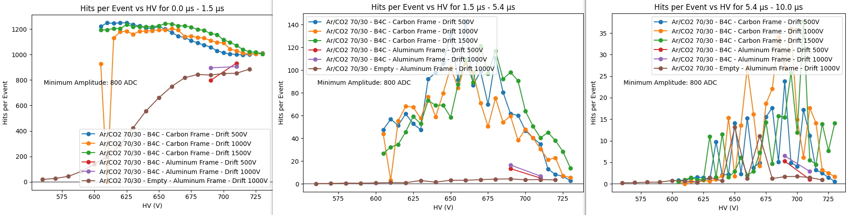

Run 120: Still in SiPM Trigger Mode!! Garbage!!! 0V drift 0V resist. In SiPM Trigger Mode!!!

Wrapped detector in aluminum to see if this would reduce the noise.
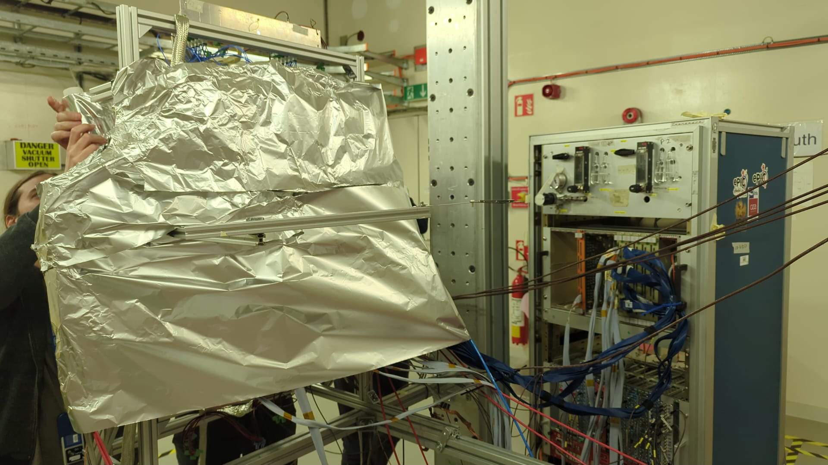

Run 121: Still in SiPM Trigger Mode!! Garbage!!! 0V drift 0V resist. In SiPM Trigger Mode!!!

Run 122: 0V drift 0V resist while wrapped in aluminum. Lead target, 6mm drift, carbon frame, Ar/CO2 70/30 gas.

No appreciable difference in noise with aluminum.
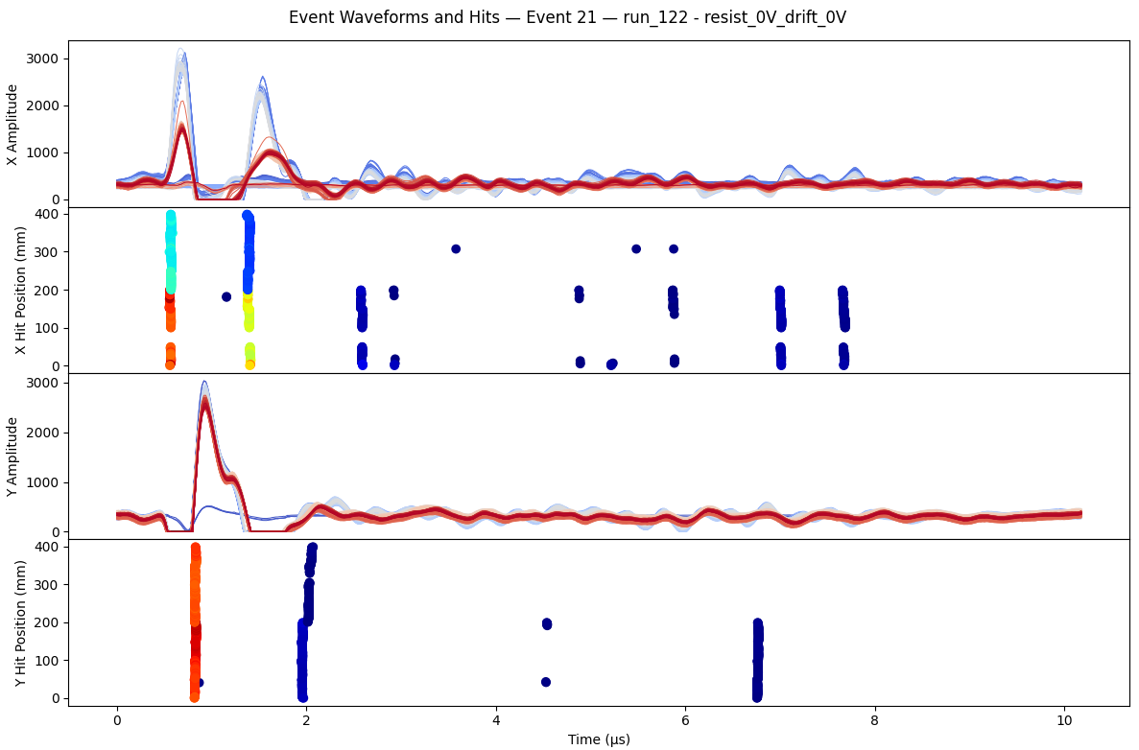

Run 123: Wrapped in aluminum. Lead target, 6mm drift, carbon frame, Ar/CO2 70/30 gas. PS trigger with 5 minute runs. HV scan at -1000V from 730V down in steps of -5V.

Made access to remove aluminum foil and add grounding to the back on screws. Still running with lead target.
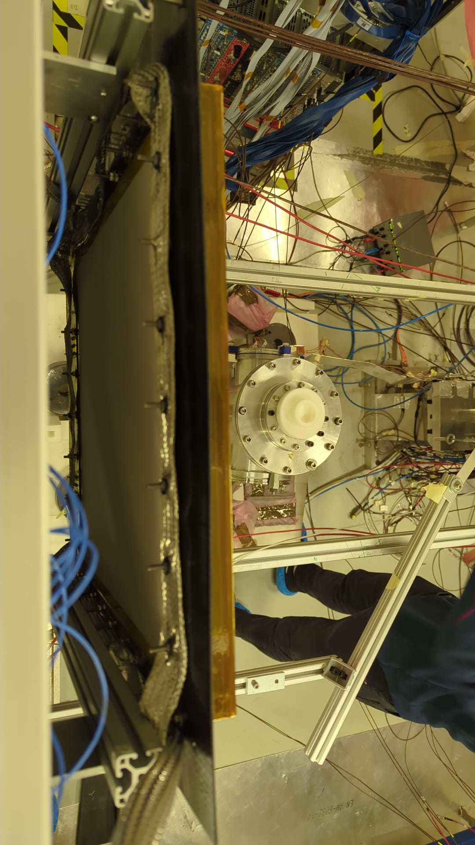
Run 124: Lead target, 6mm drift, carbon frame, Ar/CO2 70/30 gas. PS trigger with 5 minute runs. HV scan at -1000V, -500V from 730V down in steps of -5V.
Seemed like one of the cards is worse than the others for noise. Maybe that means the cards are noise source.

Made access to change gas from Ar/CO2 70/30 to He/Ethane 96.5/3.5. Also worked on the grounding of the cards.

Run 125: Lead target, 6mm drift, carbon frame, He/Ethane 96.5/3.5 gas. PS trigger with 5 minute runs. Gas change run with drift -1000V and resist +500V for 2 hours.

Run 126: Lead target, 6mm drift, carbon frame, He/Ethane 96.5/3.5 gas. PS trigger with 5 minute runs. Gas change run for 2 hours at -1000V drift +500V resist. HV scan at -500V, -1500V, -1000V, -500V from +540V to +400V down in steps of -5V.

Noise much better after last access. The assumption is that it’s the grounding of the cards?

Saturday February 28

Finishing HV scan at -1000V on arrival. Plan to make access next.

Run 127: Quick noise run at 0V drift 0V resist. Lead target, 6mm drift, carbon frame, He/Ethane 96.5/3.5 gas. PS trigger with 2 minute run.

Plan for access:
- Get mec8 cards for Stephan to solder
- Put on B4C target.
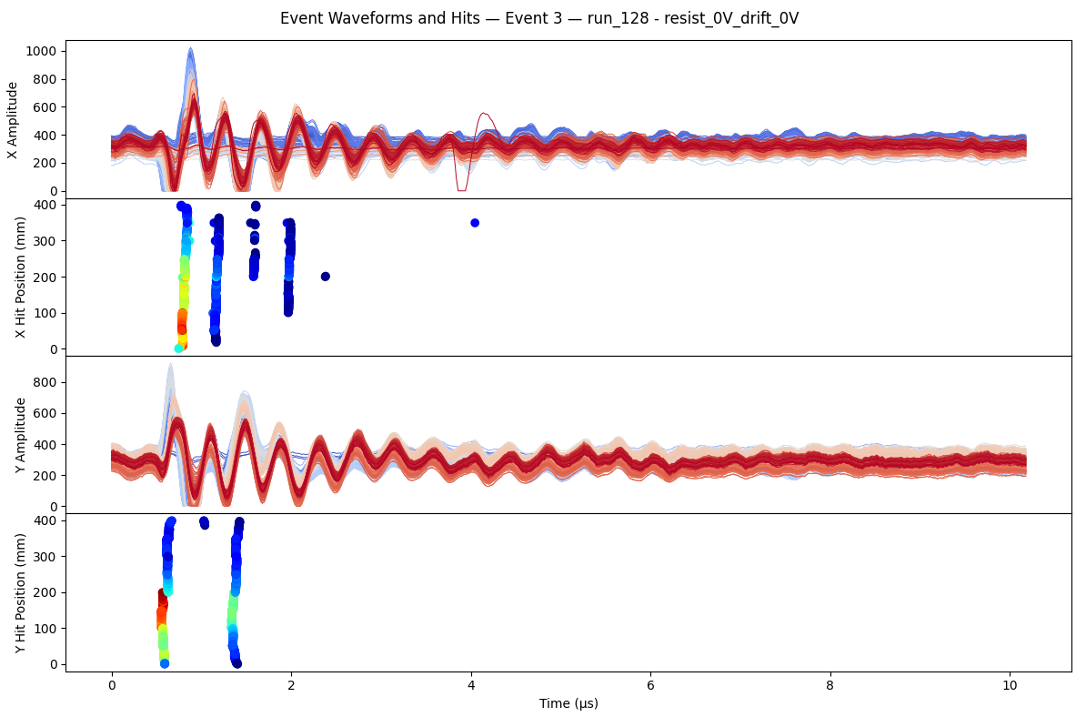
Short access to get both mec8 boards and replace lead with thin (2.5mm) B4C target. Plugged dream cable that was going to n_Tof daq back into FEU. Nblms still up and reading and detector still at 55 cm.

Stephan now going to solder 6 or so circuits between the two mec8 connector cards. Pierfrancesco is working on the copper board to put behind detector for hopefully better shielding. Plan is to install these things in about an hour.

Checking noise in a few runs today and things look the same as last night, so pretty good. Optimistic about our understanding of the cards being the receivers, hopefully paying attention to our shielding of these can reduce the noise in the final detectors.

Mesh Transparency: Talking with Stephan today confirmed suspicion about results from HV scans with different drift voltages. When drift field becomes larger, the mesh becomes less transparent – primary electrons don’t get sucked into holes and instead hit and are blocked by the wires. We couldn’t find reference but Stephan has in his mind a drop in efficiency below a ratio of ~50 for E_{Amp}/E_{Drift} while we sit around ~20 with -1000V drift and +500V resist (150 micron amplification gap, 6mm drift gap).

Run 128: Quick ~1 hr HV scan while Stephan and Pierfrancesco work. B4C, 6mm drift, carbon frame, He/Ethane 96.5/3.5 gas. PS trigger with 5 minute runs. Drift at -1000V, -500V and Resist going from +550V down to +400 in steps of -10 V.

Plan to delay trigger past gamma flash to make sure Dream is still saturated. If somehow not saturated, means saturation comes from somewhere we don’t expect and have a lead. Delay of 2.6 us + the nominal 9.4 us.

Run 129: Quick test of Dream saturation. Shift timing 2.6 us later to miss flash and see if still saturated. B4C, 6mm drift, carbon frame, He/Ethane 96.5/3.5 gas. PS trigger with 5 minute runs. Drift at -1000V, -500V and Resist going from +550V down to +400 in steps of -10 V.

Still seeing saturation in Run 129, good test to tell us it’s probably not the read out or anything that late in the chain.

Made access to attach Stephan’s creation. Put MM x1 to one card, then from other card to FEU 6.1. Also took x0 from FEU 5.0 to FEU 6.0 for comparison.
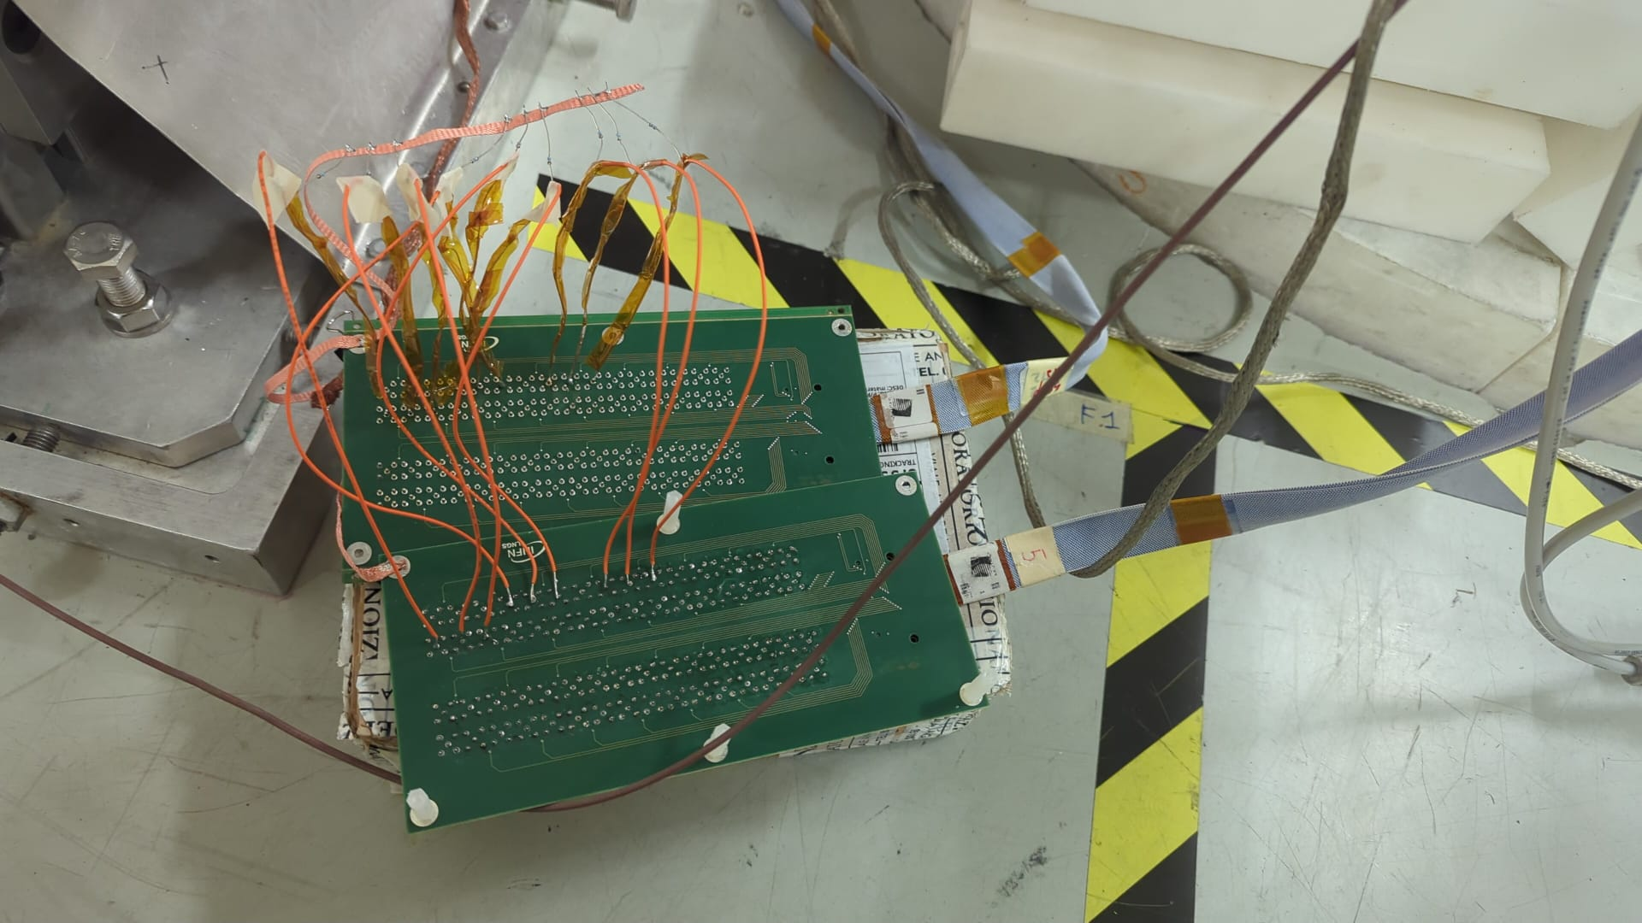

Run 130: Attached Stephan’s circuit. B4C, 6mm drift, carbon frame, He/Ethane 96.5/3.5 gas. PS trigger with 5 minute runs. Drift at -1000V, -500V and Resist going from +550V down to +400 in steps of -10 V.

Lots of noise with attenuated signal, but kind of works in theory. Can see the recovery time.
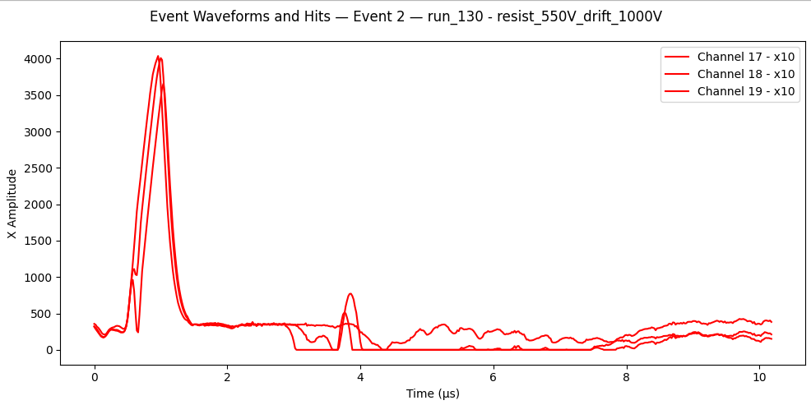

Made access with Riccardo. Removed nblms and moved detector from 55 cm back to 20 cm.

Talked to Irakli. Good conversation.

Realized that since Dream is the problem we should be able to just switch the flash signal with Marco’s switch. Plugged switch between the mec8 to lemo board and mcx to mec8 board. Goes to dream daq from there.

Turn back on at 10.6 us for 10 us

Run 131: Attached switch to one of the MM channels (X2 #16). Quick test. B4C, 6mm drift, carbon frame, He/Ethane 96.5/3.5 gas. PS trigger with 5 minute runs. Drift at -1000V and Resist going from +550V.

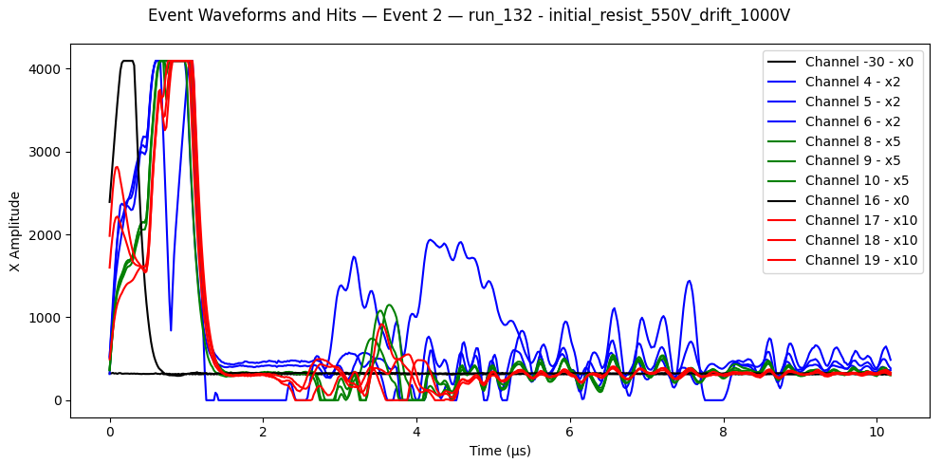
Seem to be early? Not sure why. 11.6 us delay.

Run 132: Attached switch to one of the MM channels (X2 #16). Quick test. B4C, 6mm drift, carbon frame, He/Ethane 96.5/3.5 gas. PS trigger with 5 minute runs. Drift at -1000V and Resist going from +550V.

14 us delay. Weird

Run 133: Attached switch to one of the MM channels (X2 #16). Quick test. B4C, 6mm drift, carbon frame, He/Ethane 96.5/3.5 gas. PS trigger with 5 minute runs. Drift at -1000V and Resist going from +550V.

Switch seems to be a problem. Induces saturation level signal in all connected strips.

Run 134: 14 us delay.

Run 135: 6 us delay, before window.

Made access to put lead as target and send gated signal to n_Tof daq.

Run 136: HV scan with lead target, 6mm drift, carbon frame, He/Ethane 96.5/3.5 gas, 20 cm from target. PS trigger with 5 minute runs. Drift at -1000V, -500V and Resist going from +550V to +410V.
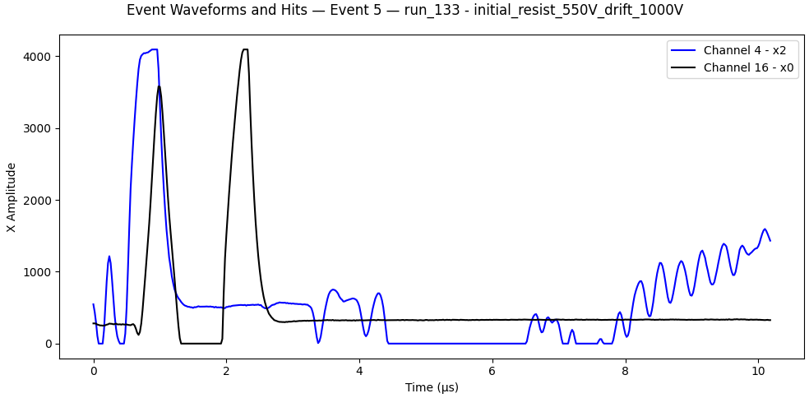
Slightly fewer hits with carbon frame compared to aluminum frame (plus nblms), ~-10%. Voltage at which Dream is saturated almost identical.
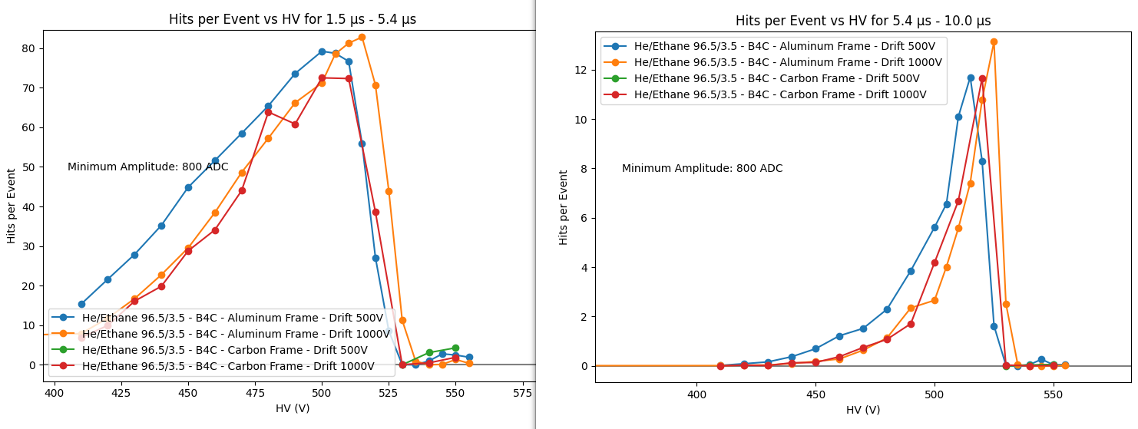
Made access with Stephan to install low pass filter after switch. Try running with this to see what it looks like. 56 Ohm and 56 pC.

Run 137: Quick HV scan with low pass filter to test. Empty target holder, 6mm drift, carbon frame, He/Ethane 96.5/3.5 gas, 20 cm from target holder. PS trigger with 5 minute runs. Drift at -1000V and Resist +550, +540, +530.

Run 138: HV scan with empty target holder, 6mm drift, carbon frame, He/Ethane 96.5/3.5 gas, 20 cm from target holder. PS trigger with 5 minute runs. Drift at -1000V, -500V and Resist going from +550V to +410V in -10V steps.

Looks like low pass filter didn’t make much of a difference. Still seem to saturate when switch opens.
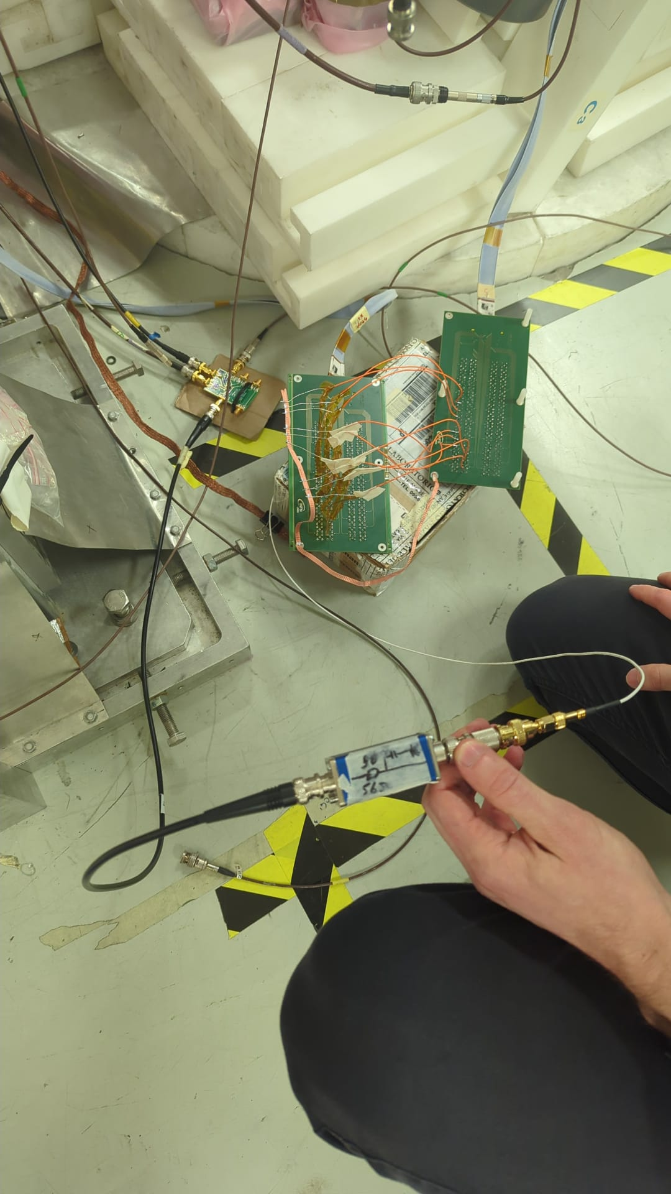
Made access to change from empty target to carbon target. Roughly aligned.

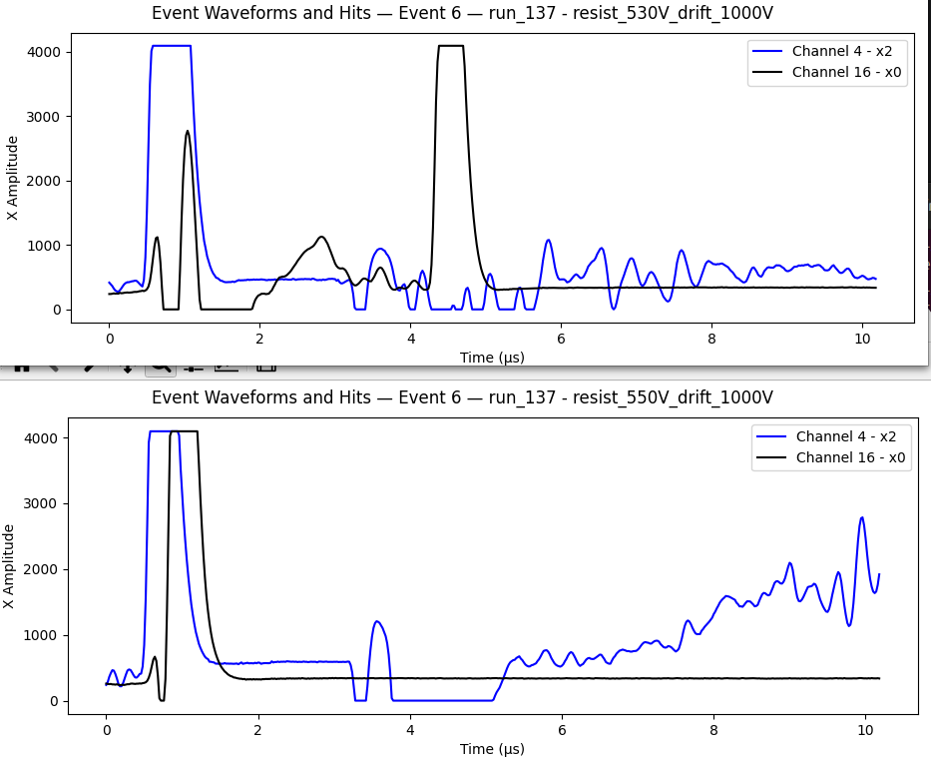
Run 139: HV scan with carbon target, 6mm drift, carbon frame, He/Ethane 96.5/3.5 gas, 20 cm from target holder. PS trigger with 5 minute runs. Drift at -1000V, -500V, -250V and Resist going from +550V to +410V in -5V then -10V steps. There was one longer run at the end with +515V on resist and -1000V on drift, ~40 minutes. It had the same name as the 5 minute run though, so the files will be together.

Sunday March 1
Run overnight tripped when going to -250V drift and +550V resist. Raised current limit in the morning when I arrived.

Planning to open detector and increase drift gap from ~6mm to ~12mm, just taking the vertical shims and placing under the horizontal ones.

Operation seems to have been successful. Certainly some casualties, however. Clearly pulled the mesh up when removing the drift.
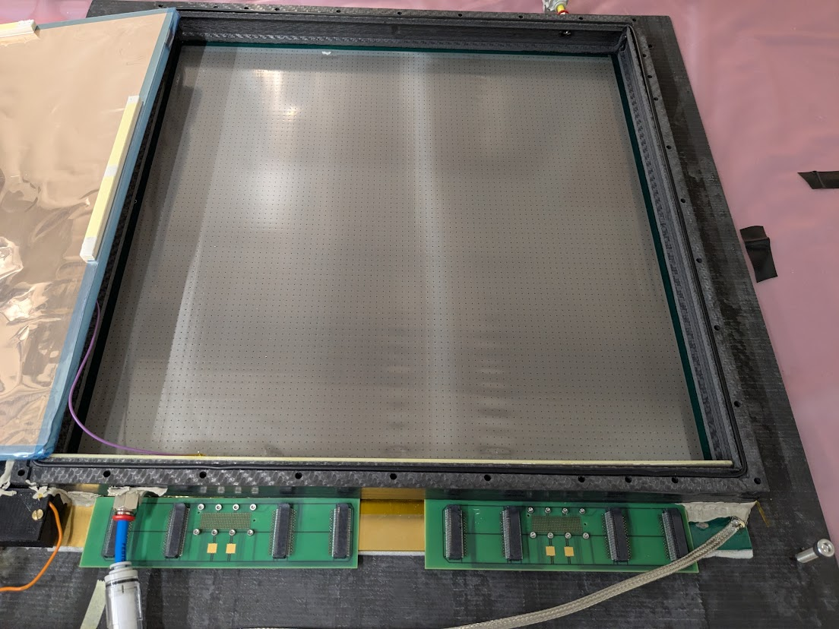
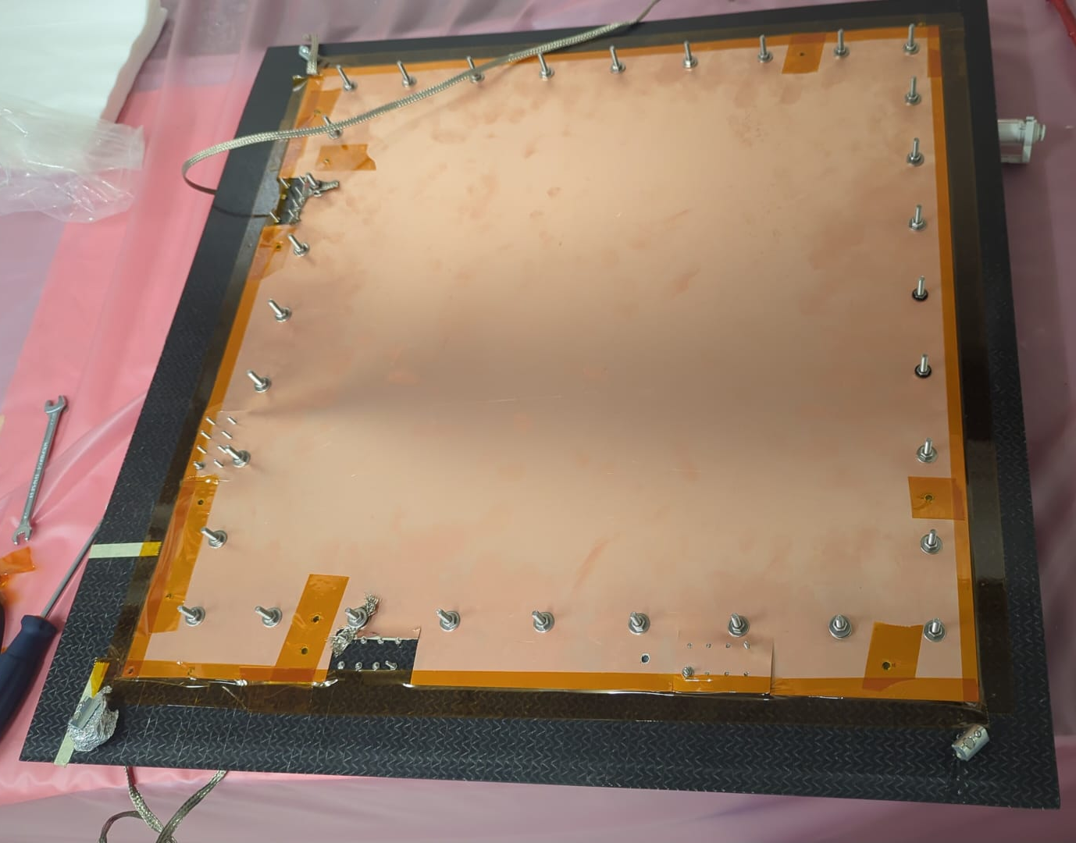

Run 140: Run while gas changes after switching from 6mm drift to 11mm. Carbon frame, He/Ethane 96.5/3.5 gas, 20 cm from target holder. PS trigger.

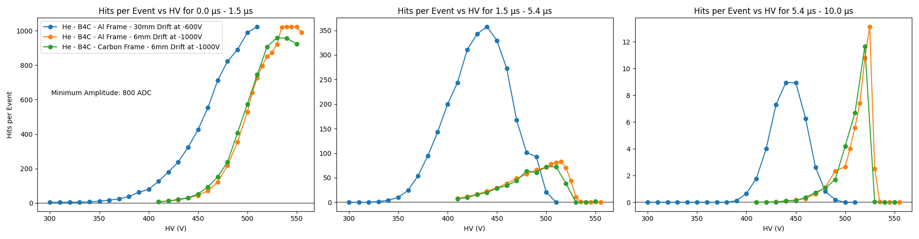
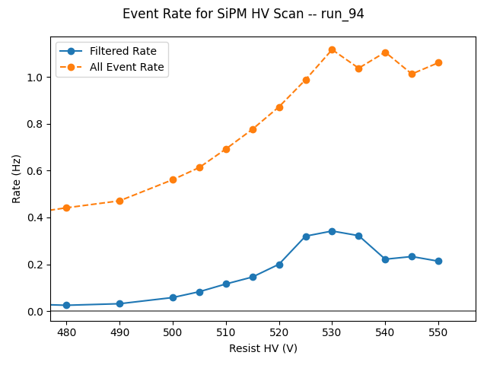
Seeing sparks on drift after change at -900V. Set at -800V for next run and seems to be stable.
Run 141: HV scan after switching from 6mm drift to 11mm. Gas still probably flushing the air. Carbon frame, He/Ethane 96.5/3.5 gas, 20 cm from carbon target. PS trigger. Drift HV -800V, -500V. Resist HV from +550V to +410V in steps of -5V, -10V. 5 min each.

Setting to run with SiPM trigger. Not sure which SiPM I have plugged in at this point. 30mV trigger on oscilloscope.

Run 142: HV scan with SiPM trigger for calibration after switching from 6mm drift to 11mm. Trigger on oscilloscope at 30 mV. Gas still probably flushing the air. Carbon frame, He/Ethane 96.5/3.5 gas, 20 cm from carbon target. Drift HV -800V, -500V. Resist HV from +550V to +410V in steps of -5V, -10V. 5 min each.

Run 143: HV scan with PS trigger for statistics after switching from 6mm drift to 11mm. Gas still probably flushing the air. Carbon frame, He/Ethane 96.5/3.5 gas, 20 cm from carbon target. PS trigger. Drift HV -800V, -500V. Resist HV +515V, +510V, +520V, …. 2 hours each.

Monday March 2
Stopped the last run around 8:30AM. Dismounted the detector and everything was cleared by RP. Packed everything into the truck and returned it all to CEA. Left DAQ PC to finish data transfer to lxplus.

